**VIET NAM NATIONAL UNIVERSITY HCMC**

**UNIVERSITY OF INFORMATION TECHNOLOGY**

**--------------------------------------------------------**



**FINAL REPORT**

Information System Analyst and Design

**TOPIC**

**VINHOMES RESIDENT SERVICES MANAGEMENT**

Teacher: TS. Cao Thi Nhan

ThS. Ta Viet Phuong

Class: IS210.M22.HTCL

Group: 12

Member: Trinh Duong Ngoc Tran - 20522036

Vu Chan Hung - 20521377

Le Phuong Tuyet - 20522135

Do Huynh My Tam - 20520746

**Ho Chi Minh, June 2022**

REPORT SUMMARY

Report summary

With the development of technology networks today, the management of residents and services in apartment buildings also needs systems for easy management. The project is created based on the need to manage a large number of residents, along with convenient services in the Vinhomes urban area. Our project provides a way to deploy, analyze, and design a residential management system in Vinhomes urban area. Provides the way the system works, the solutions, and the behavior required. Functional and non-functional requirements, use cases, activity diagrams, sequence diagrams...

1. **Structure of the report**

This report is presented in 5 chapters, the main content is summarized as below:

* + Chapter 1: Introduction

Provide an overview of the project.

* + Chapter 2: Requirement specification

Identify software requirements.

* + Chapter 3: Analysis and design

Create requirements model (use case models, use case description, activitydiagram used to describe the flow of main use case). Create class diagrams, sequence diagrams, and state diagrams.

* + Chapter 4: Implementation and testing

Show some main user interfaces used for typical user’s tasks. Describe some test case.

* + Chapter 5: Conclusion

My group opinions after building my software.

**Table of Contents**

Chapter 1: INTRODUCTION 4

1.1. Introduction 4

1.2. Research problems / Problems of the project 4

1.3. Research Objectives / Objectives of the project 5

1.4. Scope of project / Limitations of the study 5

Chapter 2: REQUIREMENT SPECIFICATION 6

2.1. Situation survey/ Survey of the current situation 6

2.2. Software requirements 11

Chapter 3: ANALYSIS AND DESIGN 14

***3.1.*** ***Use-case Diagram*** 14

3.1.1. List of actors: 15

3.1.2. List of Use-case: 15

**3.2. USECASE DESCRIPTIONS** 19

***3.3.*** ***Activity diagram*** 50

**3.4.** ***ERD*** 82

***3.5.*** ***DFDs*** 82

***3.7.*** ***Sequence Diagram*** 85

***3.8.*** ***Class Diagram*** 148

**3.9.** ***Mapping to Relational Model from ERDs*** 148

Chapter 4: IMPLEMENTATION AND TESTING 148

**4.1.** **Introduction to the implementation environment** 148

**4.2.** **User Interface** 149

Chapter 5: CONCLUSION 157

References 157

# Chapter 1: INTRODUCTION

* 1. Introduction

- Realizing that the demand for accommodation as well as recreational activities of people is increasing. We decided to analyze, design and build an application to manage residents of a small and medium sized urban area.

- With a full range of functions for managing people's personal information, managing services and infrastructure in each area along with other supports to bring convenience as well as fully meet the needs of customers. about entertainment and entertainment for the people.

- Not only that, the strictness in each process makes it easier and more comfortable for administrators to use. Besides the administrator, people also feel more interested in settling here because they will be served wholeheartedly thanks to the feedback function and high security of the system.

- Finally, based on what we researched and learned from Vinhomes' s residential management application, we have also built a similar application.

* 1. Research problems / Problems of the project

- Market research to bring better quality to users in addition to increase competitiveness with other systems

- Research and learn about real user experiences to understand customers better and come up with the best strategies to upgrade the application as well as the enterprise's management system.

- Understand the importance of each feature in the system to upgrade and update carefully to avoid affecting the customer experience

- Came up with many ideas aimed at providing multiple functions as well as bringing comfort and excitement to customers

- From the above problems, we summarize and give the following analysis methods: redraw the usecase diagrams meticulously; analyze the operation phase through diagrams so that it is reasonable and logical; and put it into practice by programming[1]

* 1. Research Objectives / Objectives of the project

We divided in Two type of Objectives, Admin and Resident of Vinhomes

There are a special one, it’s maids, but we would like to classify them into same class as Residents. Maids are Gained access to limited functions which are related to their job.

All admin can perform basic function operation: add, search, update and delete functions.

|  |  |  |
| --- | --- | --- |
| No. | User | Description |
| 1 | System admin (Head Admin) | who can manage all admins of the system  provided with basic operations such as add, search, update and delete admins. And assign access right to them  Take responsibity for Maintaining system |
| 2 | Resident admin | who can manage resident information  provided with basic operations such as add, search, update, delete residents,  and enhanced search type function like Residency statistics |
| 3 | Service admin | who can manage service in general. Provided with built-in tools to   * + Managing Service information (basic operations)   + Monitor the service booking process of residents |
| 4 | Resident | Get to managing their booking services activity also as hire maids, report problems, signing to gain right to use some Specific Services (intercom for instance) |

* 1. Scope of project / Limitations of the study
  + User-oriented features such as paying bills, hiring maids, viewing traffic cameras , register guest participation and many otherss
  + Including set of functions for manage residents of a small and medium sized urban area purposes

# Chapter 2: REQUIREMENT SPECIFICATION

* 1. Situation survey/ Survey of the current situation
     1. Interview

|  |  |
| --- | --- |
| **Application Manager Interview** | |
| **Interviewer:** *Thai Nhat Hoa* **Date interview:** *21/5/2022* | |
| **Question** | **Answer** |
| Describe the application's resident management process | After a user buys any real estate at Vinhome, the system automatically grants the user an identifier for each property that he or she buys. Then save the personal information of the people as well as the people that the people allow to use that place under the database management system.  **Response attitude:** probable |
| With such a resident management process, does the application meet many requirements of residents? | Still meeting the needs of customers, but the waiting time will be longer than usual  **Response attitude:** probable |
| Store data with what tools? | Use a database management system to store  **Response attitude:** probable |
| How do I update the functions in the app regularly? | Get feedback from residents, collect it once, and update it completely  **Response attitude:** probable |
| How to update the price of the service | The application will update immediately if there is a change in the supplier's side price  **Response attitude:** probable |

|  |  |
| --- | --- |
| **Residential staff interview** | |
| **Interviewer:** *Truong Tinh Vu* **Date interview:** *23/5/2022* | |
| **Question** | **Answer** |
| From what time to what time do you work? | If you are a full-time employee, you will work 11 hours a day from 8 am to 7 pm.  **Response attitude:** probable |
| Do you currently find your work much and strenuous? Why? | It's hard, but I can't get over it  **Response attitude:** probable |
| The application has a lot of different functions, so do you have trouble consulting or managing? How would you like to manage the app's functionality? | Yes, i have encountered many times in manipulating and administering my system and applications. I want to manage it closely and control it so that there are no serious errors that affect users as well as the business system.  **Response attitude:** probable |
| What factors do you think determine the behavior of customers using the service? | In my opinion, the decisive factor to customers' use of the product depends on what they feel our application meets their needs.  **Response attitude:** probable |
| How to update the price of the service | We will base on the price of our daily supply, besides dealing with inventory, we will offer promotions to increase attractiveness with customers and solve inventory problems.  **Response attitude:** probable |

|  |  |
| --- | --- |
| **Interview residents** | |
| **Interviewer:** *Le Phuong Tuyet* **Date interview:** 23*/5/2022* | |
| **Question** | **Answer** |
| How do you see employees and residents management in Vinhomes? | Vinhomes staff are very friendly and caring for residents. The management team and staff here always handle the problems quickly and effectively.  **Response attitude:** probable |
| How often do use services in Vinhomes urban areas? | I usually use utility services of vinhomes. It’s about 2 to 3 days a week.  And I use Free services such as swimming pool, volleyball …  **Response attitude:** probable |
| Have you ever used any applications to book/ schedule Vinhomes utility services? | Yes, I had!  **Response attitude:** probable |
| Are you satisfied with the application? | To be honest. I am quite satisfied.  **Response attitude:** probable |
| Is there any problems that you want it to be improved? | I want a channel for interacting with maids so that I can easily contact and hire them.  And if the app could run faster it would be great.  **Response attitude:** probable |

* + 1. Survey of the organization/ Current organizational situation
  + Resident:
    - One real estate:
      * + One person owns only one apartment and can accommodate many people
    - More than one real estate:
      * + A person who owns many accomodations at the same time but only in his or her name and can allow more than one person to live together
  + Real – Estate including 2 options:
    - House:
      * Is a house that does not belong to any apartment building and has a full floor to meet the needs of customers
    - Department:
      * An apartment that belongs to an apartment building and does not last long but still fully meets the daily living needs of people
  + Services:
    - Also provide functions such as travel, dining, entertainment, use, etc
    1. Survey of business processes, major activities

When residents want to use Vinhomes' services, residents can book an appointment through the system.

There is also a forum that not only allows residents to post posts to help contribute ideas to the system, but also can schedule a maid service.

After setting a schedule to use the services, the system will automatically record those services into the data.

Before residents want to use Vinhomes services, residents must have an account granted on the system by registering an account under user mode. There are two user modes as official resident and temporary resident.

A permanent resident is a resident who has a bill to pay the house contract,

As the owner of the house while temporary residents are tenants, they can still use Vinhomes services.

When the resident wants to pay the bill, the resident can pay directly on the system by logging in and then selecting the pay button. The system will automatically display the steps to fill in information, pay and issue invoices if needed.

The administrator manages the information of the residents, manages the service information and statistics the number and composition of the resident data to compare with the government.

* + 1. Survey of the existing system

- After a user buys any real estate at Vinhome, the system automatically grants the user an identifier for each property that he or she buys. Then save the personal information of the people as well as the people that the people allow to use that place under the database management system specifically MySQL

- After each customer's service experience, we give discounts to increase customer's love for that service, and also absorb feedback from customers to improve services better and better. customer satisfaction and bring the best quality of experience to customers

- After a customer pays for any service, we will save the information of that experience and print an invoice (or contract if it is a real estate service) and save it on the system. Customer's application system and our management system to increase the rigor of controlling customer activities in urban areas.

* 1. Software requirements
     1. Functional requirements

**Storage requirements**

Storage feature is the most important requirement of the system, and is the basis for implementing most of the system's functions, in order to ensure effective residential management, the system needs to store the following information:

* + - * Store login information.
      * Storage of resident information.
      * Storing employee information.
      * Store service information.

**Request to look up**

Residential information lookup: The function of looking up residential and apartment information is done when employees and residents need to view information. This function supports searching by criteria such as the name of the owner, number of people currently living in the apartment, number of apartments, and number of buildings or displays all information related to residents and apartments. Results after looking up: information (if any) according to the standard.

Detailed invoice information lookup: The function of Searching for detailed bill information is done when residents want to see the apartment management fee and water bill. This function supports searching by criteria such as invoice encryption, and apartment number. Result of output after searching: invoice information (if any) according to standards.

Look up existing services: Look up existing services when residents need to register to use utilities in the Vinhomes urban area. The output after the lookup is standard information and available service hours (if any).

**Service registration requirements:**

Registering available utilities: The function of registration for available utilities is performed when a resident needs to register to use available facilities such as BBQ, fishing, tennis court, football field baskets, and swimming pools, ... in Vinhomes urban area. This function supports registration according to criteria such as the resident's name, apartment code, and building number. The registration will be automatically saved on the system.

Resident card or vehicle card service registration: The function of registering for the service of making a resident card or vehicle card is done when a resident needs to register for a card to facilitate access, move the elevator or have a need parking bridge through a monthly payment. This function supports registration according to standards: resident's name, citizen's identity, license plate number, apartment code, and building number. The registration will be automatically saved on the system and awaited for processing.

Housekeeping service registration: The housekeeping service registration function is performed when residents have a need to hire a maid. This function supports standard registration: resident's name, apartment code, and building number.

* + 1. Non-functional requirements

**Interface requirements**: Friendly and friendly interface. Users can use it easily, conveniently and highly interactive. Operation is quick and easy to use.

**Quality Requirements**: Quality requirements run well during use, respond quickly and accurately. Each request must be processed strong 10 seconds. The functions must ensure tight linkage, and still, ensure the preservation of data when encountering unexpected problems.

**System Requirements**: can be used on almost all computers with a higher operating system than Windows 7.

**Evolution**: Easy to upgrade or add other utility modules.

**Compatibility**: Works well on computer platforms, and mobile.

# Chapter 3: ANALYSIS AND DESIGN

* 1. 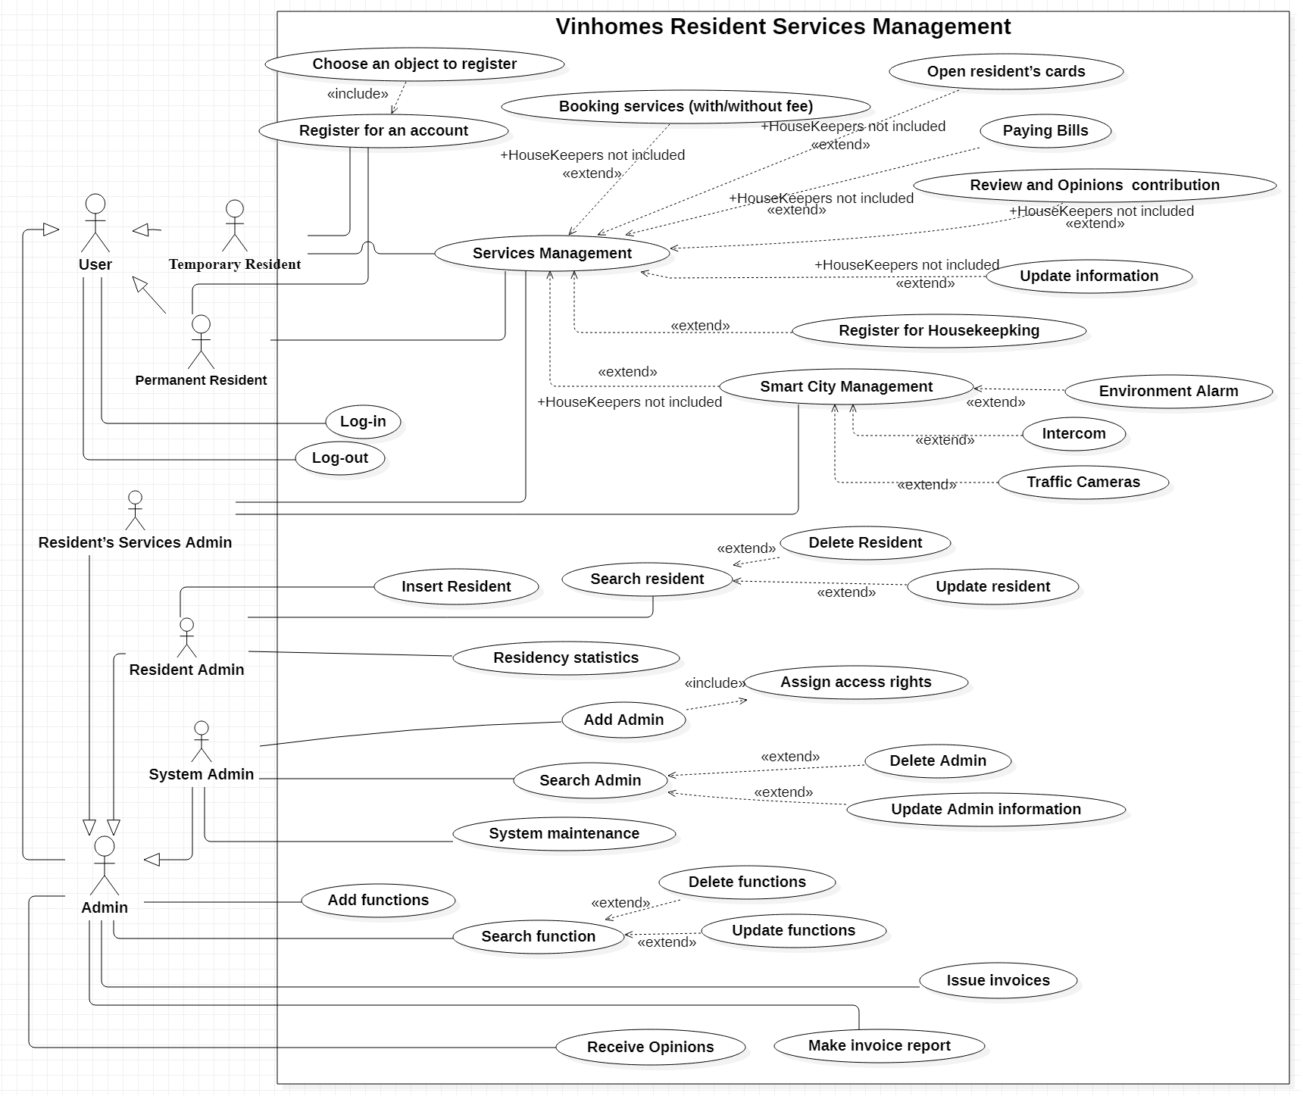***Use-case Diagram***

### 3.1.1. List of actors:

|  |  |  |  |
| --- | --- | --- | --- |
| No | Actor | | Meaning |
| 1 | Resident | Temporary | Users (tenants, housekeepers) |
| Permanent | Users (landlords) |
| 2 | Administ rator | Resident’s  Information  Management | To manage system about resident’s information |
| Resident’s  Services  Management | To manage system about resident’s services |
| System  Management | Head of the administrator – Managing both information  and services of the resident |

### 3.1.2. List of Use-case:

**List use – case for resident:**

|  |  |  |
| --- | --- | --- |
| No | Use – case name | Meaning |
| 1. Basic User Use-case | | |
| 1 | Register for an account | Register for an account to start using software |
| 2 | Choose an object to register | Choose an suitable object to register (Landlords,  Tenants, Housekeepers) |
| 3 | Log-in | Confirm the account’s information to use the  functions of software |
| 4 | Log-out | Log out and end-up the Using-process |
| 2. Services Management | | |
| 1 | Booking services  (with/without fee) | To book the public services without  fee(Badminton,Basketball,Table-tennis,..) |
| To book the public services with fees(BBQ, Fishing,..) |
| 2 | Open resident’s cards | To open resident’s cards, parking cards |
| 3 | Paying Bills | To pay management fees, services fees |
| 4 | Review and Opinions  contribution | Resident contribute opinions and suggestions. |
| **5** | **Update information** | **To update information (Finding Tenants,**  **HouseKeepers or other requirements)** |
| 6 | Register for Housekeepking | Housekeepers can find landlords to interact about their work thought an open Forum |
| 3. Smart City Management | | |

|  |  |  |
| --- | --- | --- |
| 1 | Environment Alarm | Announce AQI (air quality index) notification:  Temperature, Humidity, Fine Dust, Wind strength |
| 2 | Intercom | Register faces for guests to enter and exit the  apartment, forward calls on the doorbell to the App  installed on the owner's phone |
| 3 | Traffic Cameras | Display traffic cameras in urban areas |

**List use – case for Admin:**

|  |  |  |
| --- | --- | --- |
| No | Use – case  name | Meaning |
| 1. For All type Administrators | | |
| 1 | Add functions | Add more functions of software |
| 2 | Delete  functions | Delete functions of software |
| 3 | Search function | Search functions of software |
| 4 | Update  functions | Update functions of software |
| 5 | Receive  Opinions | Receive resident opinion, review, feedback |
| 6 | Issue invoices | Export, print the invoice |
| 7 | Make invoice  report | Make periodic reports (weekly, monthly, yearly), to evaluate resident services and promptly handle arising incident |

|  |  |  |
| --- | --- | --- |
| 5. Resident Admin | | |
| 1 | Insert Resident | Insert information about residents |
| 2 | Delete Resident | Delete information about residents |
| 3 | Update resident | Update information about residents |
| 4 | Search resident | Search information about residents |
| **5** | **Residency statistics** | **Is an enhanced version of Search resident function.**  **Help Resident Admin in Residency statistics, for details: show number of Residents by court, area, or by their own room** |
| 6. System Management’s function | | |
| 1 | Assign access  rights | Delegating access rights for the Admins to manage residents /  manage services |
| 2 | Add Admin | Add Admin to manage |
| 3 | Delete Admin | Delete Admin to manage |
| 4 | System  maintenance | Maintenance and troubleshooting of individual management system |
| 5 | Search Admin | Search information about Admin |
| 6 | Update Admin  information | Update information about Admin |

## **3.2. USECASE DESCRIPTIONS:**

**1. Resident’s Information Management**

|  |  |
| --- | --- |
| **Use-case’s Name** | Register for an account |
| **Primary actor** | Residents |
| **Brief description** | This use case helps users to register an account to  use the system |
| **Pre-condition** | N/A |

|  |  |
| --- | --- |
| **Post-condition** | Display user successfully registered for an account |
| **Trigger** | Users want to register an account |
| **Relationship** | N/A |
| **Basic-flow** | User presses “create a new account” button  The system displays the registration form  User enters required information -> press “register”  button  The system stores data and announces successful  registration |
| **Alternative flow** | N/A |
| **Exceptional flow** | Save to database failed -> requires user to re-enter |

1.2

|  |  |
| --- | --- |
| **Use-case’s Name** | Choose an object to register |
| **Primary actor** | Residents |
| **Brief description** | This use case describes a user choosing a  compatible user object |
| **Pre-condition** | N/A |
| **Post-condition** | Successfully chose user object |
| **Trigger** | User want to choose a compatible user object |
| **Relationship** | N/A |
| **Basic-flow** | The system displays user objects  User presses the button to choose the compatible  user object  The system stored data and announce successful |
| **Alternative flow** | N/A |

|  |  |
| --- | --- |
| **Exceptional flow** | Save to database failed -> requires user to re-enter |

1.3

|  |  |
| --- | --- |
| **Use-case’s Name** | Log-in |
| **Primary actor** | Residents |
| **Brief description** | This use case describes the function of logging into  the system |
| **Pre-condition** | The account has been registered before |
| **Post-condition** | User successfully logged into the system  Can use permissions that the system allows |
| **Trigger** | Users want to log into the system |
| **Relationship** | N/A |
| **Basic-flow** | The system displays the login form  User enter phone number and password (required) -> Press “login” button  System check login information  The system returns to the account screen |
| **Alternative flow** | N/A |
| **Exceptional flow** | Login information is incorrect  -> The system displays a message that the  email/password does not exist. |

1.4

|  |  |
| --- | --- |
| **Use-case’s Name** | Log-out |
| **Primary actor** | Residents |
| **Brief description** | This use case describes the function of logging out the system |
| **Pre-condition** | User has logged into the system |

|  |  |
| --- | --- |
| **Post-condition** | User logs out of the system |
| **Trigger** | User want to log out the system |
| **Relationship** | N/A |
| **Basic-flow** | User presses “log out” button  The system logs out and returns to the login screen |
| **Alternative flow** | N/A |
| **Exceptional flow** | N/A |

**2. Services Management**

2.1

|  |  |
| --- | --- |
| **Use-case’s Name** | Booking services  (with/without fee) |
| **Primary actor** | Residents |
| **Brief description** | This use case describes how to book services  without fee(Badminton ,Basketball, Table-tennis, .. )/with fee (BBQ, Fishing, ...) |
| **Pre-condition** | Employee log into system successfully   Fill full information |
| **Post-condition** | Booking successfully announcement |
| **Trigger** | Residents want book services of Vinhomes |
| **Relationship** | Booking Services |
| **Basic-flow** | Actor log into system -> press Booking service -> Fill  information -> Successful  Announce when insert successfully |
| **Alternative flow** | N/A |
| **Exceptional flow** | Booking failed and system returns error result |

2.2

|  |  |
| --- | --- |
| **Use-case’s Name** | Open resident’s cards |
| **Primary actor** | Residents |
| **Brief description** | This use case describes how to open resident’s card, parking cards |
| **Pre-condition** | Employee log into system successfully   Fill full information |
| **Post-condition** | Open successfully announcement |
| **Trigger** | Residents want parking cars, use entry gates of the of Vinhomes |
| **Relationship** | N/A |
| **Basic-flow** | Actor log into system -> press Open Cards -> Fill  information -> Successful  Announce when insert successfully |
| **Alternative flow** | N/A |
| **Exceptional flow** | Opening failed and system returns error result |

2.3

|  |  |
| --- | --- |
| **Use-case’s Name** | Paying Bills |
| **Primary actor** | Residents |
| **Brief description** | This use case describes how to pay management  fees, services fees |
| **Pre-condition** | Employee log into system successfully   Fill the Resident Appartment number |
| **Post-condition** | The invoices has been paid |
| **Trigger** | Customer want to pay money for the bills |

|  |  |
| --- | --- |
| **Relationship** | N/A |
| **Basic-flow** | - When user pay invoice, they will pay money - After  paying, Invoice is completely successful paid |
| **Alternative flow** | N/A |
| **Exceptional flow** | Paying failed and system returns error result |

2.4

|  |  |
| --- | --- |
| **Use-case’s Name** | Review and Opinions  contribution |
| **Primary actor** | Residents |
| **Brief description** | This use case describes how resident contribute  opinions and suggestions |
| **Pre-condition** | Employee log into system successfully   Fill the Resident Appartment number |
| **Post-condition** | The invoices has been paid |
| **Trigger** | Resident want to contribute opinions and  suggestions |
| **Relationship** | N/A |
| **Basic-flow** | • Actor log into system -> press Review and Opinions - > Fill Comments -> Successful  • Announce when insert successfully |
| **Alternative flow** | N/A |
| **Exceptional flow** | N/A |

2.5

|  |  |
| --- | --- |
| **Use-case’s Name** | Update information |

|  |  |
| --- | --- |
| **Primary actor** | Residents |
| **Brief description** | This use case describes how resident update information (Finding Tenants, House-keepers or other requirements) |
| **Pre-condition** | Employee log into system successfully   Fill the Resident Appartment number |
| **Post-condition** | Requirements are posted |
| **Trigger** | Resident want to require more services |
| **Relationship** | N/A |
| **Basic-flow** | Actor log into system -> press forum for residents ->  Fill requirements then posted -> Successful  Announce when insert successfully |
| **Alternative flow** | N/A |
| **Exceptional flow** | N/A |

2.6

|  |  |
| --- | --- |
| **Use-case’s Name** | Update information |
| **Primary actor** | Residents |
| **Brief description** | This use case describes how resident update  information(Finding Tenants, House-keepers or other  requirements) |
| **Pre-condition** | Employee log into system successfully   Fill the Resident Appartment number |
| **Post-condition** | Requirements are posted |
| **Trigger** | Residents want to require more services |
| **Relationship** | N/A |

|  |  |
| --- | --- |
| **Basic-flow** | Actor log into system -> press forum for residents ->  Fill requirements then posted -> Successful  Announce when insert successfully |
| **Alternative flow** | N/A |
| **Exceptional flow** | N/A |

**3. Smart City Management**

3.1

|  |  |
| --- | --- |
| **Use-case’s Name** | Environment Alarm |
| **Primary actor** | Residents |
| **Brief description** | Announce AQI (air quality index) notification:  Temperature, Humidity, Fine Dust, Wind strength |
| **Pre-condition** | Employee log into system successfully |
| **Post-condition** | See the information about the environment |
| **Trigger** | Resident want to know about the environment |
| **Relationship** | N/A |
| **Basic-flow** | Actor log into system -> Environment Alarm |
| **Alternative flow** | N/A |
| **Exceptional flow** | N/A |

3.2

|  |  |
| --- | --- |
| **Use-case’s Name** | Intercom |

|  |  |
| --- | --- |
| **Primary actor** | Residents |
| **Brief description** | Register faces for guests to enter and exit the  apartment, forward calls on the doorbell to the App  installed on the owner's phone |
| **Pre-condition** | Employee log into system successfully then register  faces for guest |
| **Post-condition** | Registering successful |
| **Trigger** | Guests from the outside appartment want to come  visit the residents |
| **Relationship** | N/A |
| **Basic-flow** | Actor log into system -> Register face ID ->  Successfully |
| **Alternative flow** | N/A |
| **Exceptional flow** | Cannot recognise face ID. Please try again |

3.3

|  |  |
| --- | --- |
| **Use-case’s Name** | Traffic Cameras |
| **Primary actor** | Residents |
| **Brief description** | Display traffic cameras in urban areas |
| **Pre-condition** | Employee log into system successfully |
| **Post-condition** | Can see the traffic cameras in urban areas |
| **Trigger** | Residents want to observe the environment throughout the traffic cameras |
| **Relationship** | N/A |
| **Basic-flow** | Actor log into system ->Traffic cameras ->  Successfully |

|  |  |
| --- | --- |
|  |  |
| **Alternative flow** | N/A |
| **Exceptional flow** | N/A |

**4. Functions Management**

4.1

|  |  |
| --- | --- |
| **Use-case’s Name** | Add functions |
| **Primary actor** | Administrator |
| **Brief description** | Administrator want to add more functions of  software |
| **Pre-condition** | Actor log into system successfully |
| **Post-condition** | Functions have been added |
| **Trigger** | Administrator want to add more functions of  software |
| **Relationship** | N/A |
| **Basic-flow** | Actor log into system by authorized account - >System -> Add more functions -> Succesfully |
| **Alternative flow** | N/A |
| **Exceptional flow** | Cannot add more functions. Please try again |

4.2

|  |  |
| --- | --- |
| **Use-case’s Name** | Delete functions |
| **Primary actor** | Administrator |
| **Brief description** | Administrator want to delete more functions of  software |
| **Pre-condition** | Actor log into system successfully |
| **Post-condition** | Functions have been deleted |
| **Trigger** | Administrator want to deleted unneccessary  functions of software |
| **Relationship** | N/A |
| **Basic-flow** | Actor log into system by authorized account - >System -> Delete functions -> Succesfully |
| **Alternative flow** | N/A |
| **Exceptional flow** | Cannot delete more functions. Please try again |

4.3

|  |  |
| --- | --- |
| **Use-case’s Name** | Search functions |
| **Primary actor** | Administrator |
| **Brief description** | Administrator want to search functions of  software |
| **Pre-condition** | Actor log into system successfully  Search exactly keyword of the functions |

|  |  |
| --- | --- |
| **Post-condition** | List of functions |
| **Trigger** | Administrator want to search functions of  software |
| **Relationship** | N/A |
| **Basic-flow** | Actor log into system by authorized account - >System -> Functions -> Search keywords -> Lists of  functions |
| **Alternative flow** | N/A |
| **Exceptional flow** | Cannot find function/ There is no function/ Errors/ Please try again. |

4.4

|  |  |
| --- | --- |
| **Use-case’s Name** | Update functions |
| **Primary actor** | Administrator |
| **Brief description** | Administrator want to update functions of  software |
| **Pre-condition** | Actor log into system successfully  Select a function need to updated |
| **Post-condition** | Function is updated |
| **Trigger** | Administrator want to update functions of  software |
| **Relationship** | N/A |
| **Basic-flow** | Actor log into system by authorized account - >System -> Functions -> Update -> update  succesfully |

|  |  |
| --- | --- |
| **Alternative flow** | N/A |
| **Exceptional flow** | Cannot update function/ There is no function/ Errors/  Please try again. |

4.5

|  |  |
| --- | --- |
| **Use-case’s Name** | Receive Opinions |
| **Primary actor** | Administrator |
| **Brief description** | Administrator want to receive opinions from  residents to repair immediately |
| **Pre-condition** | Actor log into system successfully |
| **Post-condition** | Lists of comments, reviews from residents |
| **Trigger** | Administrator want to receive opinions from  residents to repair immediately |
| **Relationship** | N/A |
| **Basic-flow** | Actor log into system by authorized account - >System -> Reviews from Residents -> Received and  repairing -> succesfully |
| **Alternative flow** | N/A |
| **Exceptional flow** | N/A |

4.6

|  |  |
| --- | --- |
| **Use-case’s Name** | Receive Opinions |
| **Primary actor** | Administrator |

|  |  |
| --- | --- |
| **Brief description** | Administrator want to receive opinions from  residents to repair immediately |
| **Pre-condition** | Actor log into system successfully |
| **Post-condition** | Lists of comments, reviews from residents |
| **Trigger** | Administrator want to receive opinions from  residents to repair immediately |
| **Relationship** | N/A |
| **Basic-flow** | Actor log into system by authorized account - >System -> Reviews from Residents -> Received and  repairing -> succesfully |
| **Alternative flow** | N/A |
| **Exceptional flow** | N/A |

4.7

|  |  |
| --- | --- |
| **Use-case’s Name** | Adjust information and issue invoices |
| **Primary actor** | Administrator |
| **Brief description** | Edit the information to match the service registration  information or the resident's request, then export and  print the invoice |
| **Pre-condition** | Actor log into system successfully  Insert the residents appartment code |
| **Post-condition** | Export invoices successfully |
| **Trigger** | Edit the information to match the service registration  information or the resident' s request, then export and  print the invoice |

|  |  |
| --- | --- |
| **Relationship** | N/A |
| **Basic-flow** | Actor log into system by authorized account - >System -> Residents Invoice -> Edit/Export ->  successfully |
| **Alternative flow** | N/A |
| **Exceptional flow** | Cannot Export/ Edit Resident’s invoice/ Please try again. |

4.8

|  |  |
| --- | --- |
| **Use-case’s Name** | Store invoices |
| **Primary actor** | Administrator |
| **Brief description** | Recording in books or backing up in the system so that  they can be looked up when necessary (which is the basis  for controlling accounting activities accurately and  effectively) |
| **Pre-condition** | Actor log into system successfully |
| **Post-condition** | Automatic saving invoices |
| **Trigger** | Recording in books or backing up in the system so that  they can be looked up when necessary (which is the  basis for controlling accounting activities accurately  and effectively |
| **Relationship** | N/A |
| **Basic-flow** | Actor log into system by authorized account - >System -> Residents Invoice |
| **Alternative flow** | N/A |

|  |  |
| --- | --- |
| **Exceptional flow** | N/A |

4.9

|  |  |
| --- | --- |
| **Use-case’s Name** | Make invoice report |
| **Primary actor** | Administrator |
| **Brief description** | Make periodic reports (weekly, monthly, yearly), to  evaluate resident services and promptly handle arising  incident |
| **Pre-condition** | Actor log into system successfully |
| **Post-condition** | Reporting residents invoices successfully |
| **Trigger** | Make periodic reports (weekly, monthly, yearly), to  evaluate resident services and promptly handle arising  incident |
| **Relationship** | N/A |
| **Basic-flow** | Actor log into system by authorized account ->System ->  Residents Invoice -> Report -> Successfully |
| **Alternative flow** | N/A |
| **Exceptional flow** | Cannot report Resident’s invoice/ Please try again. |

**5. Resident’s System information management**

5.1

|  |  |
| --- | --- |
| **Use-case’s Name** | Insert resident |
| **Primary actor** | Administrator |
| **Brief description** | This use case describes how to insert resident into  the system |

|  |  |
| --- | --- |
| **Pre-condition** | Actor log into system successfully |
| **Post-condition** | Resident successfully inserted |
| **Trigger** | Administrators want to insert resident |
| **Relationship** | N/A |
| **Basic-flow** | Administrator press the add button  Insert full resident information  Click the “save” button to insert success information |
| **Alternative flow** | Administrator needs to insert full information -> If   Information is missing, the system will display a  request to insert complete information. |
| **Exceptional flow** | Insert failed and system returns error result |

5.2

|  |  |
| --- | --- |
| **Use-case’s Name** | Delete Resident |
| **Primary actor** | Administrator |
| **Brief description** | Administrators want to delete information about  resident |
| **Pre-condition** | Actor log into system successfully  Keywords or ID of Resident that need to be deleted |
| **Post-condition** | Deleted Resident information do not exist in  database |
| **Trigger** | Administrators want to delete information about  resident |
| **Relationship** | N/A |
| **Basic-flow** | Actor log into system by authorized account -  >System -> Residents -> Information -> Delete ->  Successfully |
| **Alternative flow** | N/A |

|  |  |
| --- | --- |
| **Exceptional flow** | N/A |

5.3

|  |  |
| --- | --- |
| **Use-case’s Name** | Update Resident |
| **Primary actor** | Administrator |
| **Brief description** | This use case describes the function of updating  resident’s information |
| **Pre-condition** | Actor log into system successfully |
| **Post-condition** | Information about resident’s been updated |
| **Trigger** | Administrator want to update resident’s information |
| **Relationship** | N/A |
| **Basic-flow** | Actor log into system by authorized account - >System -> Residents -> Update -> successfully |
| **Alternative flow** | N/A |
| **Exceptional flow** | Cannot update information/ Errors |

5.4

|  |  |
| --- | --- |
| **Use-case’s Name** | Search resident |
| **Primary actor** | Administrator |
| **Brief description** | This use case describes how to insert resident into  the system |
| **Pre-condition** | Actor log into system successfully |

|  |  |
| --- | --- |
| **Post-condition** | Display a list of residents and information |
| **Trigger** | Administrators want to search information about  residents. |
| **Relationship** | N/A |
| **Basic-flow** | Administrators search information about resident The system displays list of residents successfully |
| **Alternative flow** | N/A |
| **Exceptional flow** | N/A |

6. System Management’s function

6.1

|  |  |
| --- | --- |
| **Use-case’s Name** | Assign access rights |
| **Primary actor** | Under management |
| **Brief description** | Delegating access rights for Admins to manage residents /  manage services |
| **Pre-condition** | Admins are going to be granted must be exist |
| **Post-condition** | Admins granted successfully |
| **Trigger** | System Management want to assign access rights to order sub-admins |
| **Relationship** | N/A |
| **Basic - flow** | Actor log into system by authorized account -> Reviews  sub-admins rights -> Assign access rights -> successfully |
| **Alternative flow** | N/A |
| **Exceptional flow** | N/A |

6.2

|  |  |
| --- | --- |
| **Use-case’s Name** | Add Admin |
| **Primary actor** | System administrator |
| **Brief description** | This use case describes how to add administrator to  manage the system |
| **Pre-condition** | All needed information about new admin |
| **Post-condition** | Admins added successfully |
| **Trigger** | System Management want to create a new admin for system. |
| **Relationship** | N/A |
| **Basic - flow** | Actor log into system by authorized account - >System ->Administrator -> Add successfully |
| **Alternative flow** | N/A |
| **Exceptional flow** | N/A |

6.3

|  |  |
| --- | --- |
| **Use-case’s Name** | Delete Admin |
| **Primary actor** | System administrator |
| **Brief description** | This use case describes how to delete administrator  to manage the system |
| **Pre-condition** | Actor log into system successfully   Keywords or ID of Admin that need to be  deleted |
| **Post-condition** | Admins deleted successfully |
| **Trigger** | System Management want to delete an existed admin in system. |

|  |  |
| --- | --- |
| **Relationship** | N/A |
| **Basic - flow** | Actor log into system by authorized account - >System ->Administrator -> delete successfully |
| **Alternative flow** | N/A |
| **Exceptional flow** | N/A |

6.4

|  |  |
| --- | --- |
| **Use-case’s Name** | System maintenance |
| **Primary actor** | System Administrator |
| **Brief description** | Maintenance and troubleshooting of individual  management system |
| **Pre-condition** | Admins log into system successfully |
| **Post-condition** | System is being repaired for resident to use |
| **Trigger** | Maintenance and troubleshooting of individual  management system |
| **Relationship** | N/A |
| **Basic - flow** | Actor log into system by authorized account -> system maintenance -> Fix successfully |
| **Alternative flow** | N/A |
| **Exceptional flow** | N/A |

6.5

|  |  |
| --- | --- |
| **Use-case’s Name** | Search Admin |
| **Primary actor** | System Administrator |

|  |  |
| --- | --- |
| **Brief description** | Search information about Admin |
| **Pre-condition** | Admins are going to be granted must be exist |
| **Post-condition** | List of admins |
| **Trigger** | Search information about Admin |
| **Relationship** | N/A |
| **Basic - flow** | Actor log into system by authorized account -> Admin -> Search -> Assign access rights-> successfully |
| **Alternative flow** | N/A |
| **Exceptional flow** | N/A |

6.6

|  |  |
| --- | --- |
| **Use-case’s Name** | Update Admin information |
| **Primary actor** | System Administrator |
| **Brief description** | Delegating access rights for Administrator/  Updating admin information |
| **Pre-condition** | Actor log into system successfully |
| **Post-condition** | Admin information is updated |
| **Trigger** | Delegating access rights for Administrator/ Updating  admin information |
| **Relationship** | N/A |
| **Basic - flow** | Actor log into system by authorized account -> Admin ->  Information -> Update -> Assign access rights-> successfully |

|  |  |
| --- | --- |
| **Alternative flow** | N/A |
| **Exceptional flow** | N/A |

* 1. ***Activity diagram***
* *List use – case for resident:*

### 3.3.1. Resident’s Information Management

1. **Register for an account**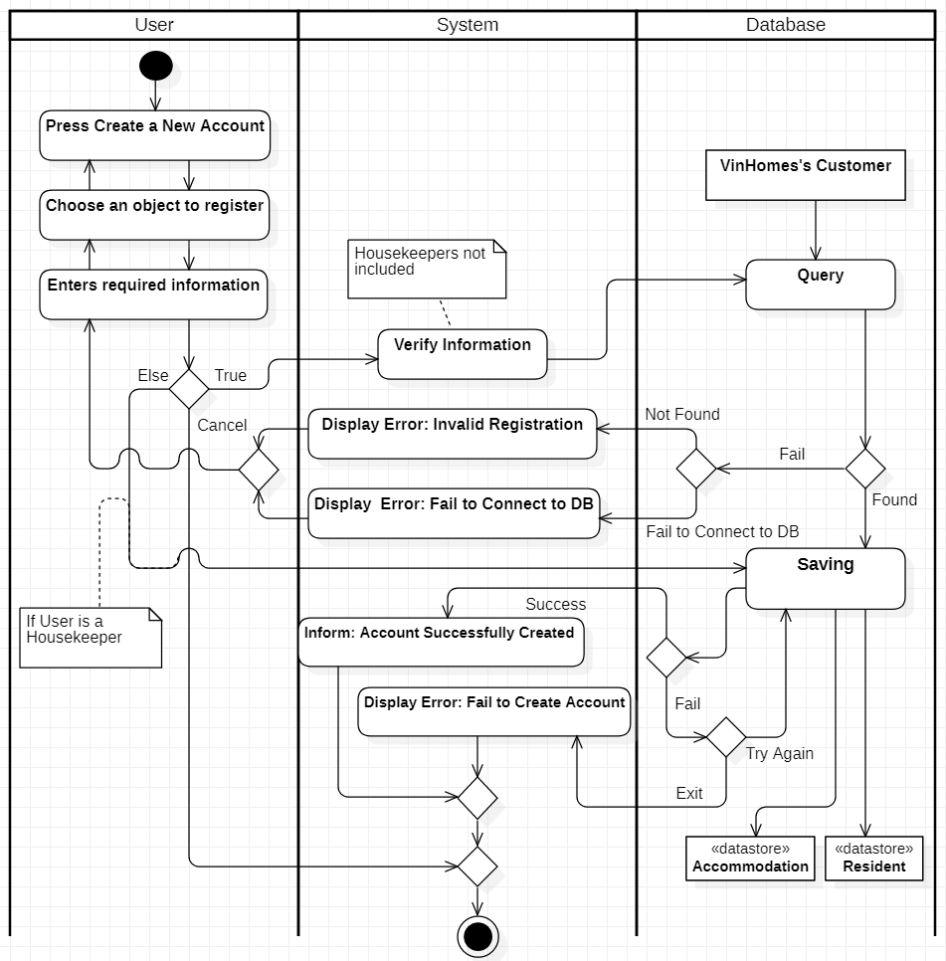

1. **Log-in**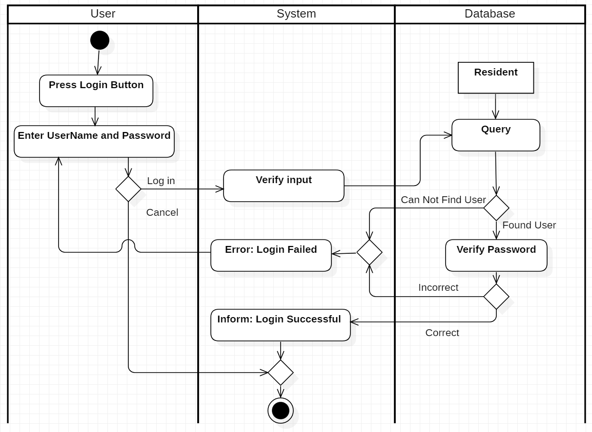

1. **Log-out**

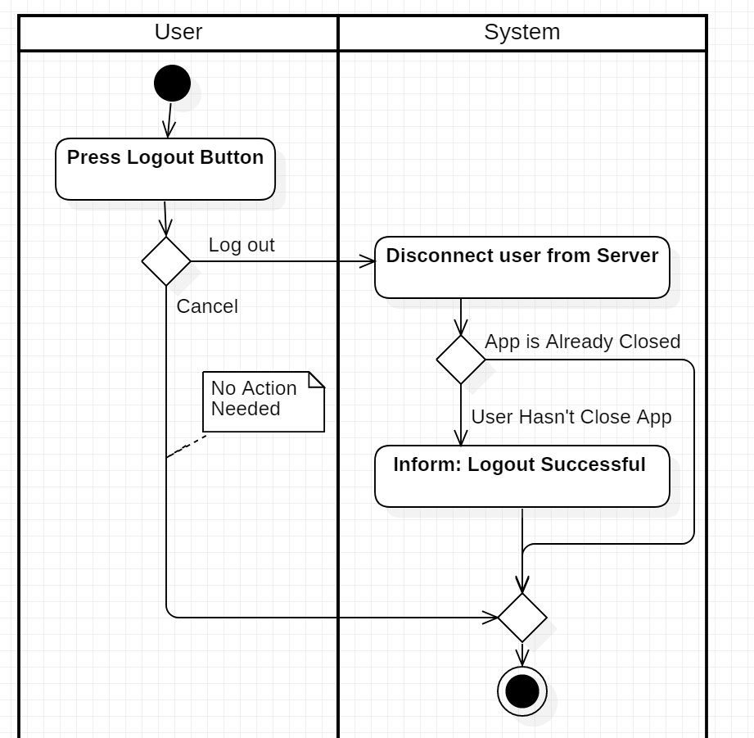

### 3.3.2. Services Management

* 1. 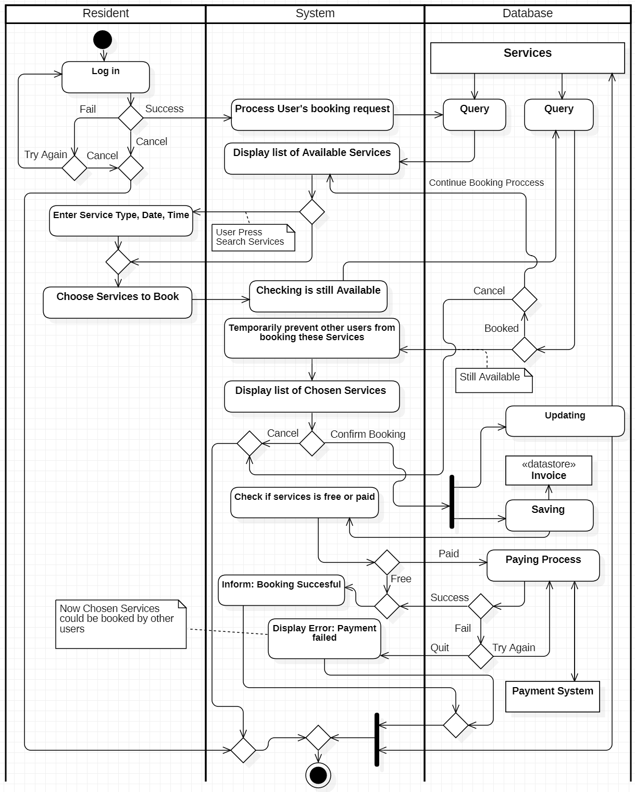**Booking services (with/without fee)**
  2. **Open resident’s cards**

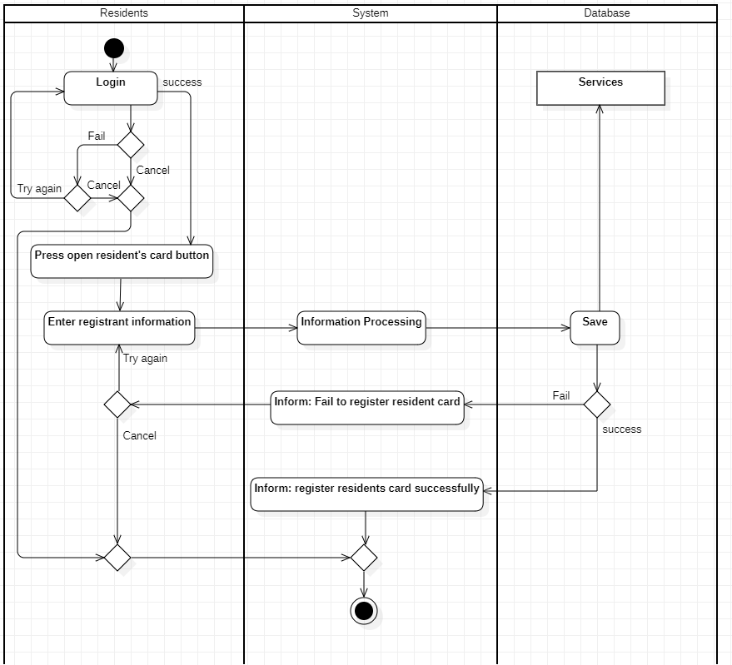

* 1. **Paying Bills**

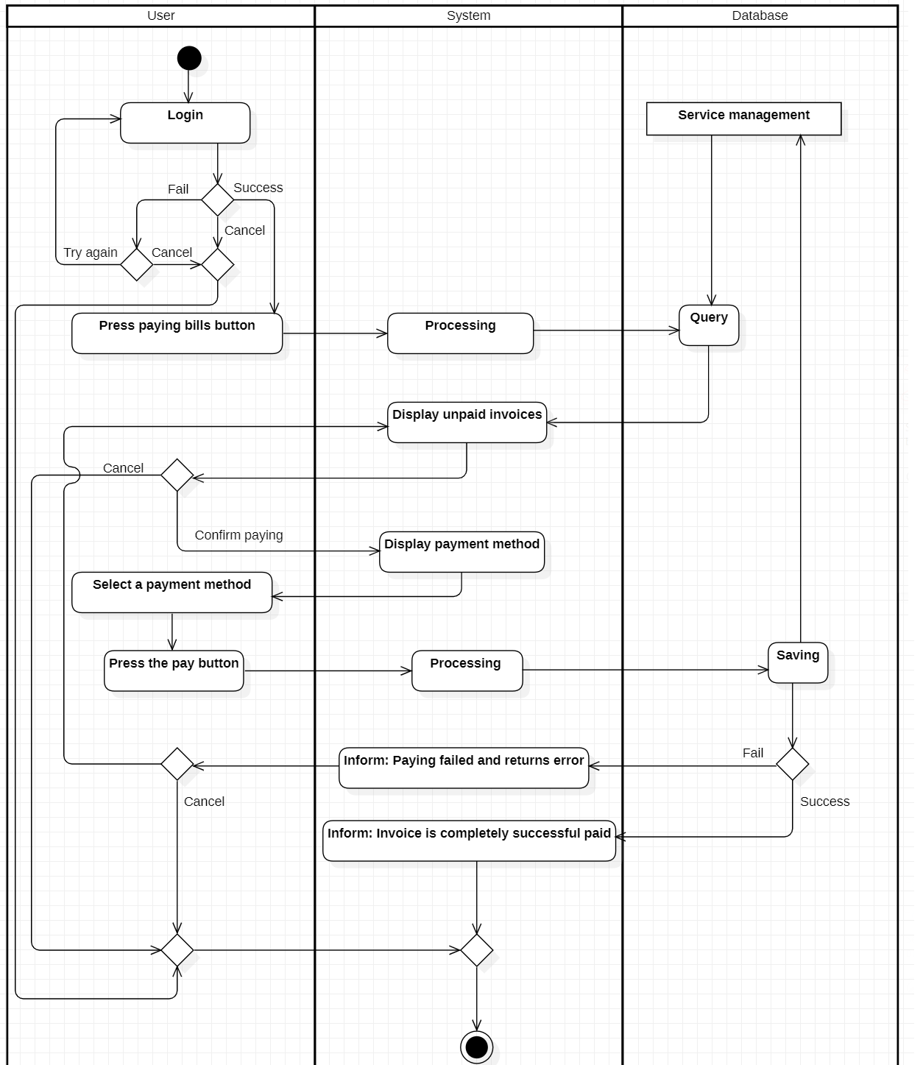

1. **Review and Opinions contribution**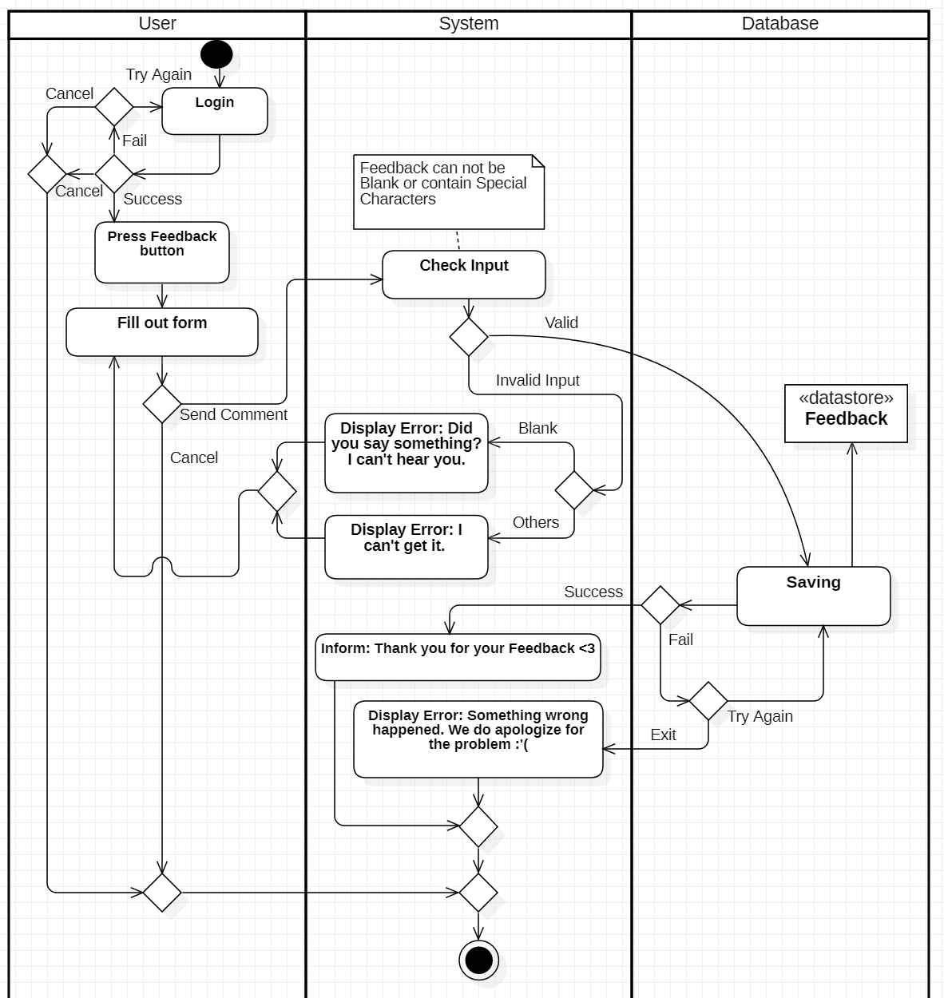
2. **Update information**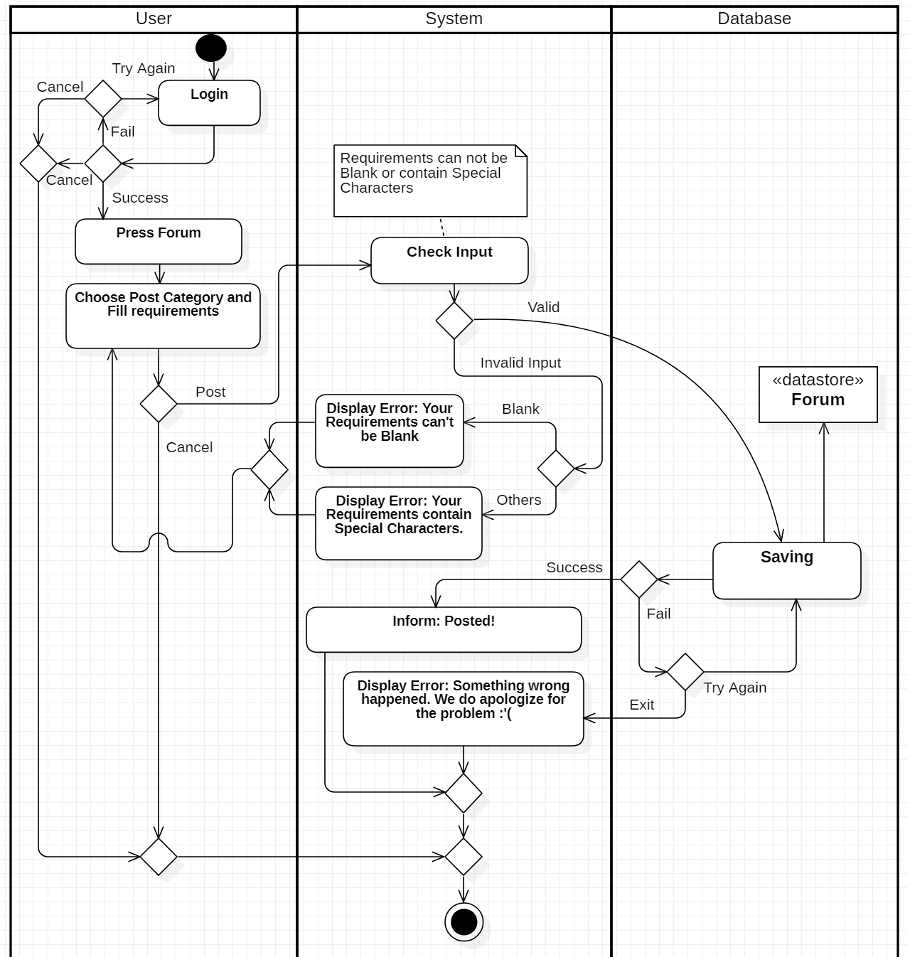
3. **Register for Housekeepking**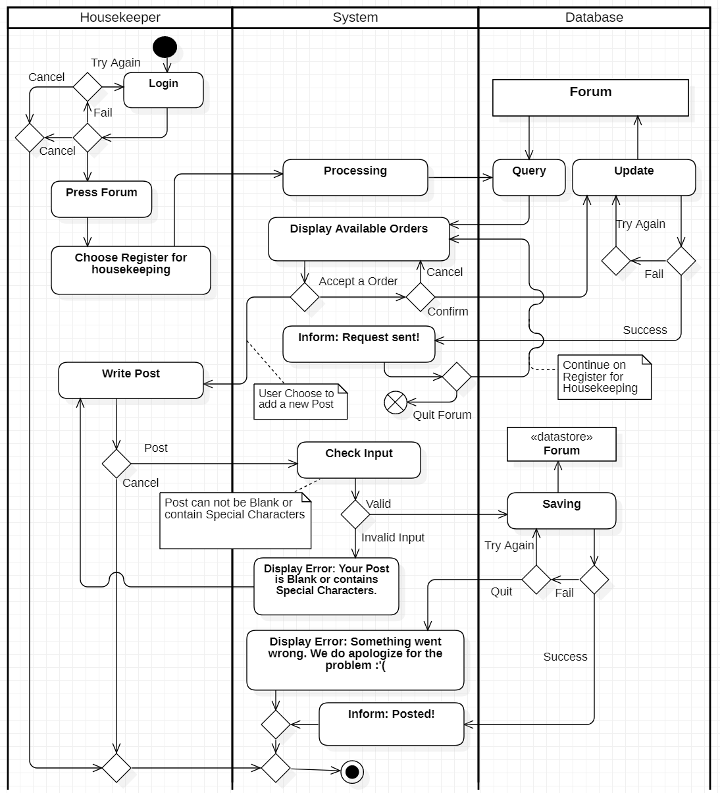

### 3.3.3. Smart City Management

1. **Environment**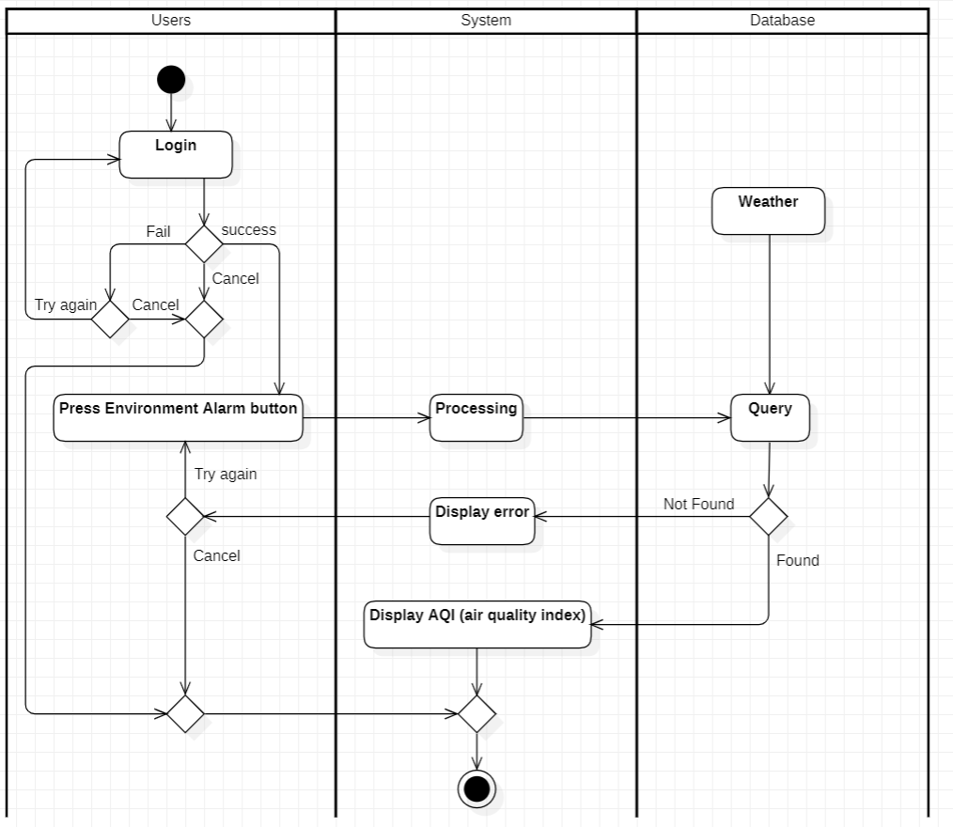
2. **Intercom**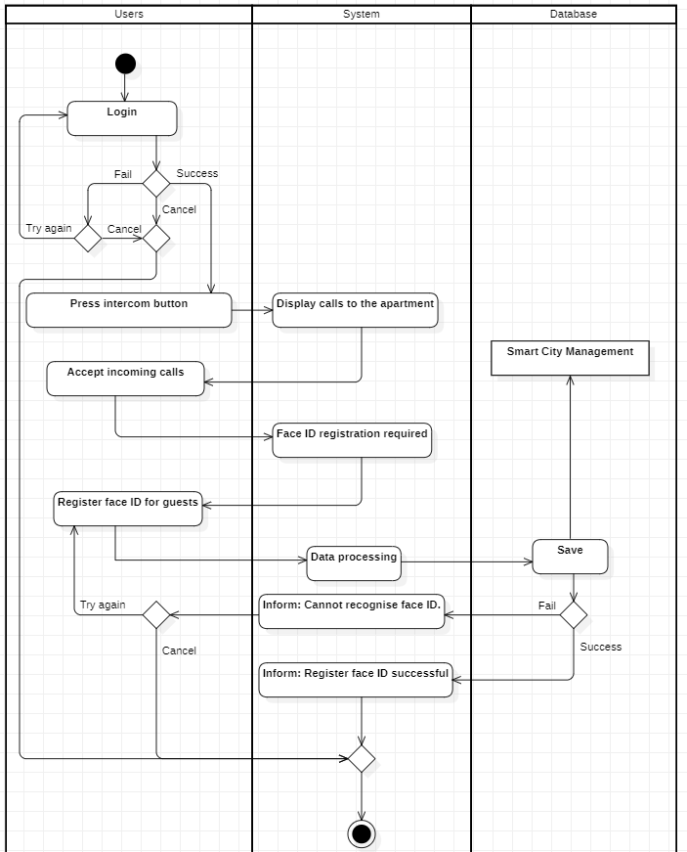

1. **Traffic Cameras**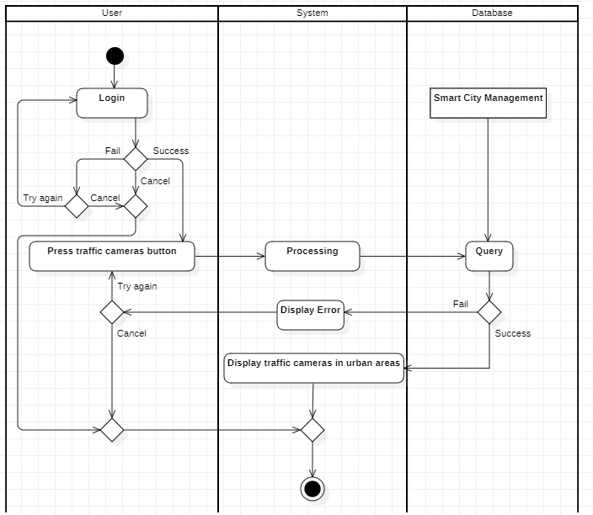

* *List use – case for Admin:*

### 3.3.4. Functions Management

1. **Add functions**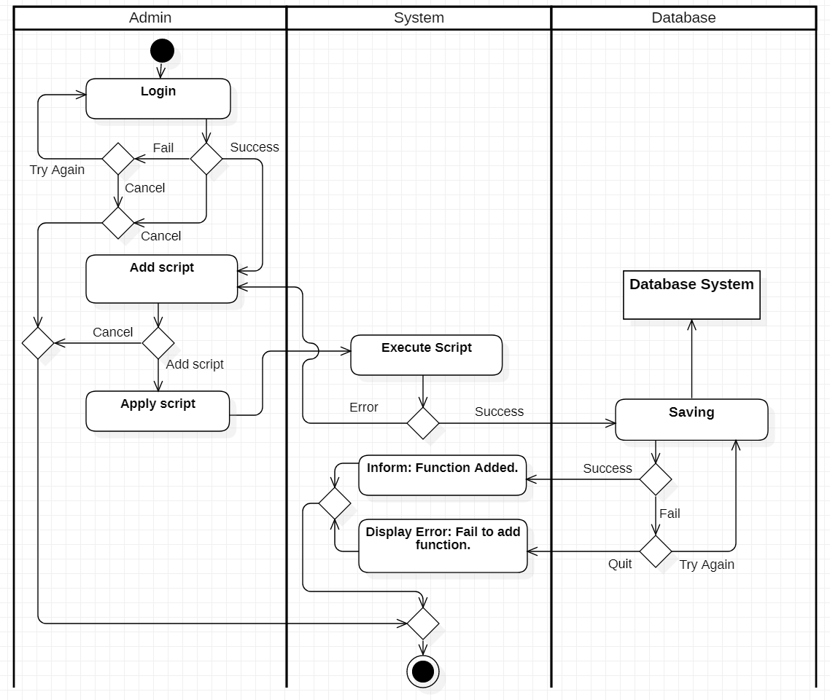
2. **Search function**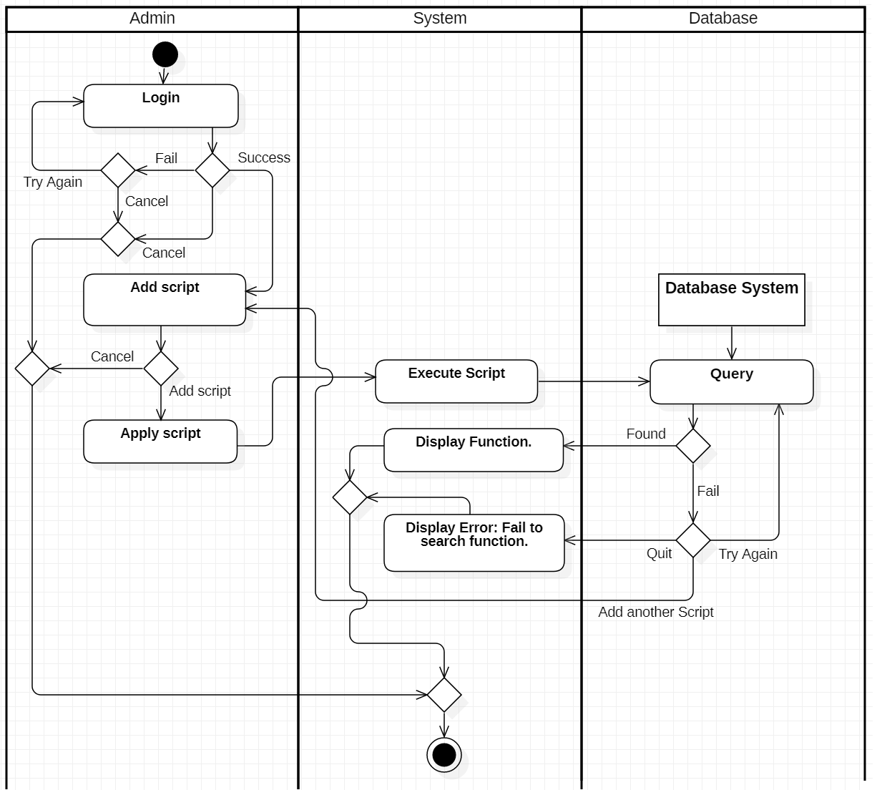
3. **Delete functions**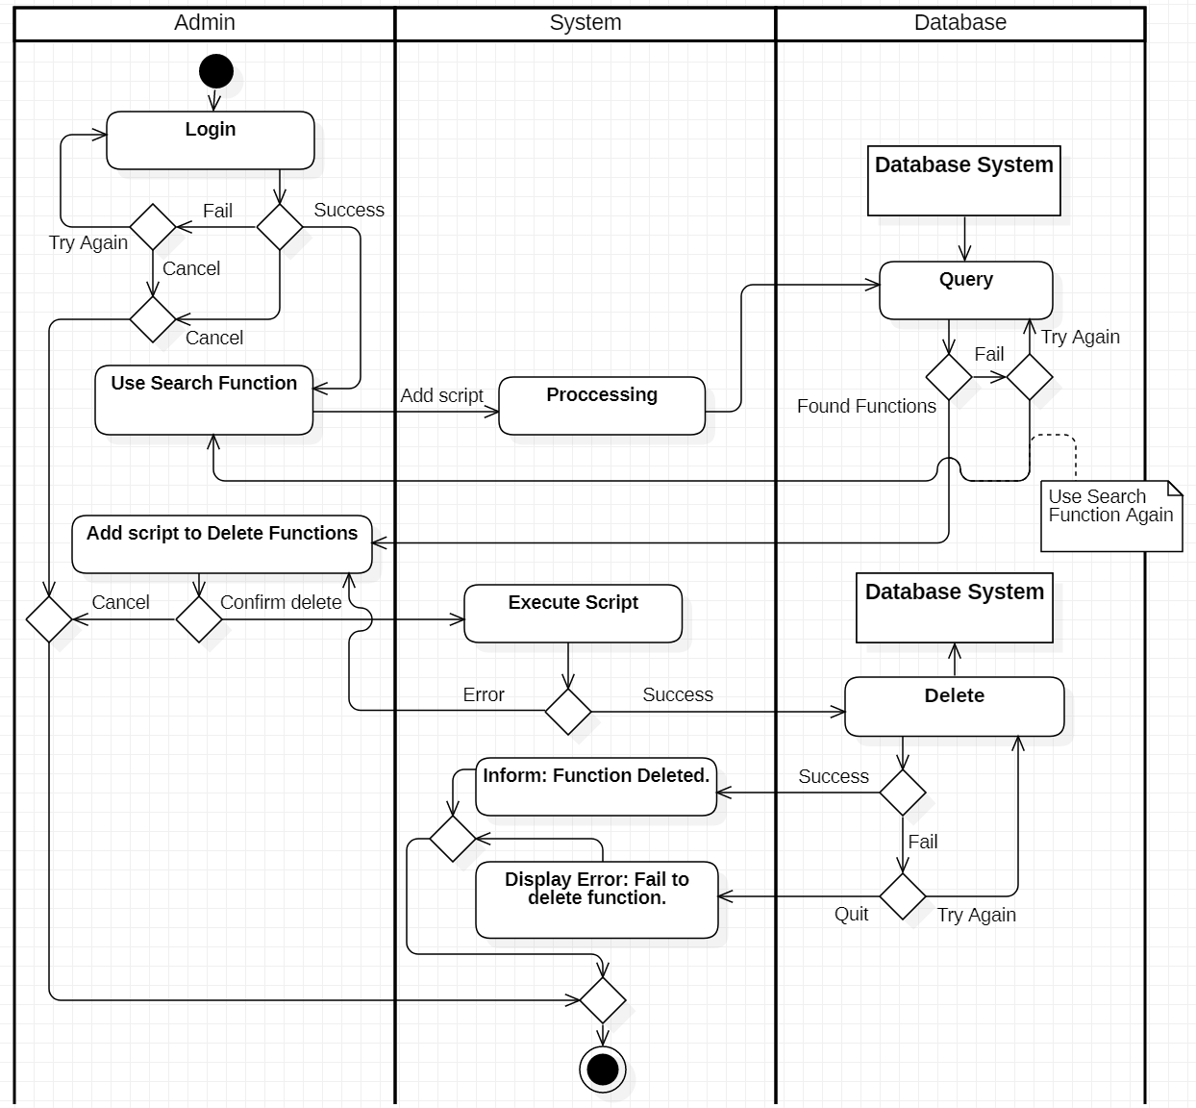
4. **Update functions**

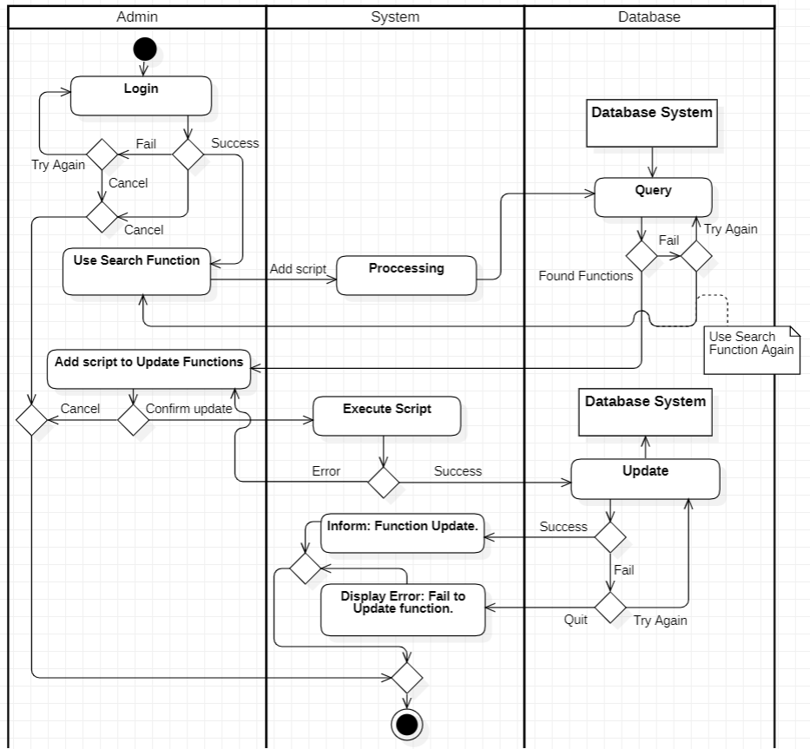

1. **Receive Opinions**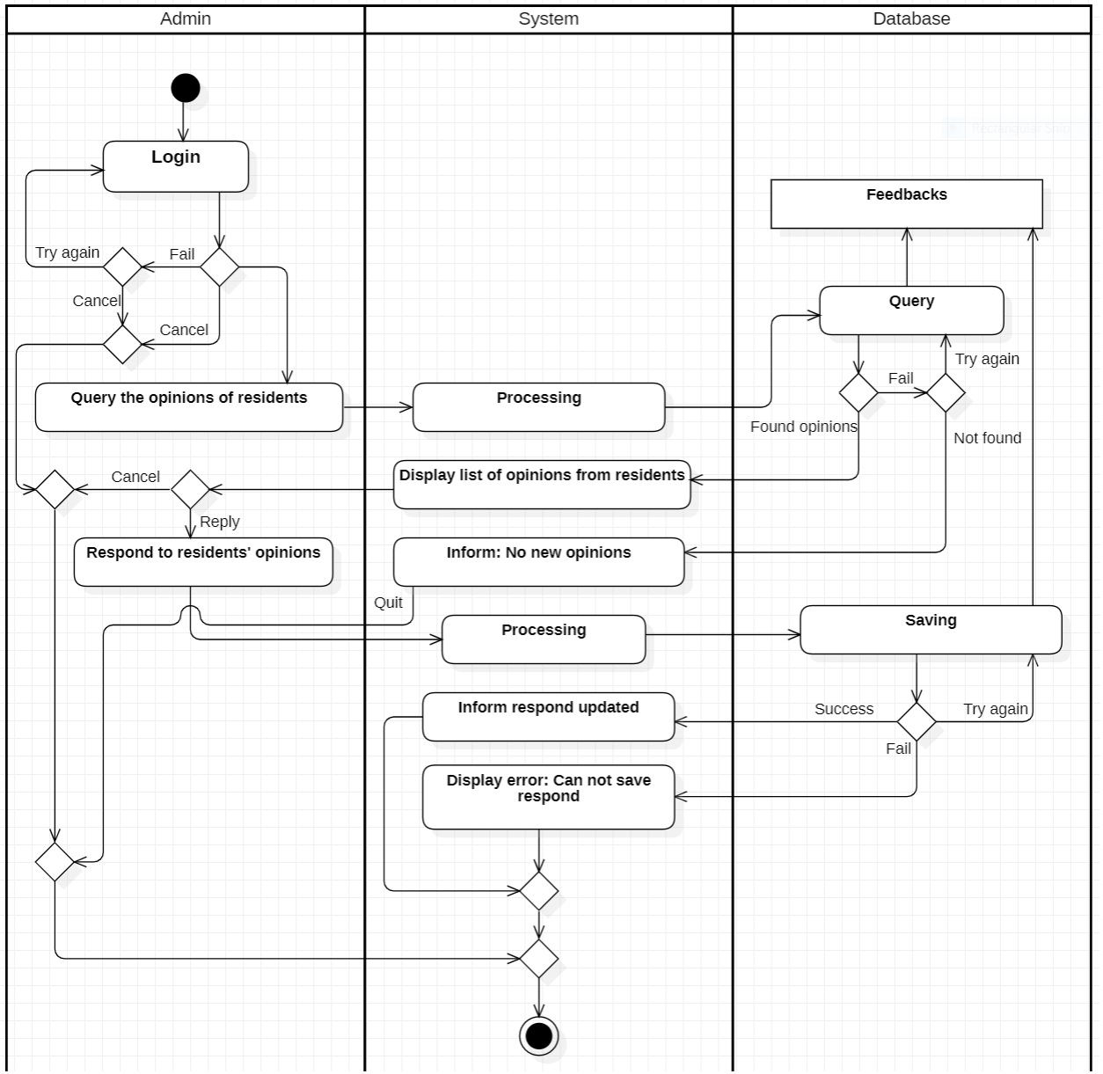
2. **Adjust information and issue invoices**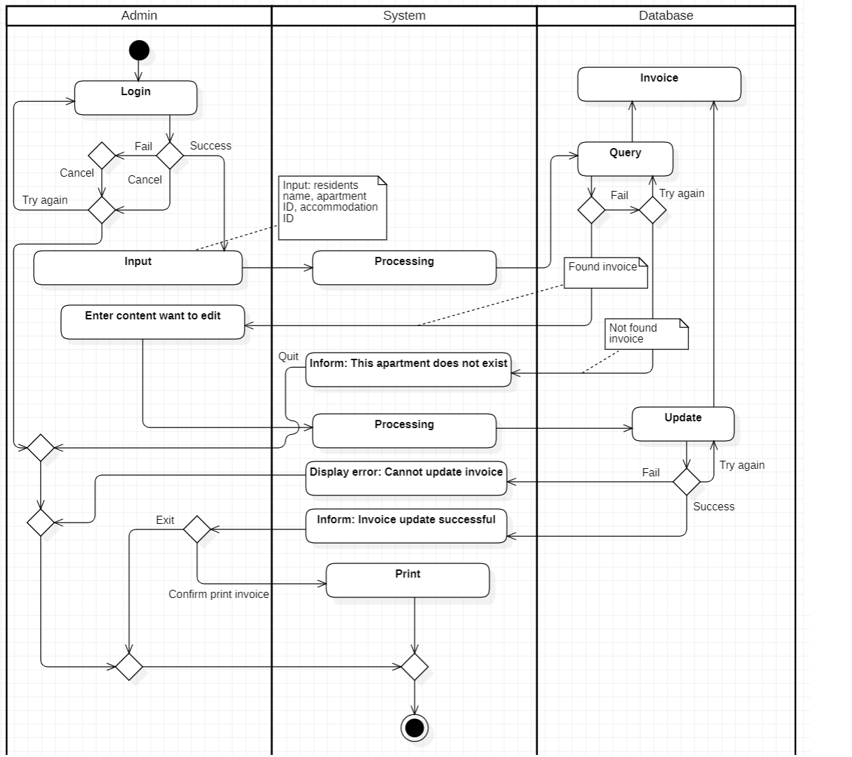
3. **Make invoice report**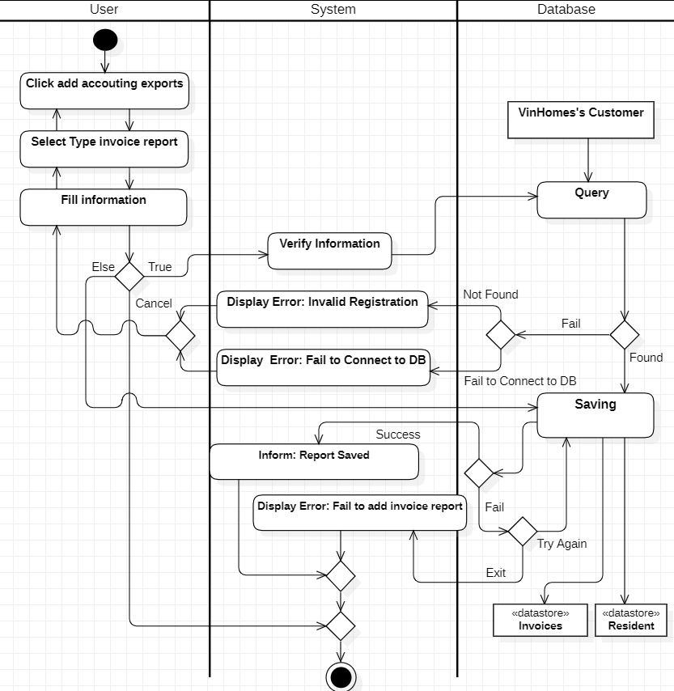

### 3.3.5. Resident’s System information management

1. **Insert Resident**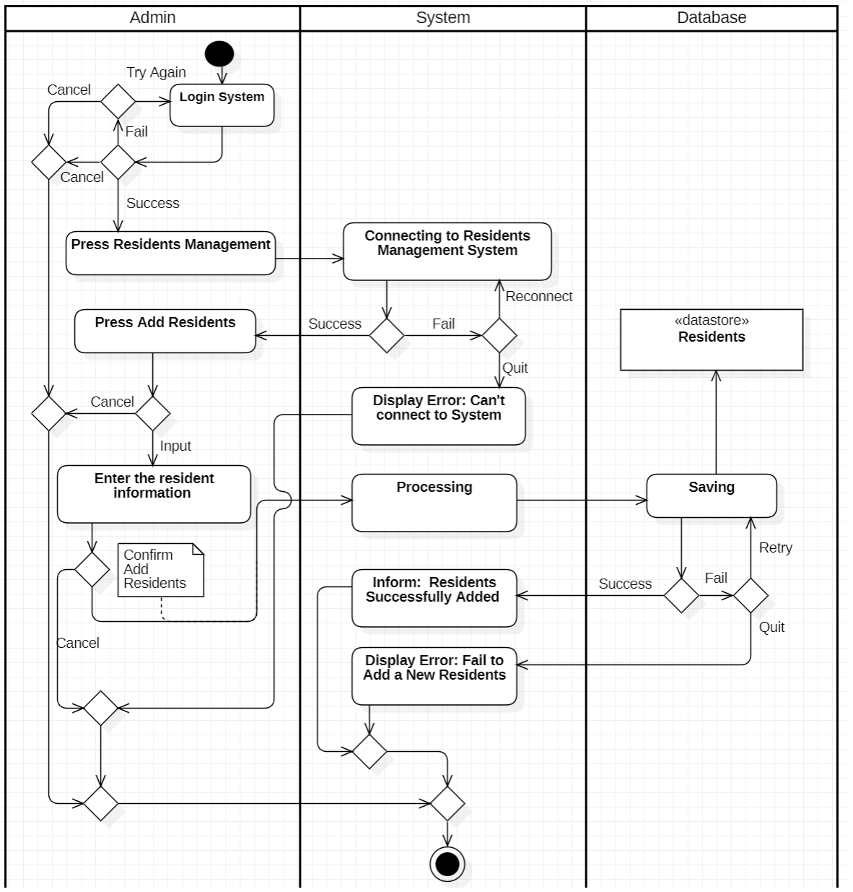
2. **Search resident**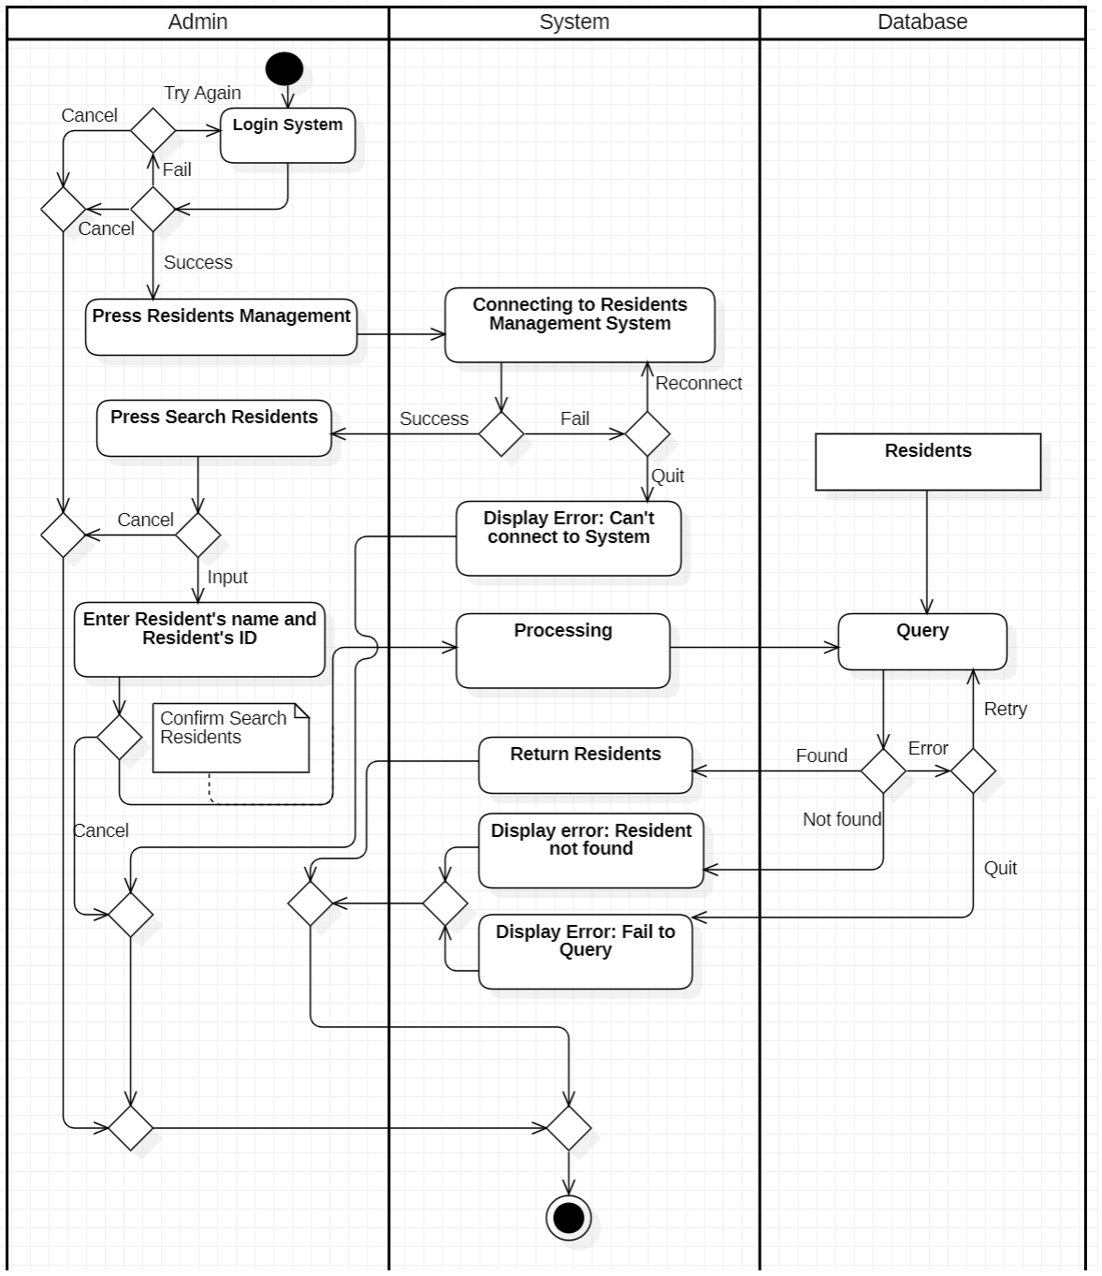
3. **Delete Resident**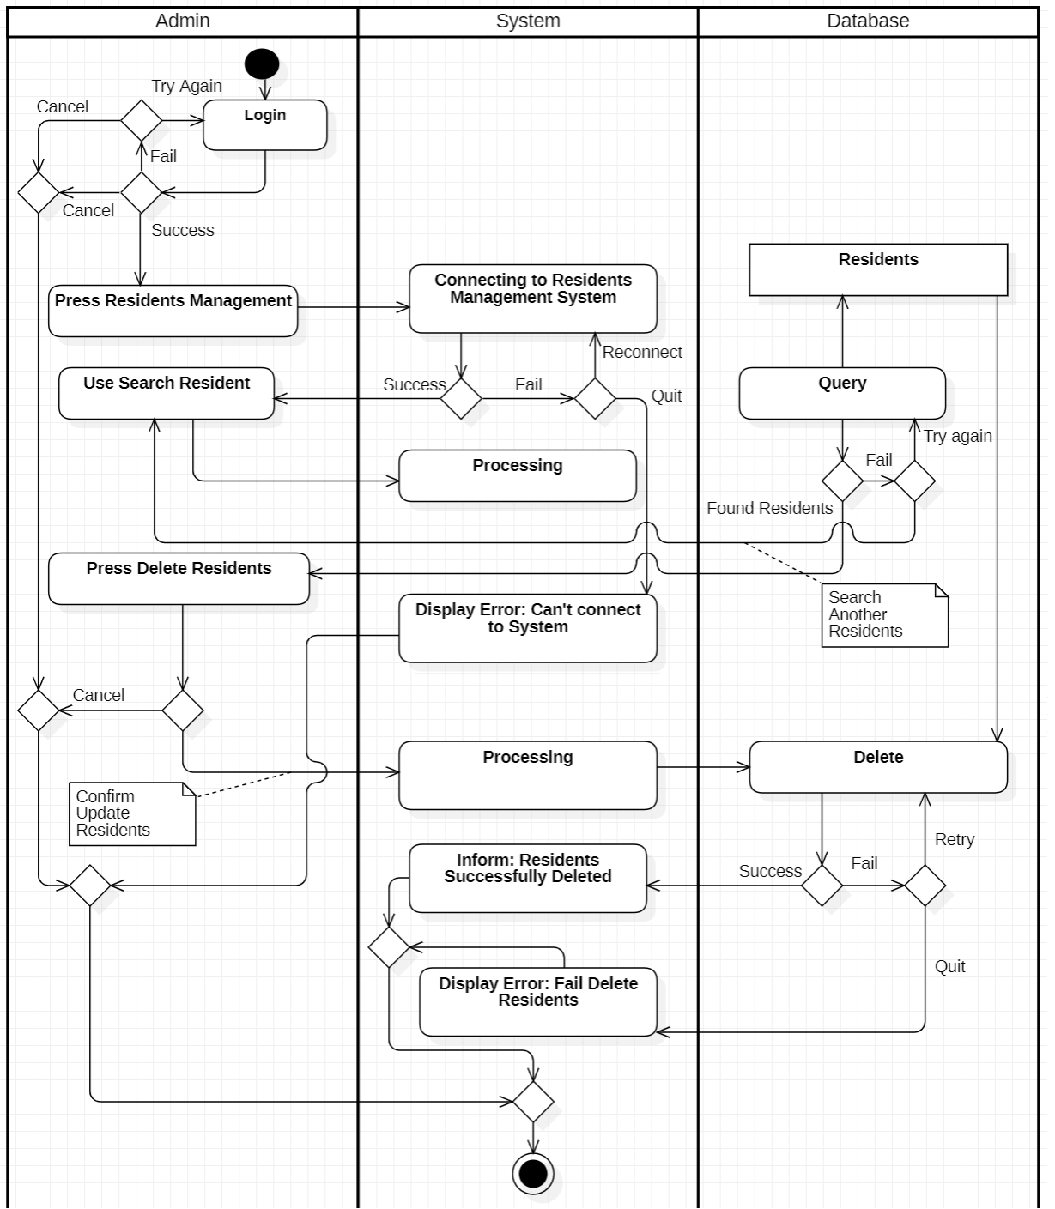

1. **Update resident**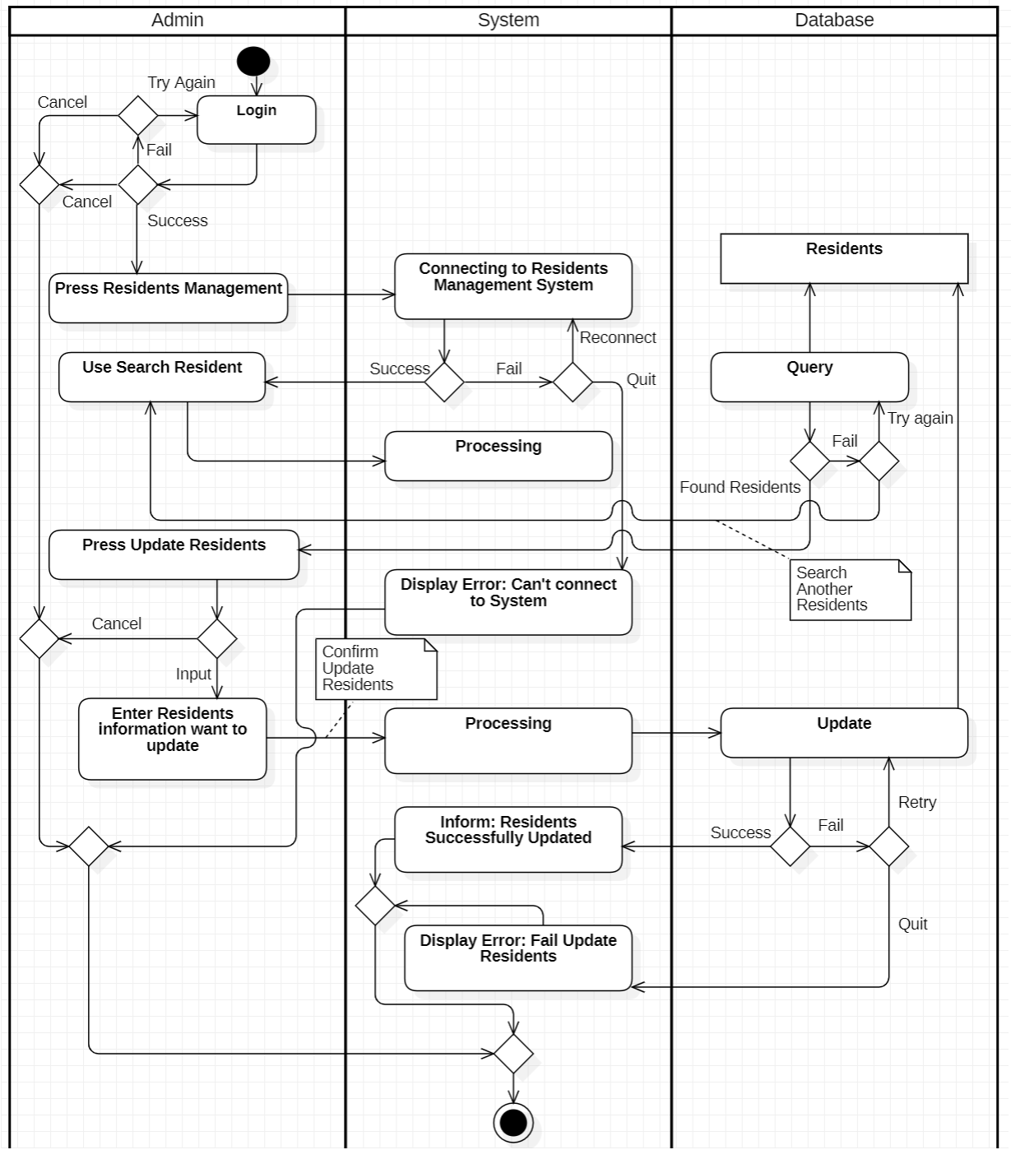

### 3.3.6. System Management’s function

1. **Assign access rights**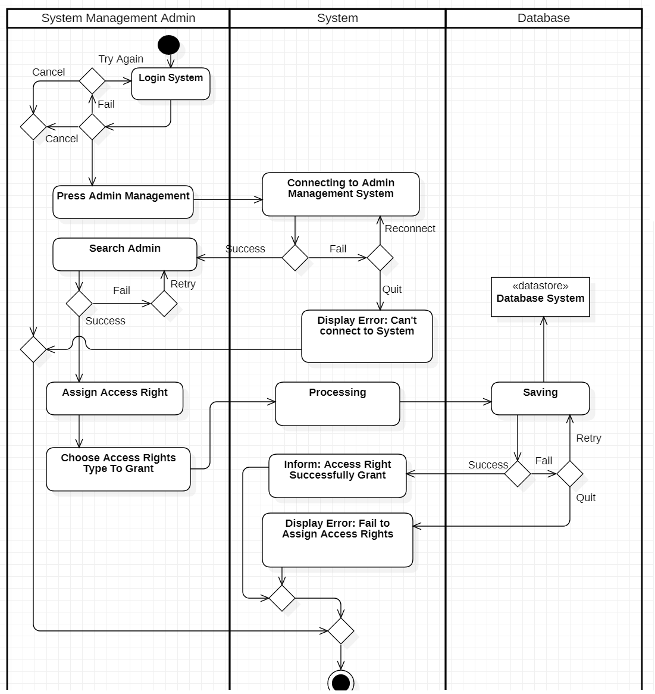
2. **Add Admin**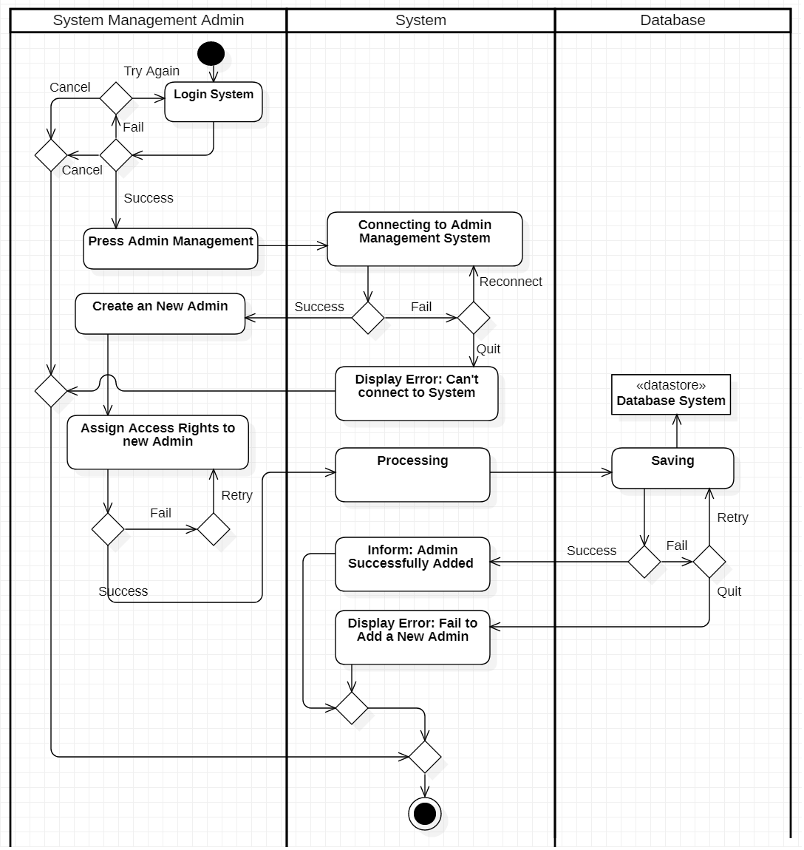
3. **Search Admin**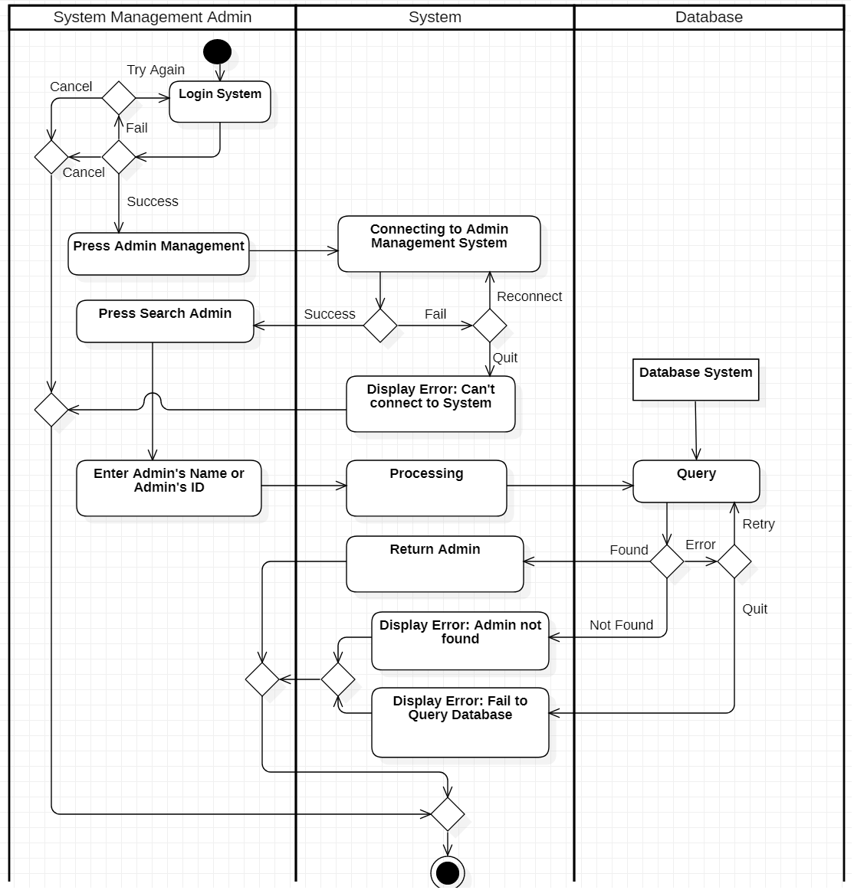
4. **System maintenance**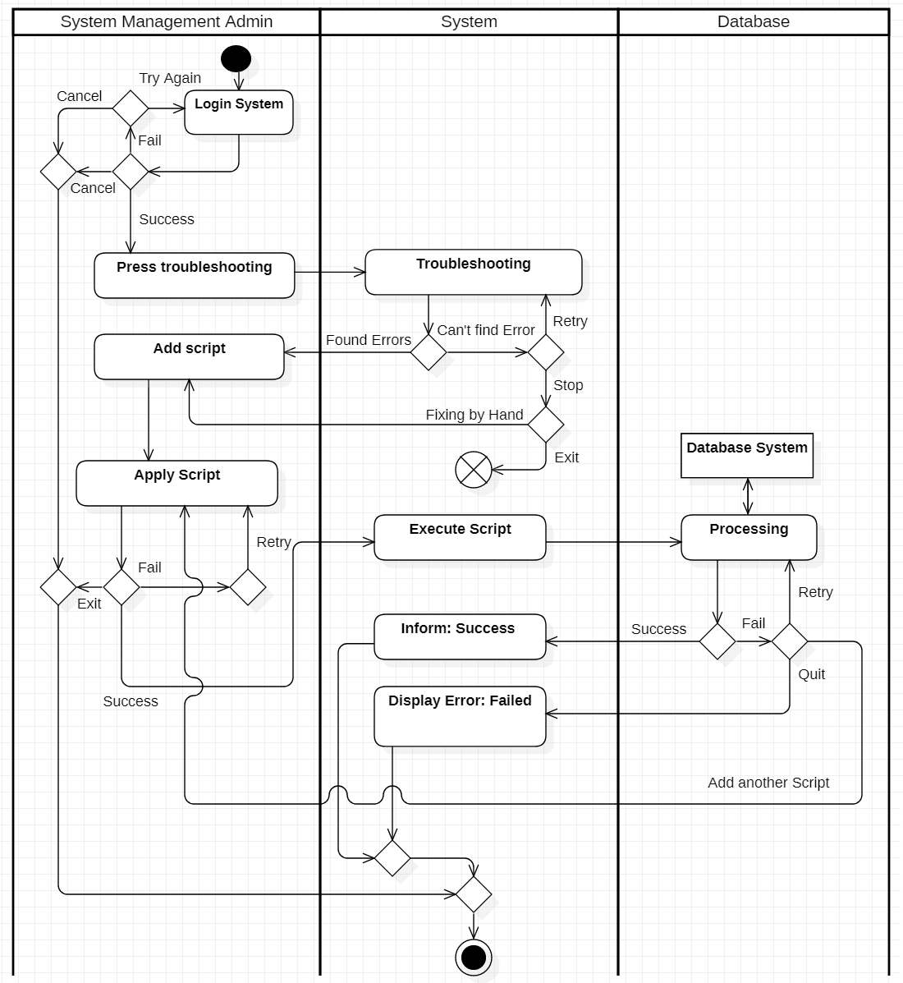

1. **Delete Admin**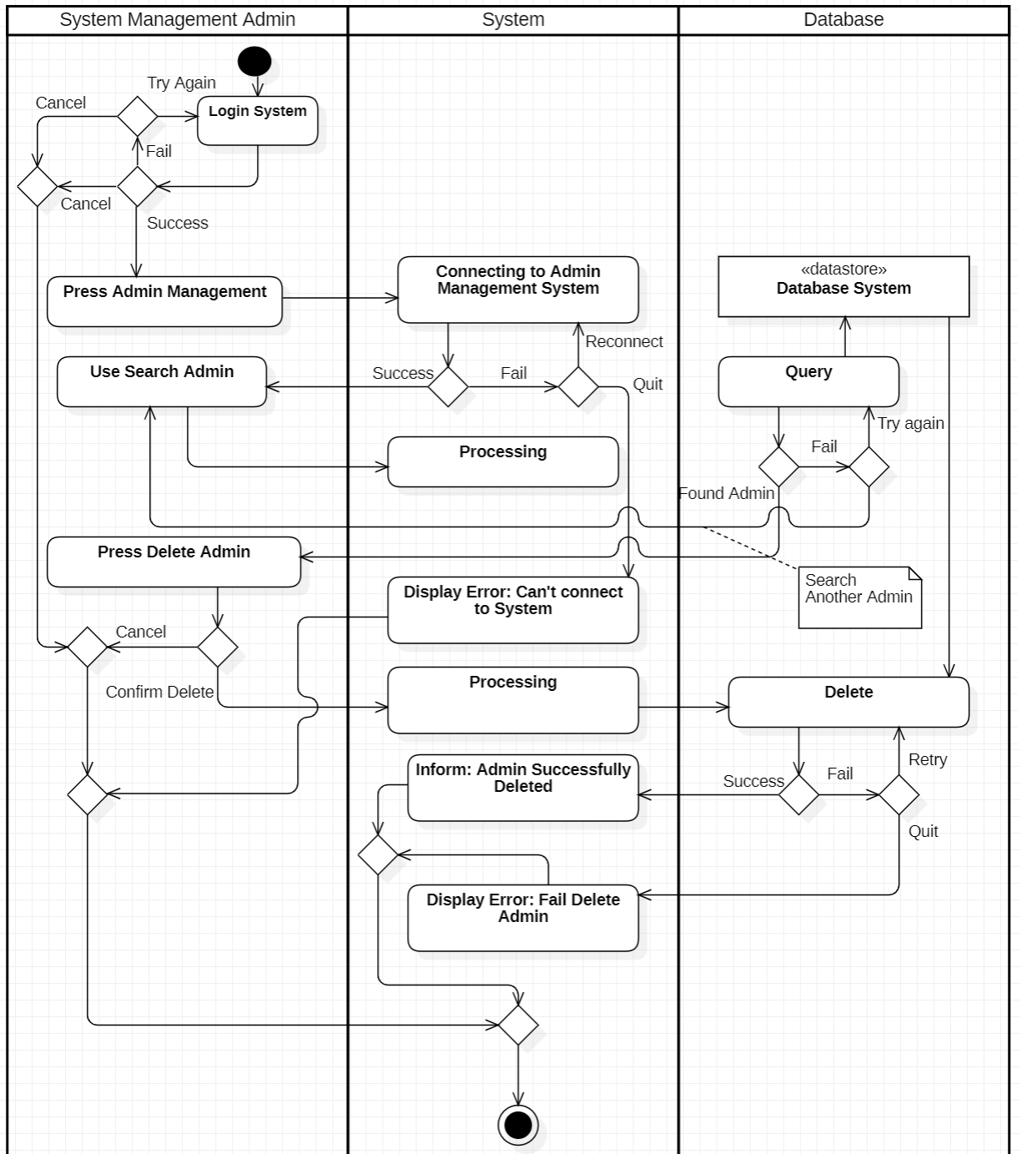
2. **Update Admin information**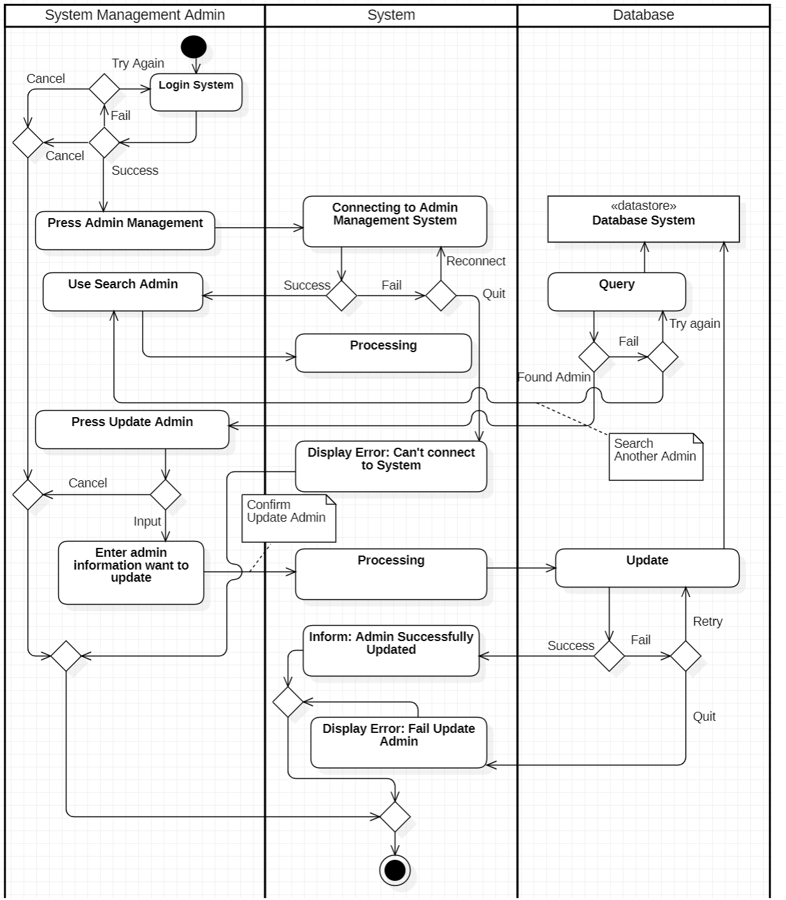

* 1. 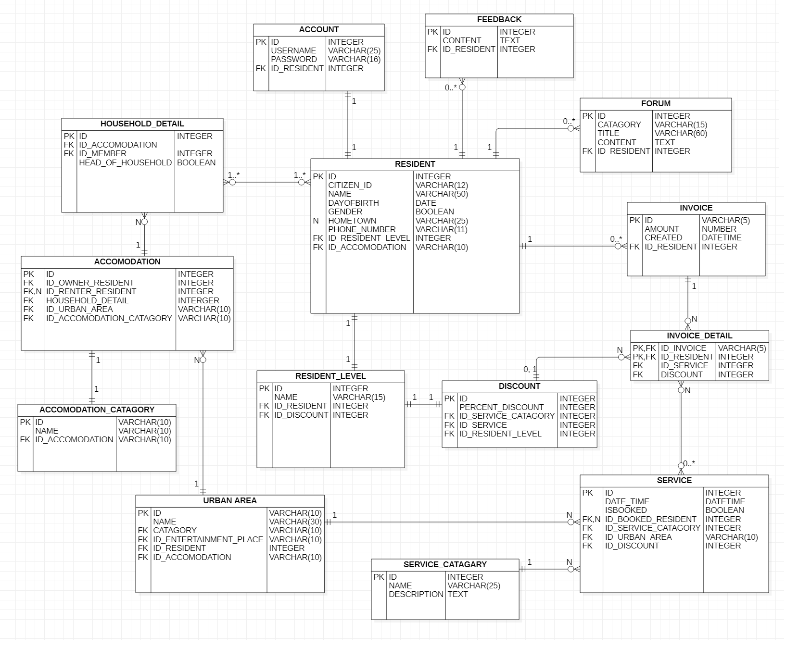***ERD***

* 1. ***DFDs***

Level 0:

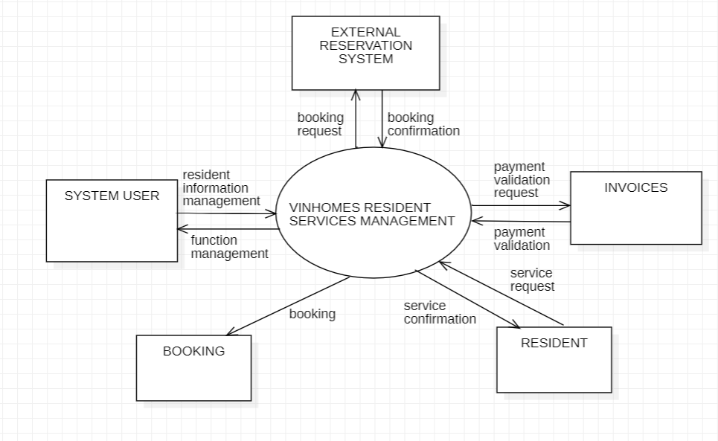

Level 1: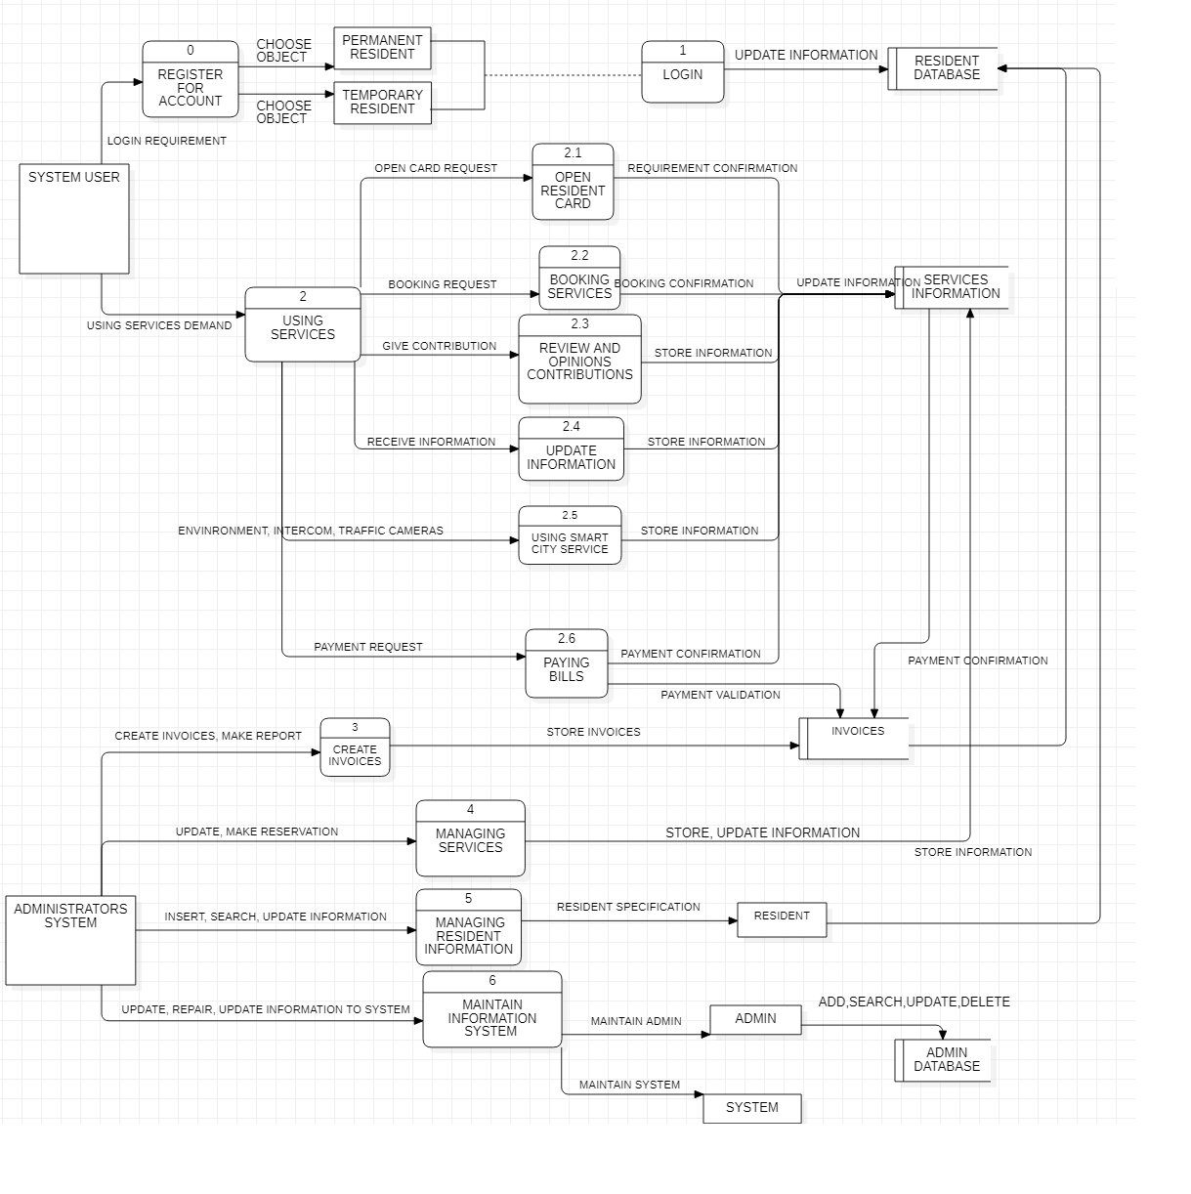

* 1. ***Sequence Diagram***

3.7.1. Resident’s Information Management

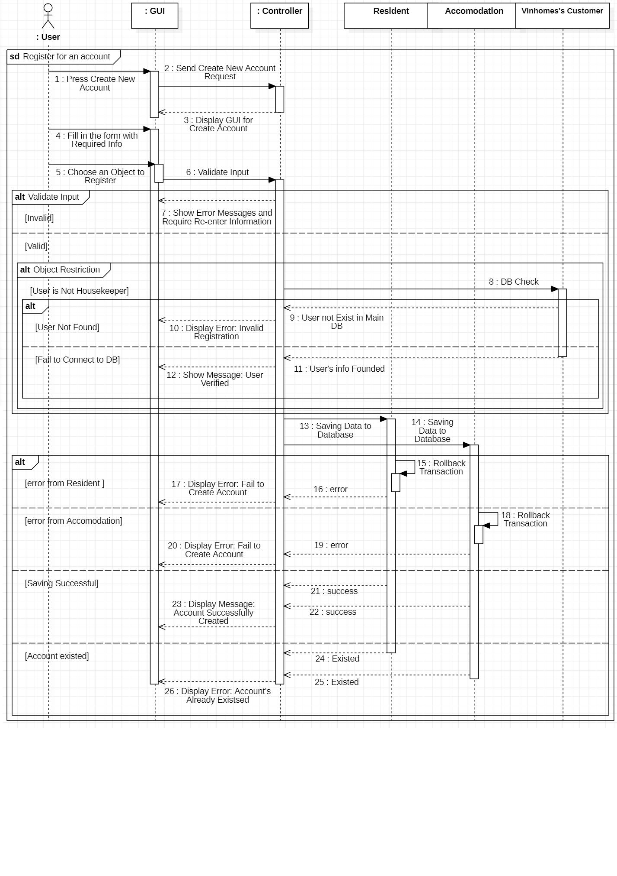1. Register for an account (except for Admins)

1. Log-in

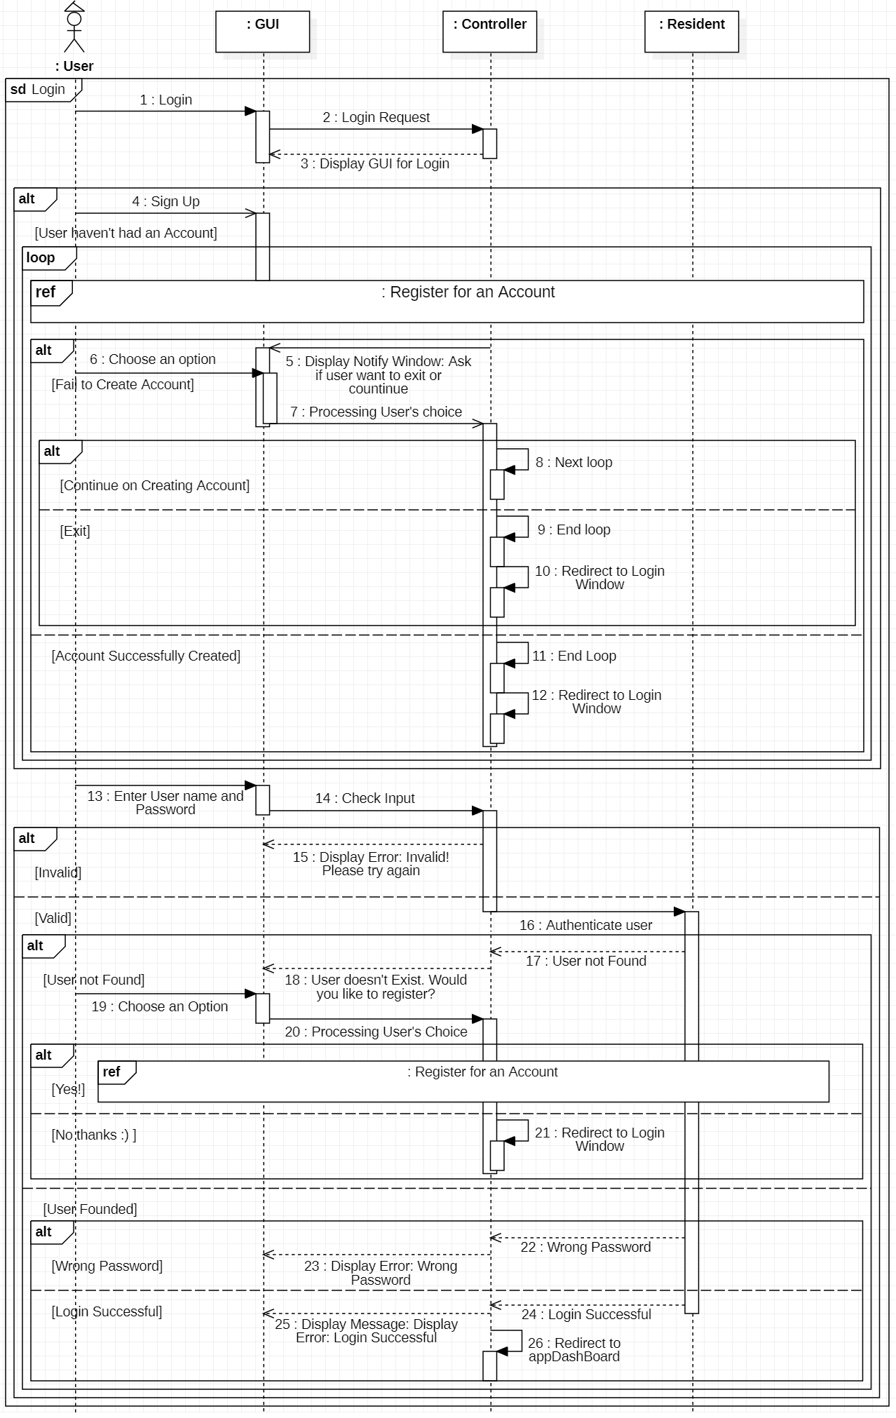

1. 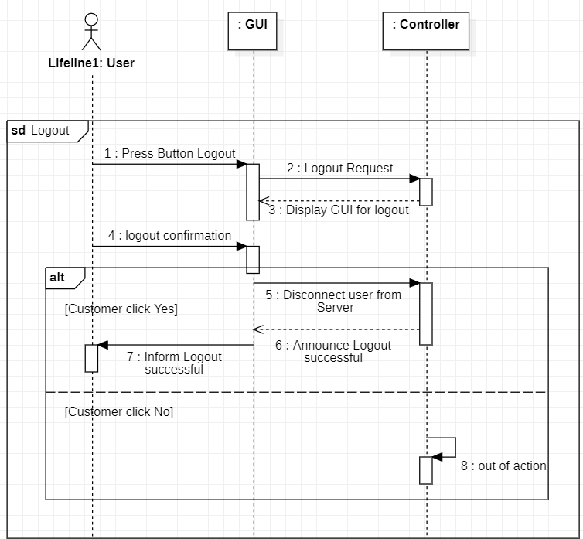Log out

3.7.2. Services Management

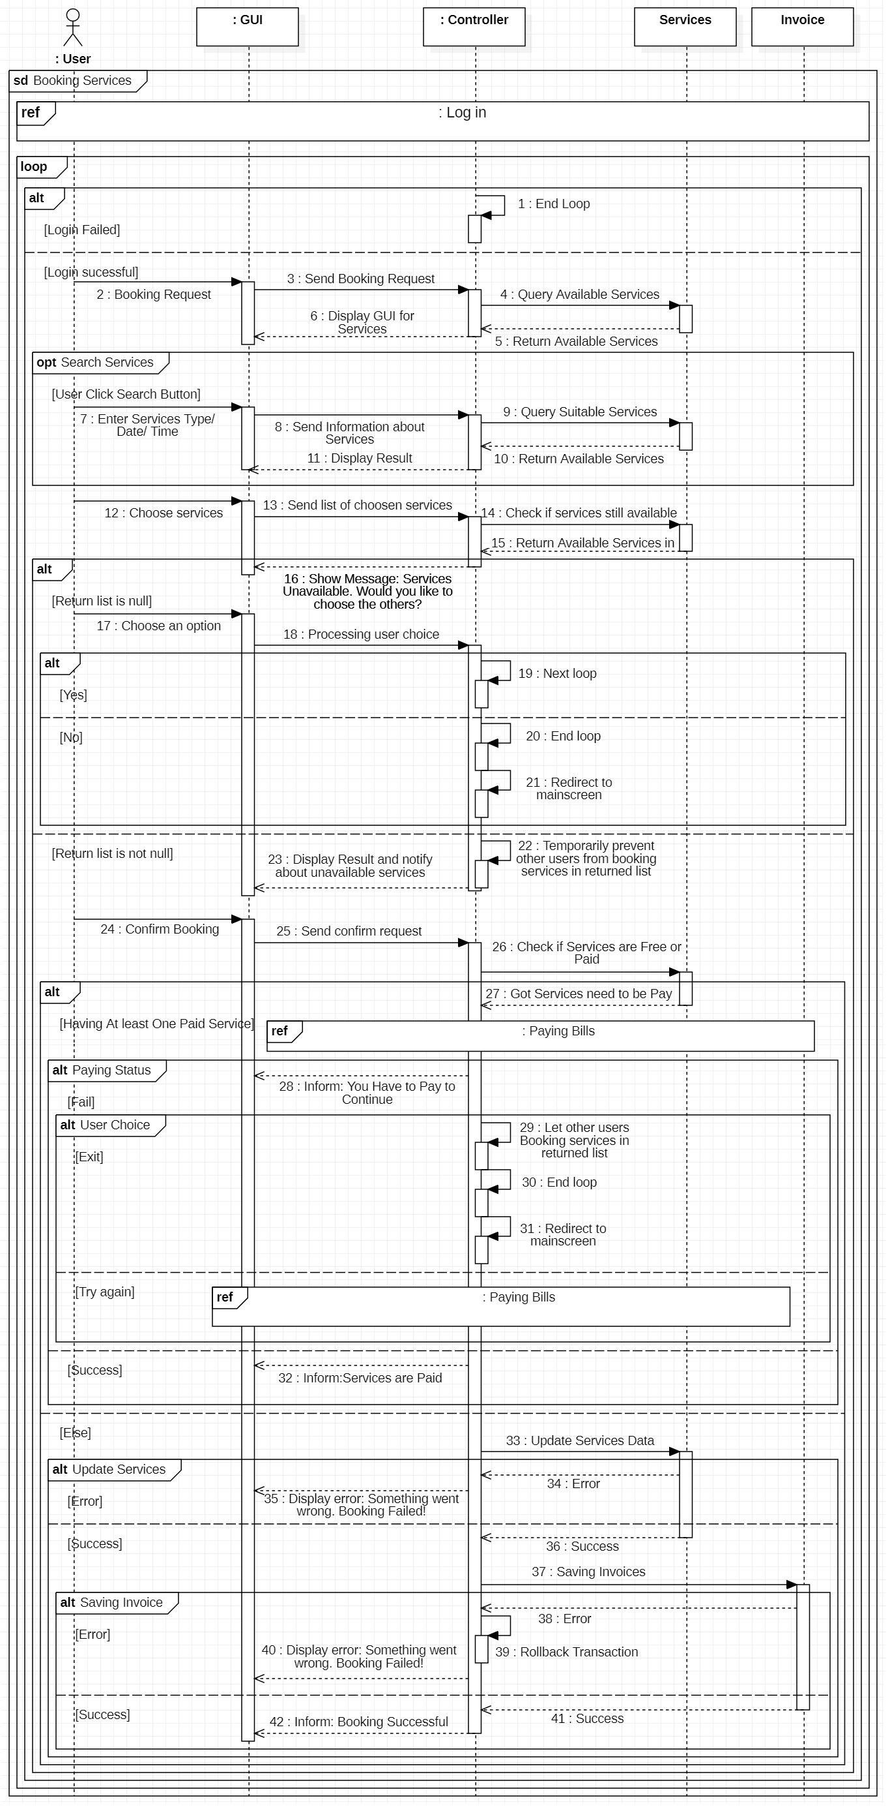1. Booking services (with/without fee)(for Vinhomes Citizen)

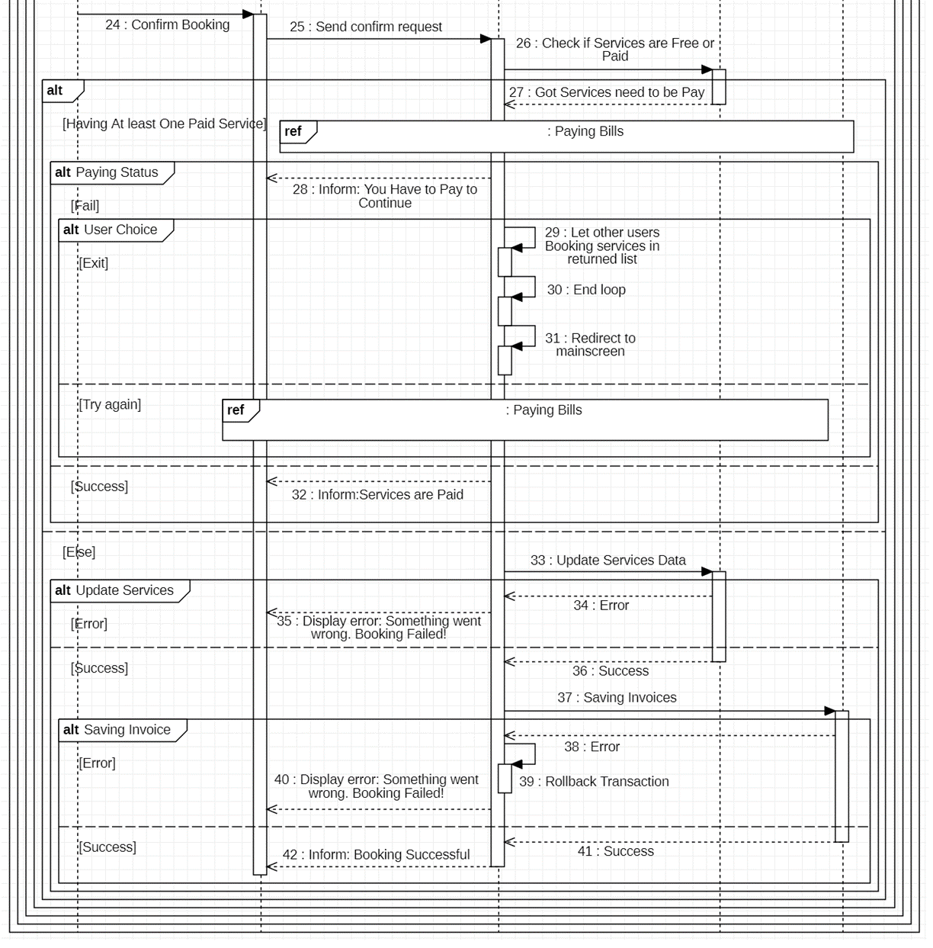

1. Open resident’s cards (for Vinhomes Citizen)
2. 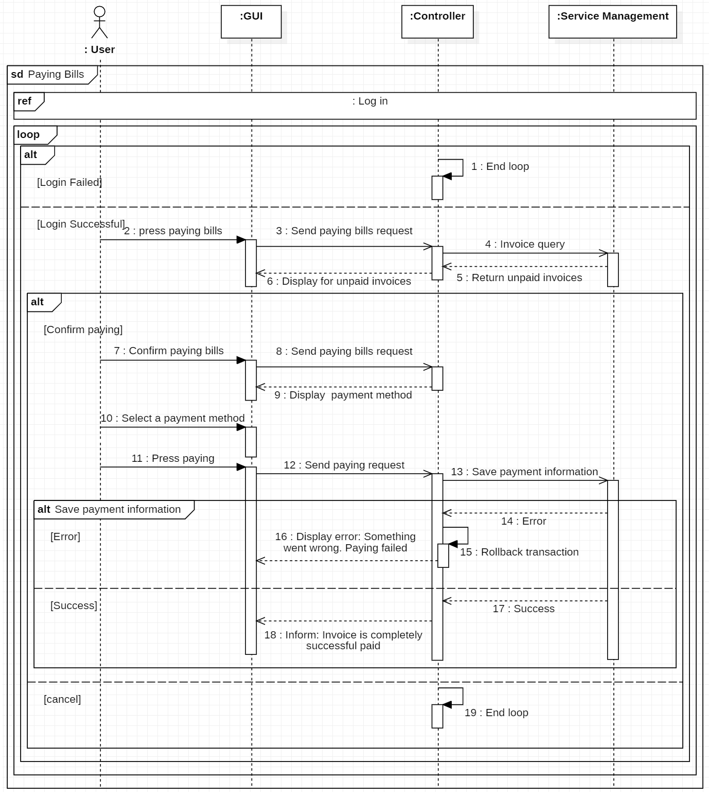Paying Bills (for Vinhomes Citizen)
3. Review and Opinions contribution(for Vinhomes Citizen)

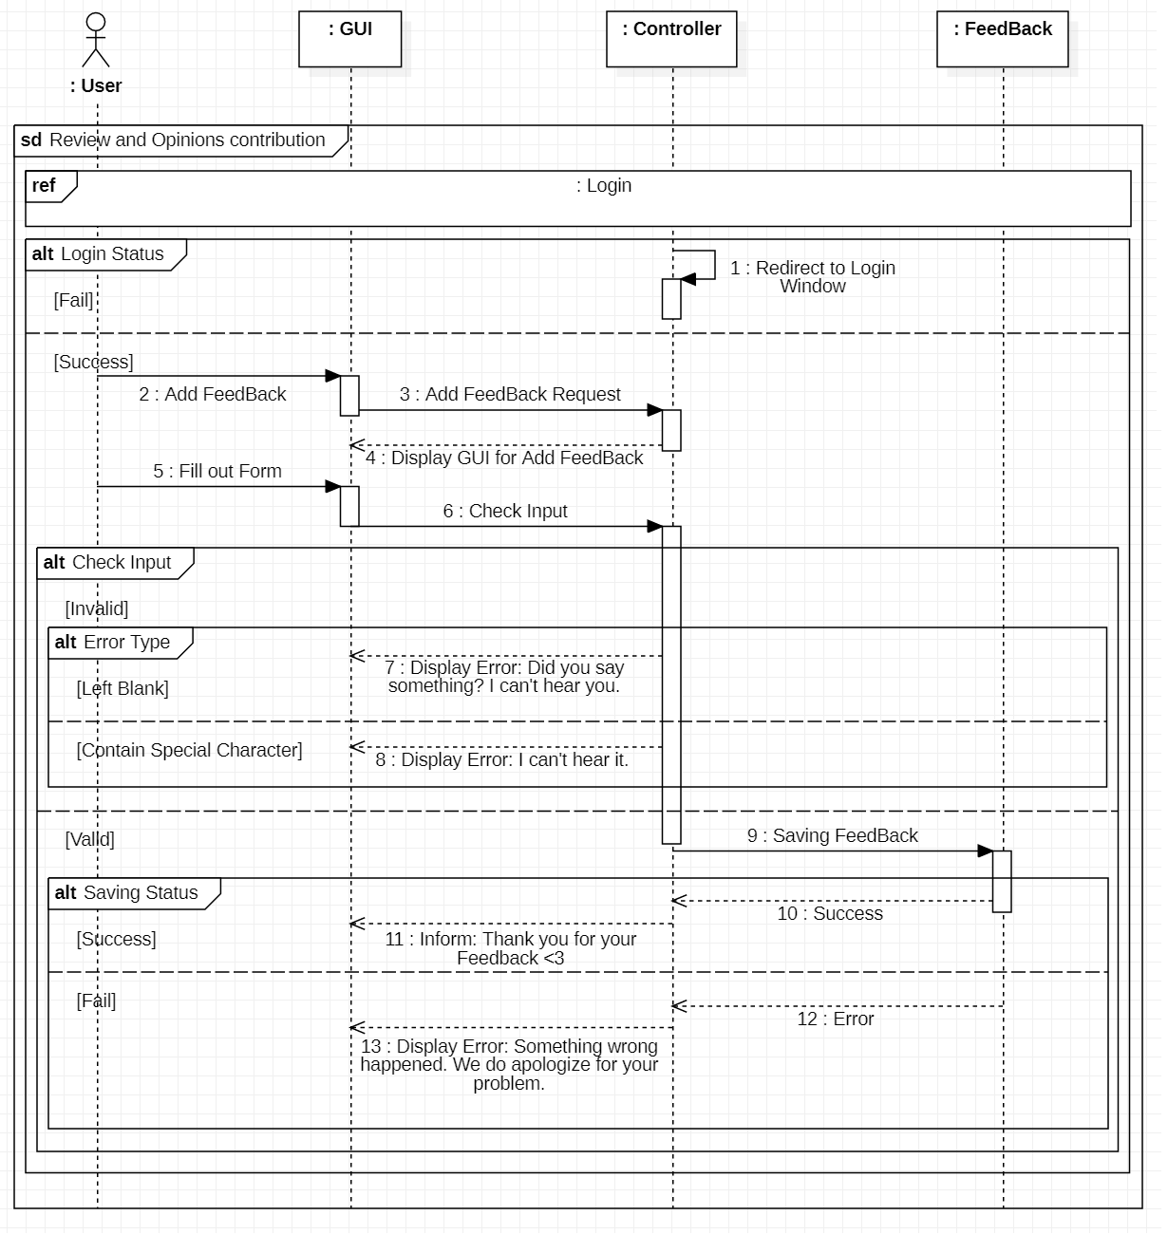

1. Update information

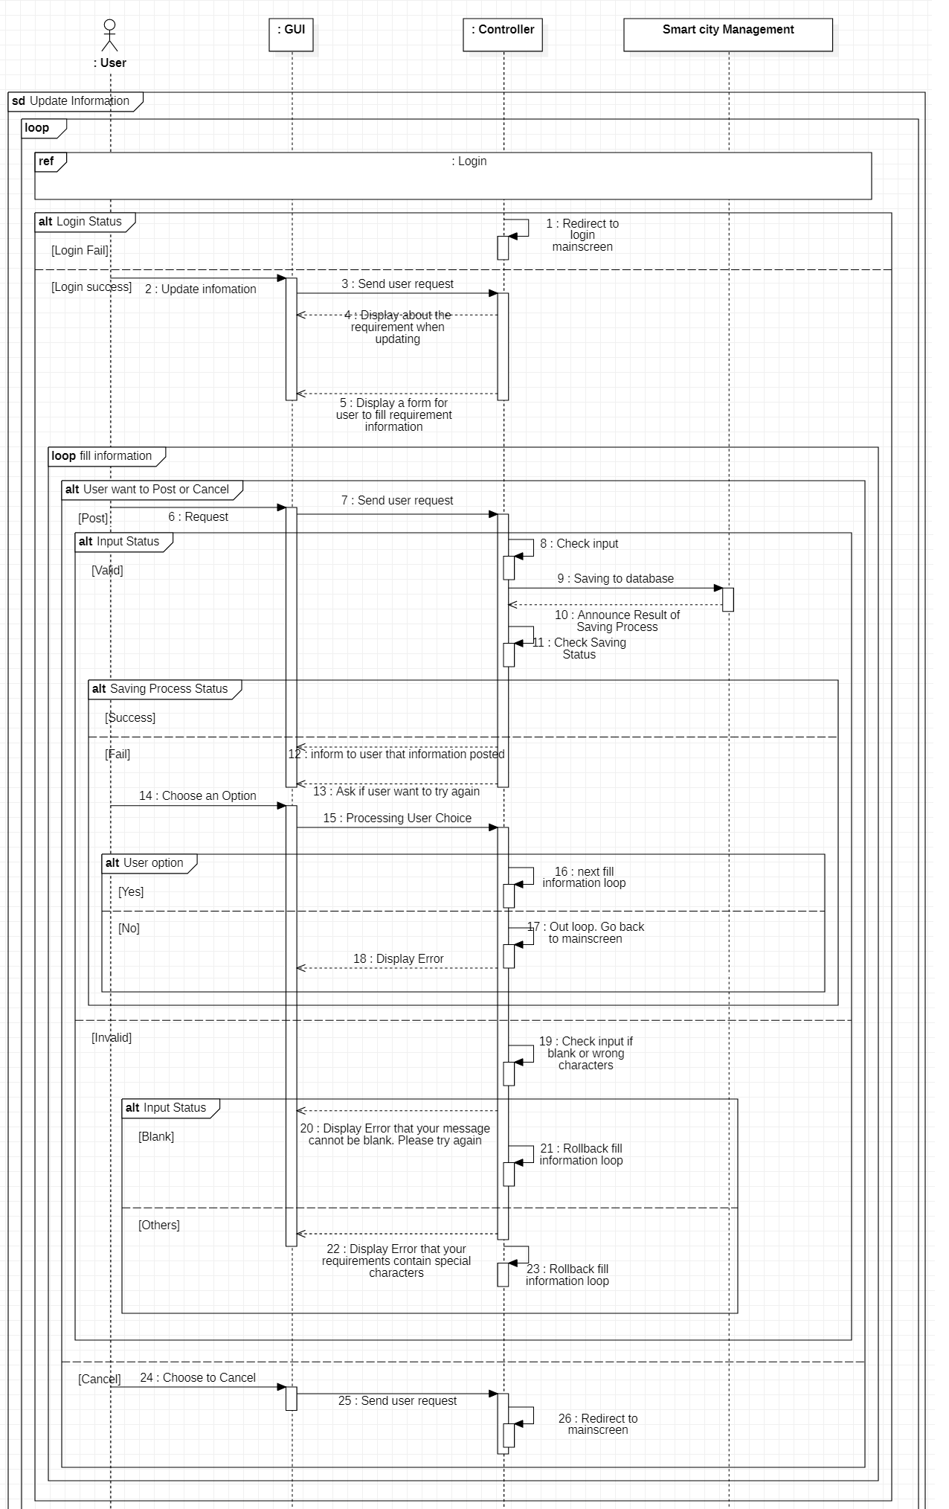



1. 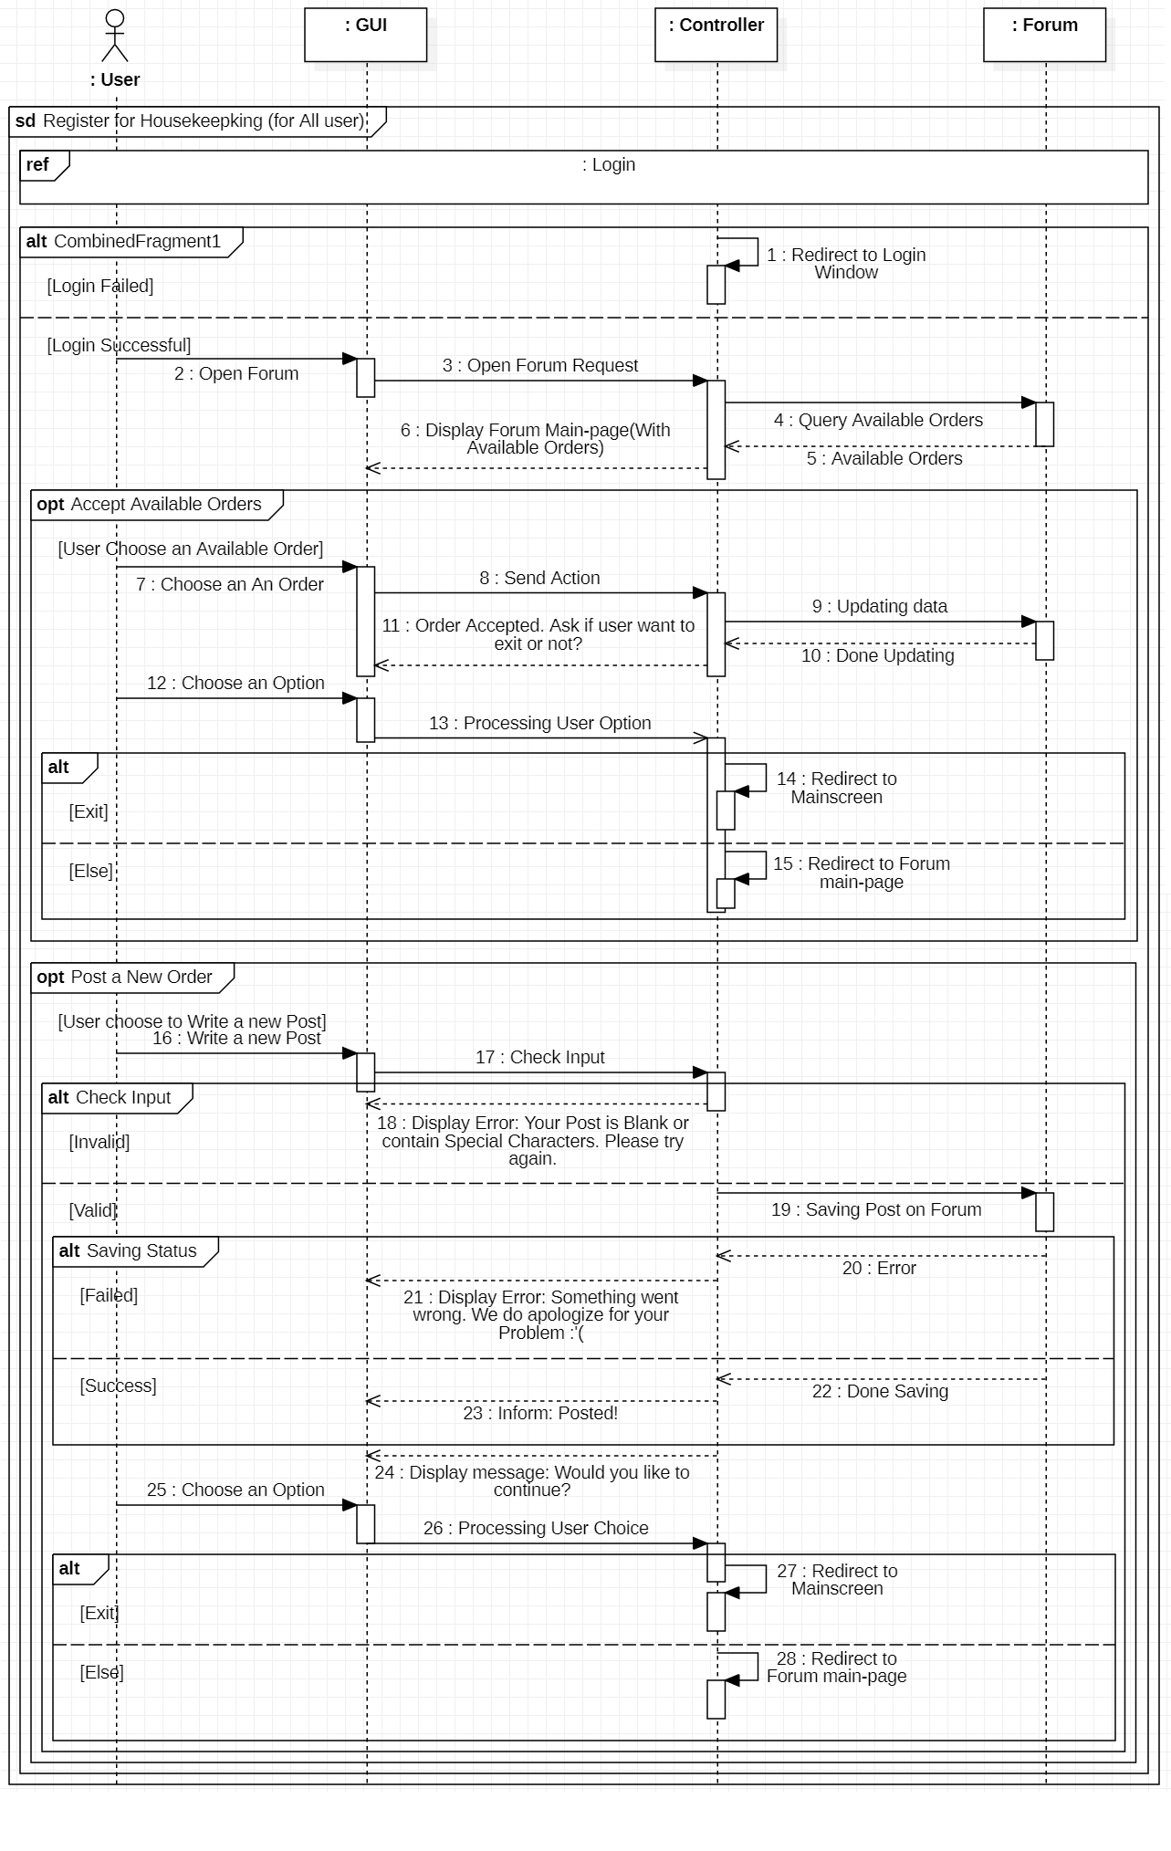Register for Housekeepking

3.7.3. Smart City Management

* 1. 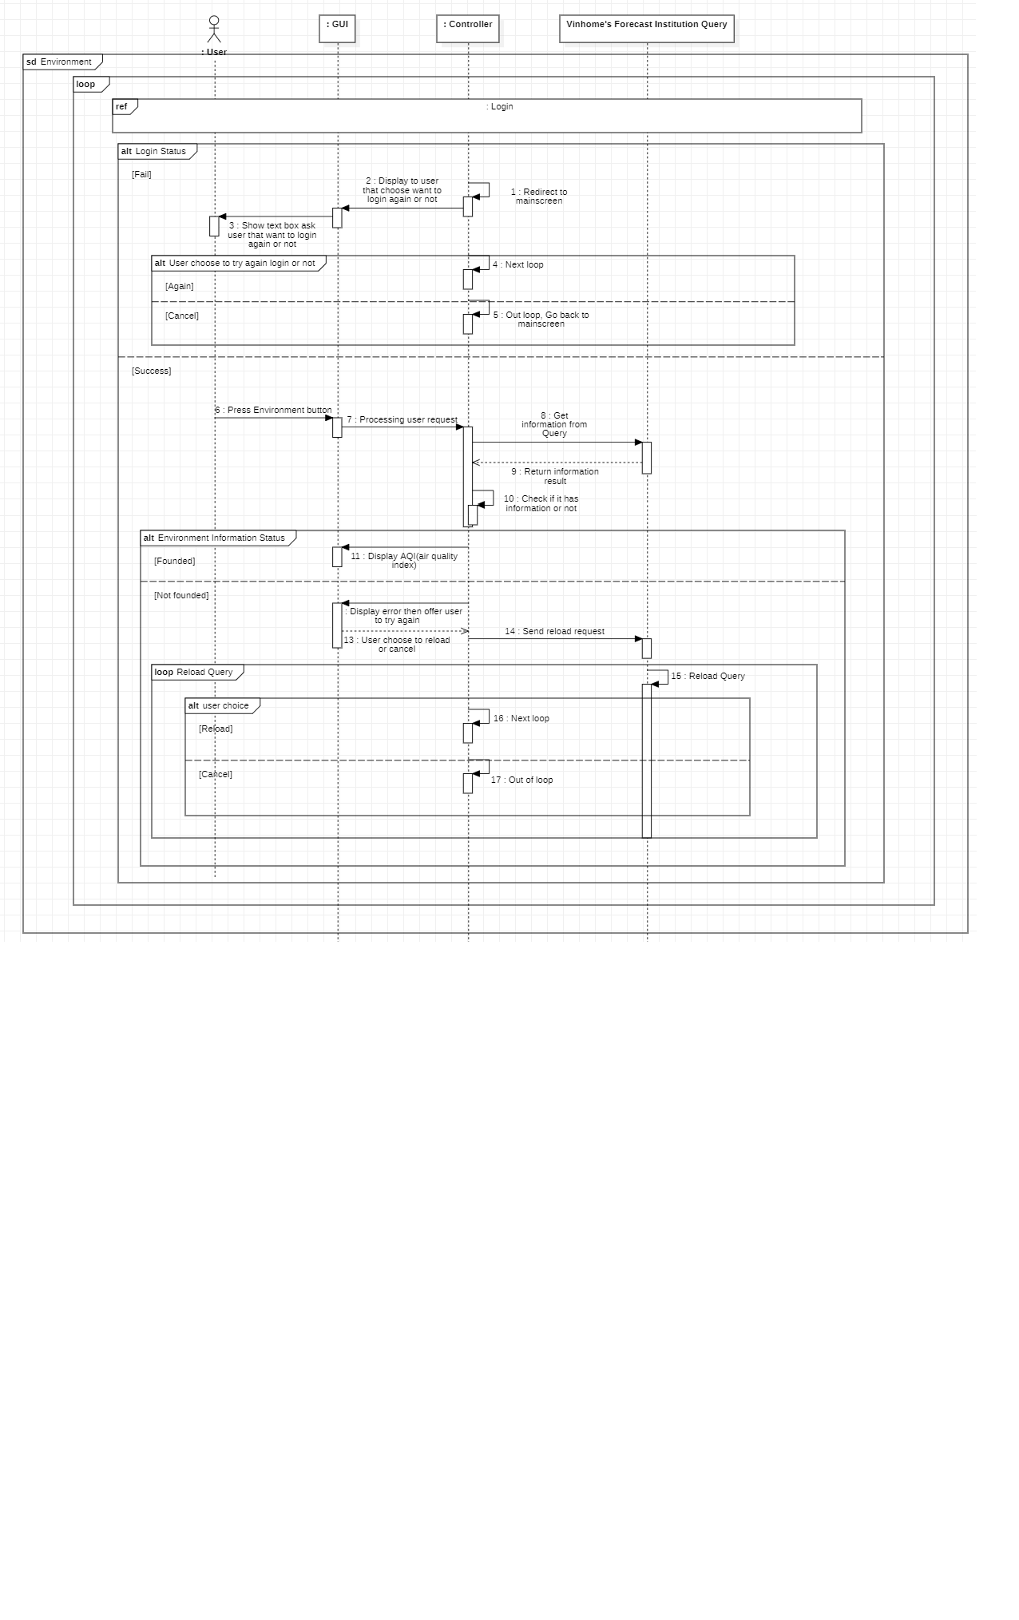Environment Alarm

1. Intercom

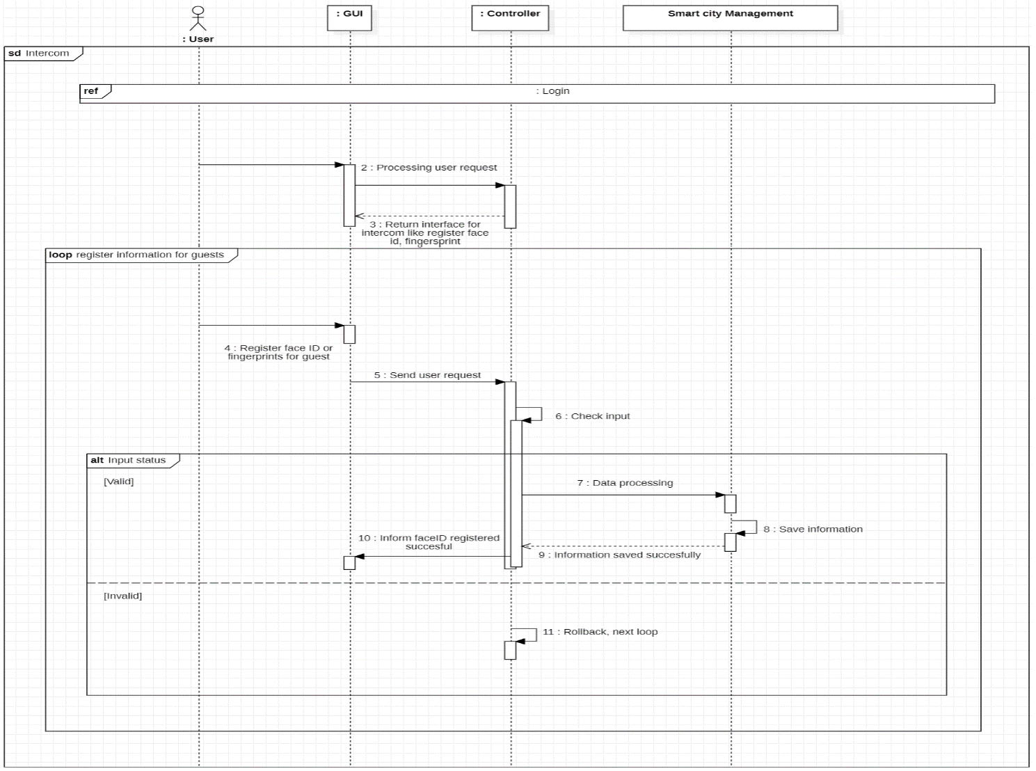

1. Traffic Cameras

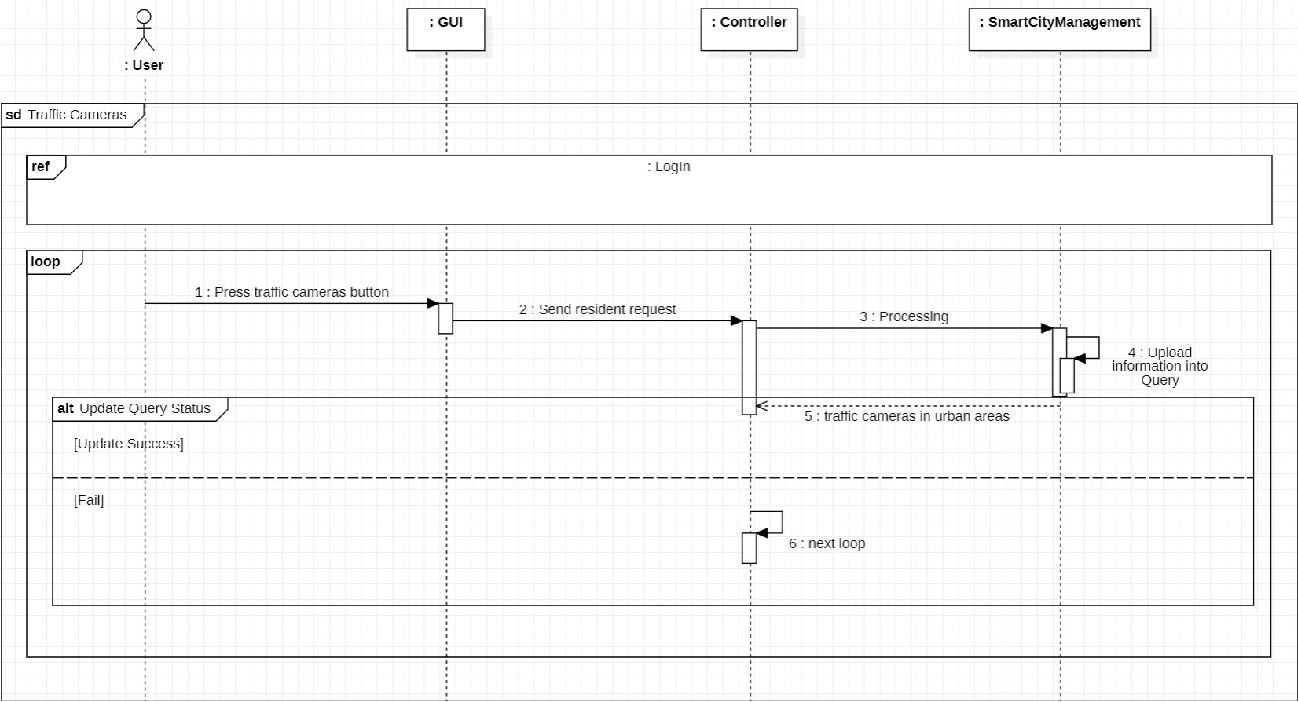

3.7.4. Function Management

1. Add function

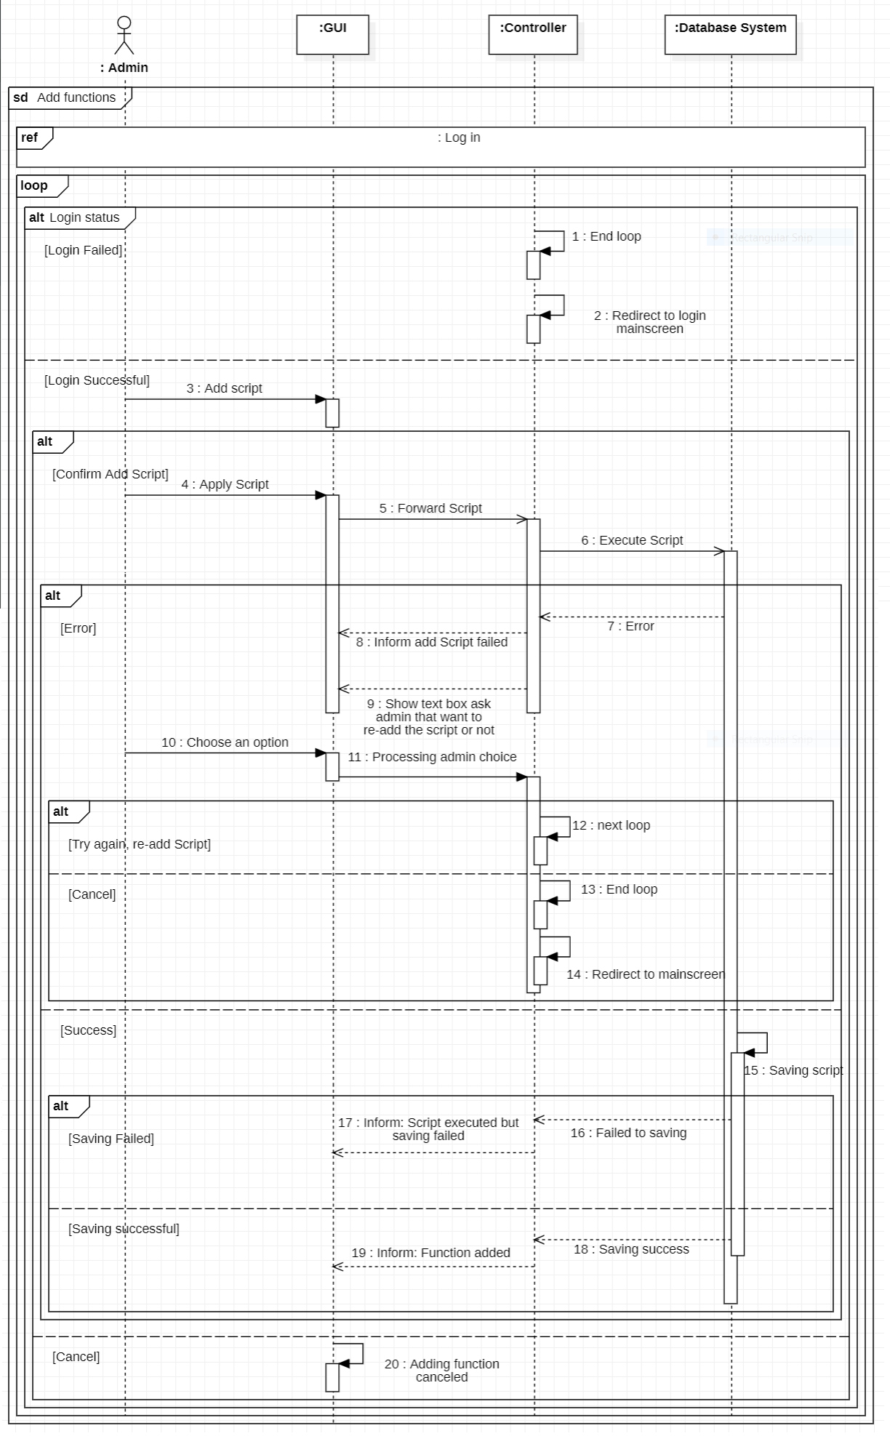

1. Delete function

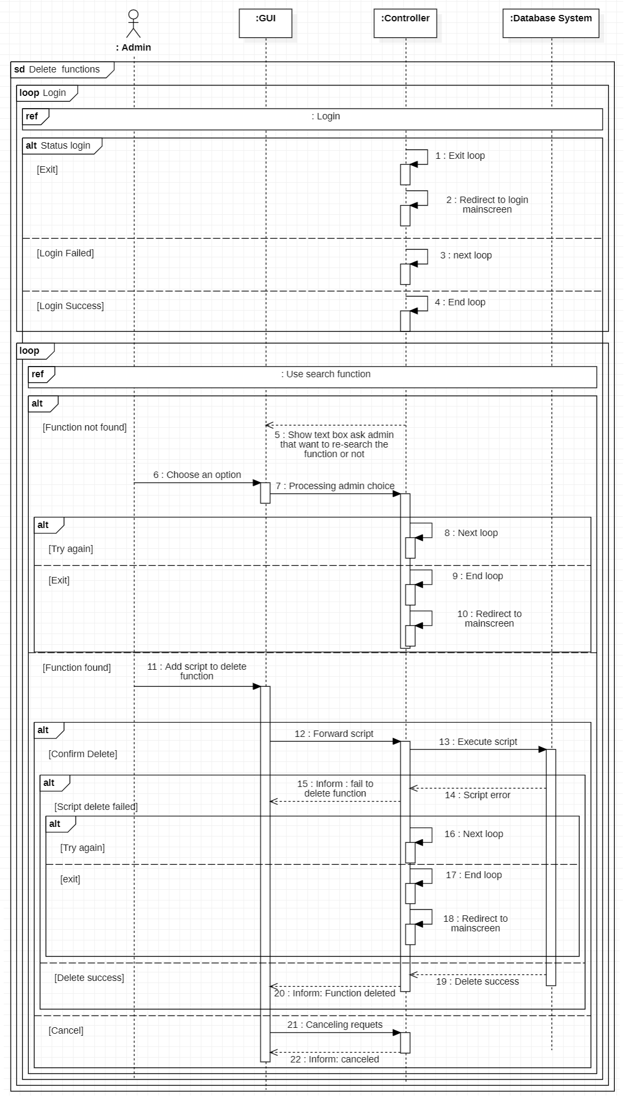

1. Search function

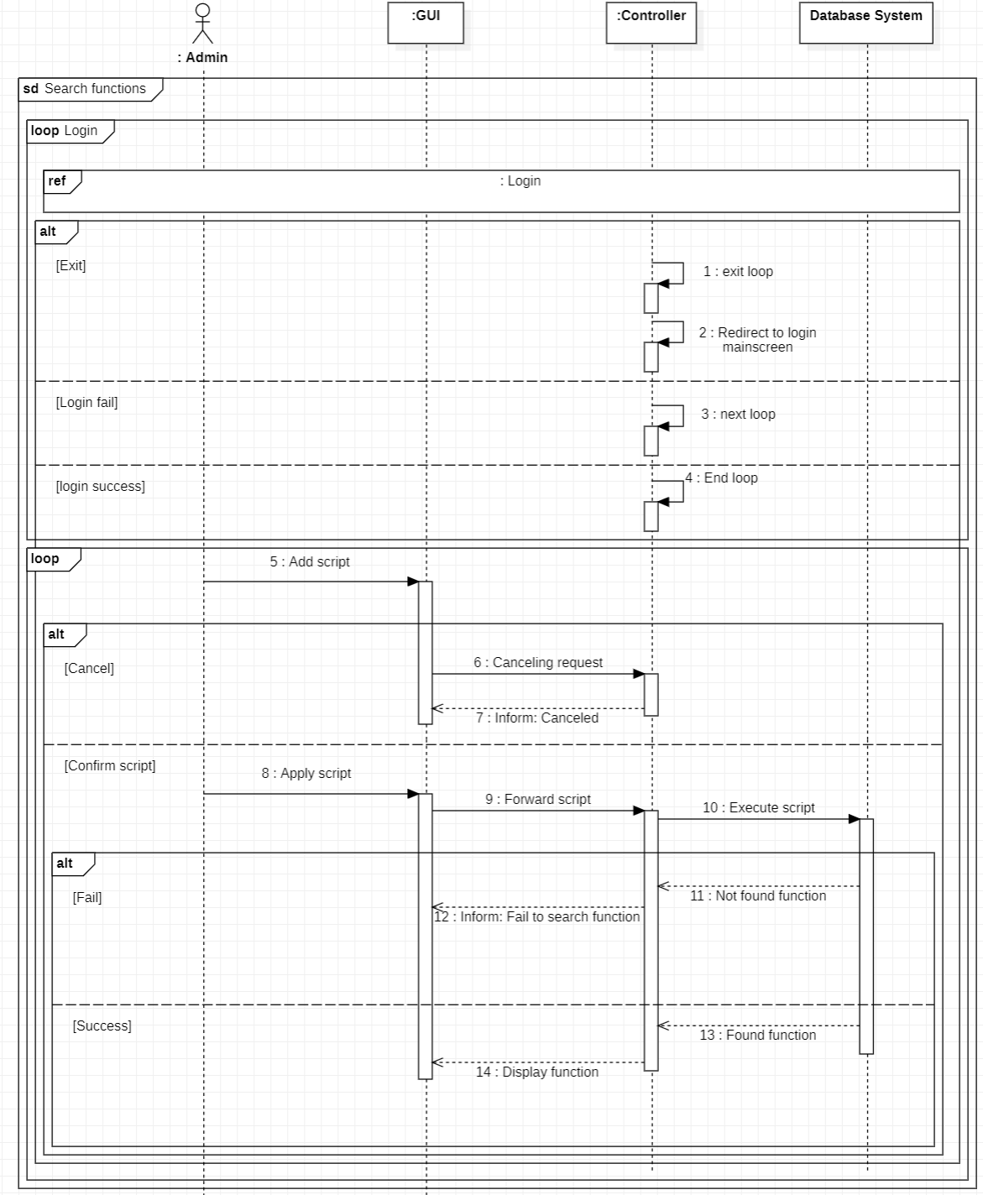

1. 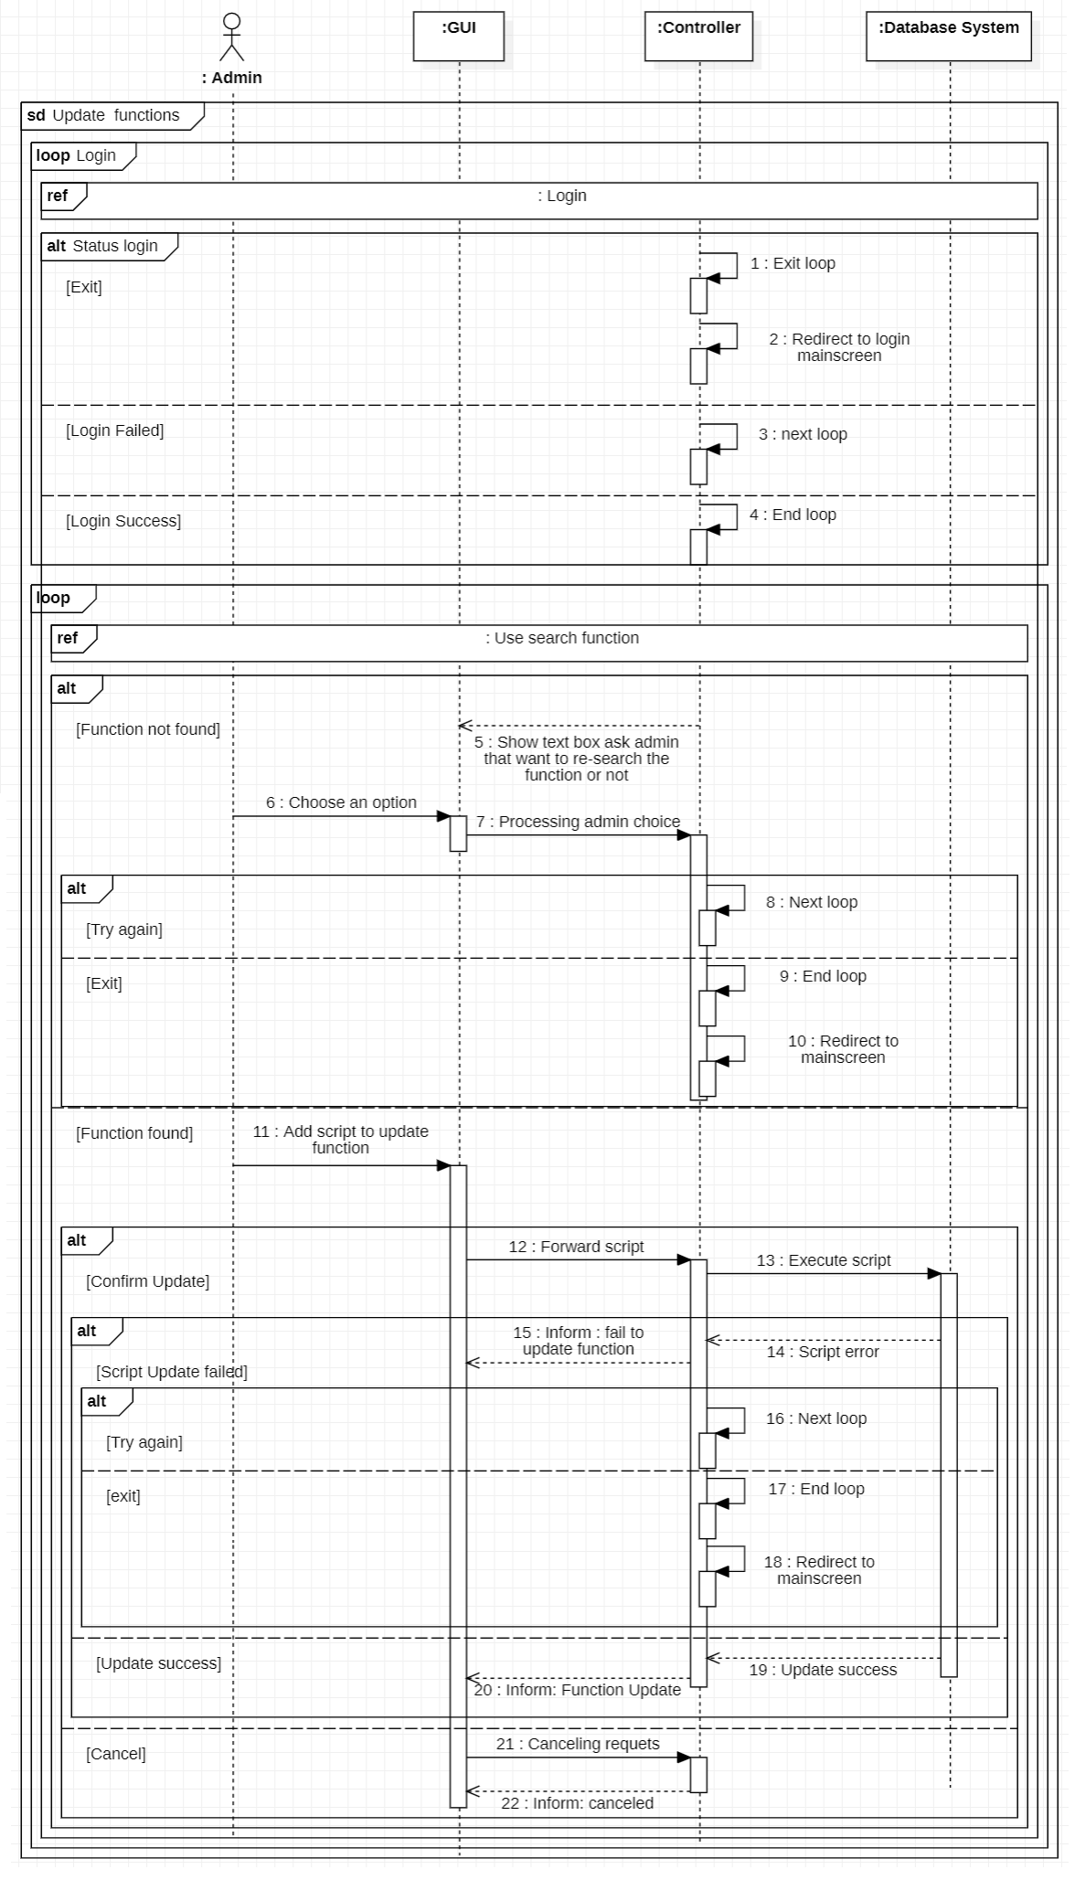Update function
2. 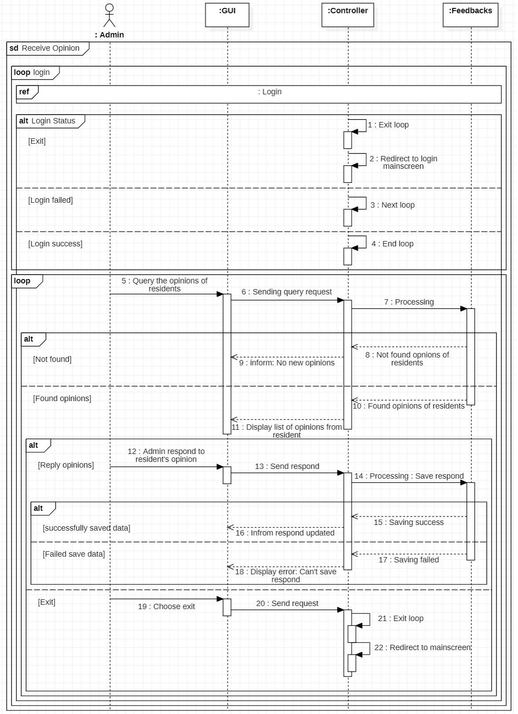Receive Opinion
3. 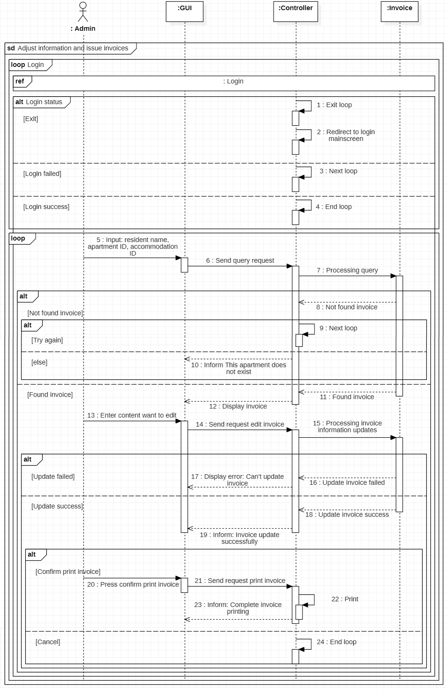Adjust information and issue invoices
4. Store Invoices

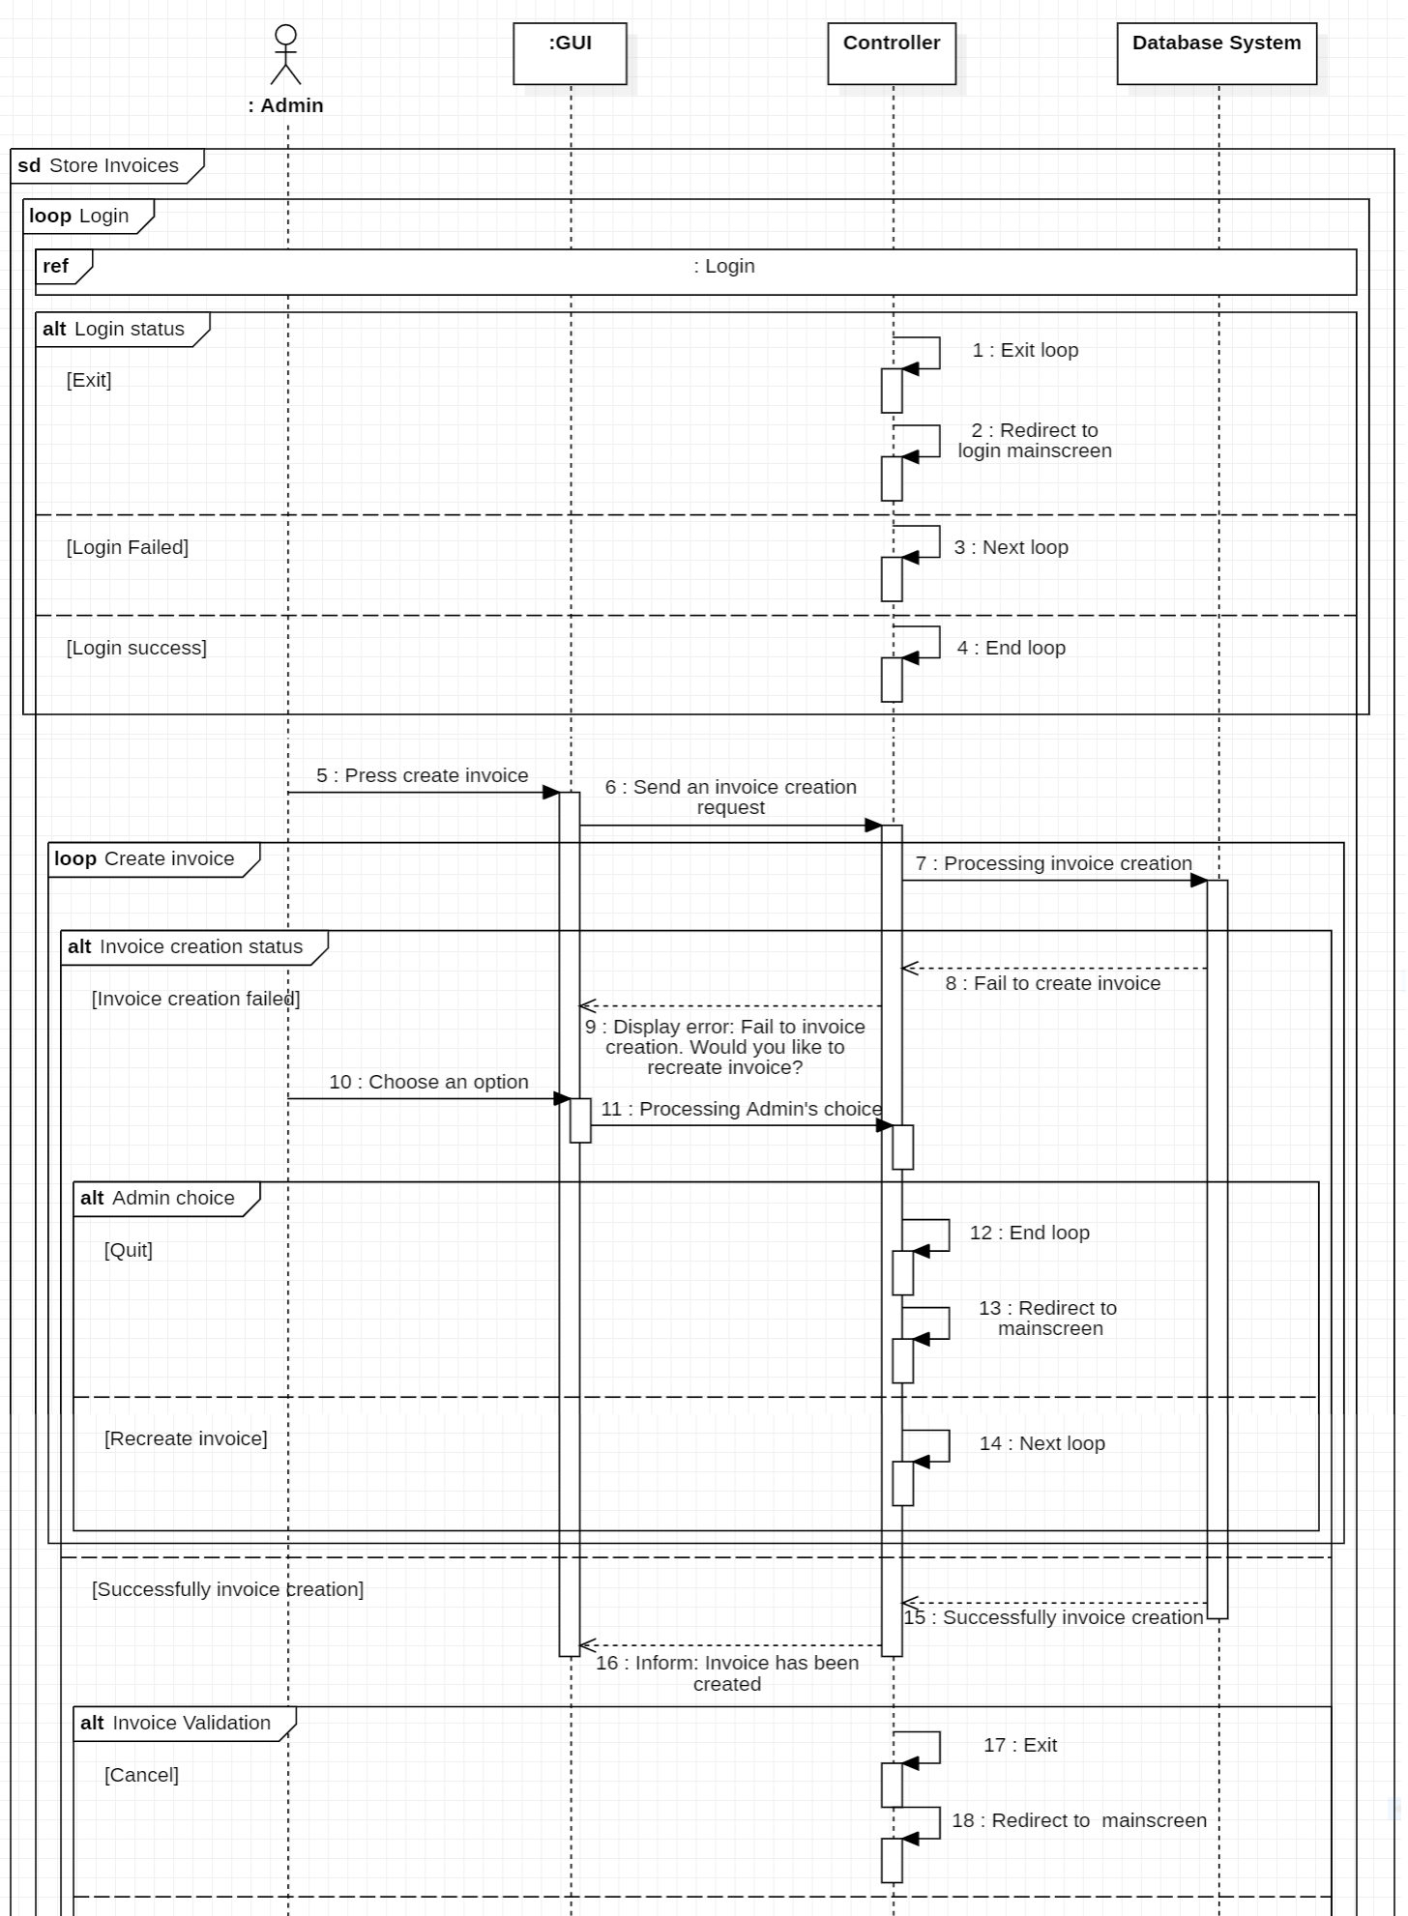

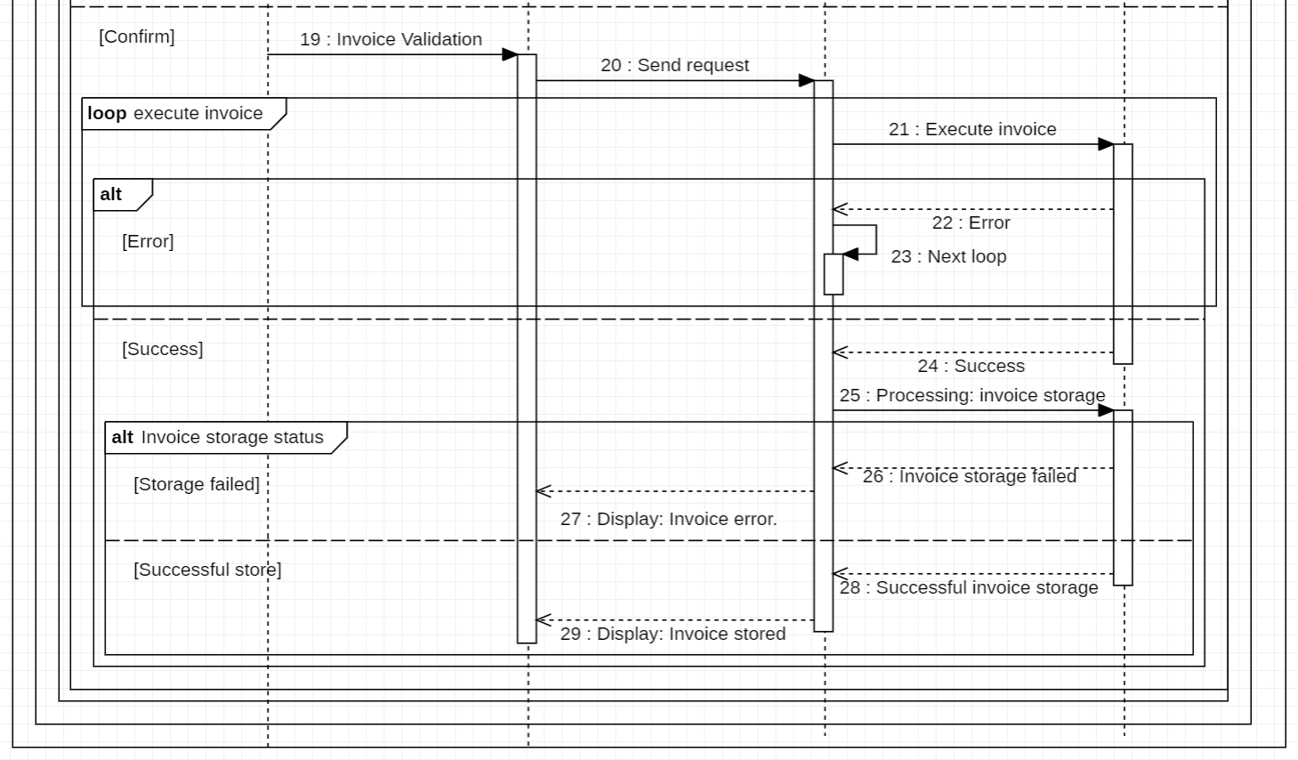

1. Make invoice report

3.7.5. Resident’s System information Management

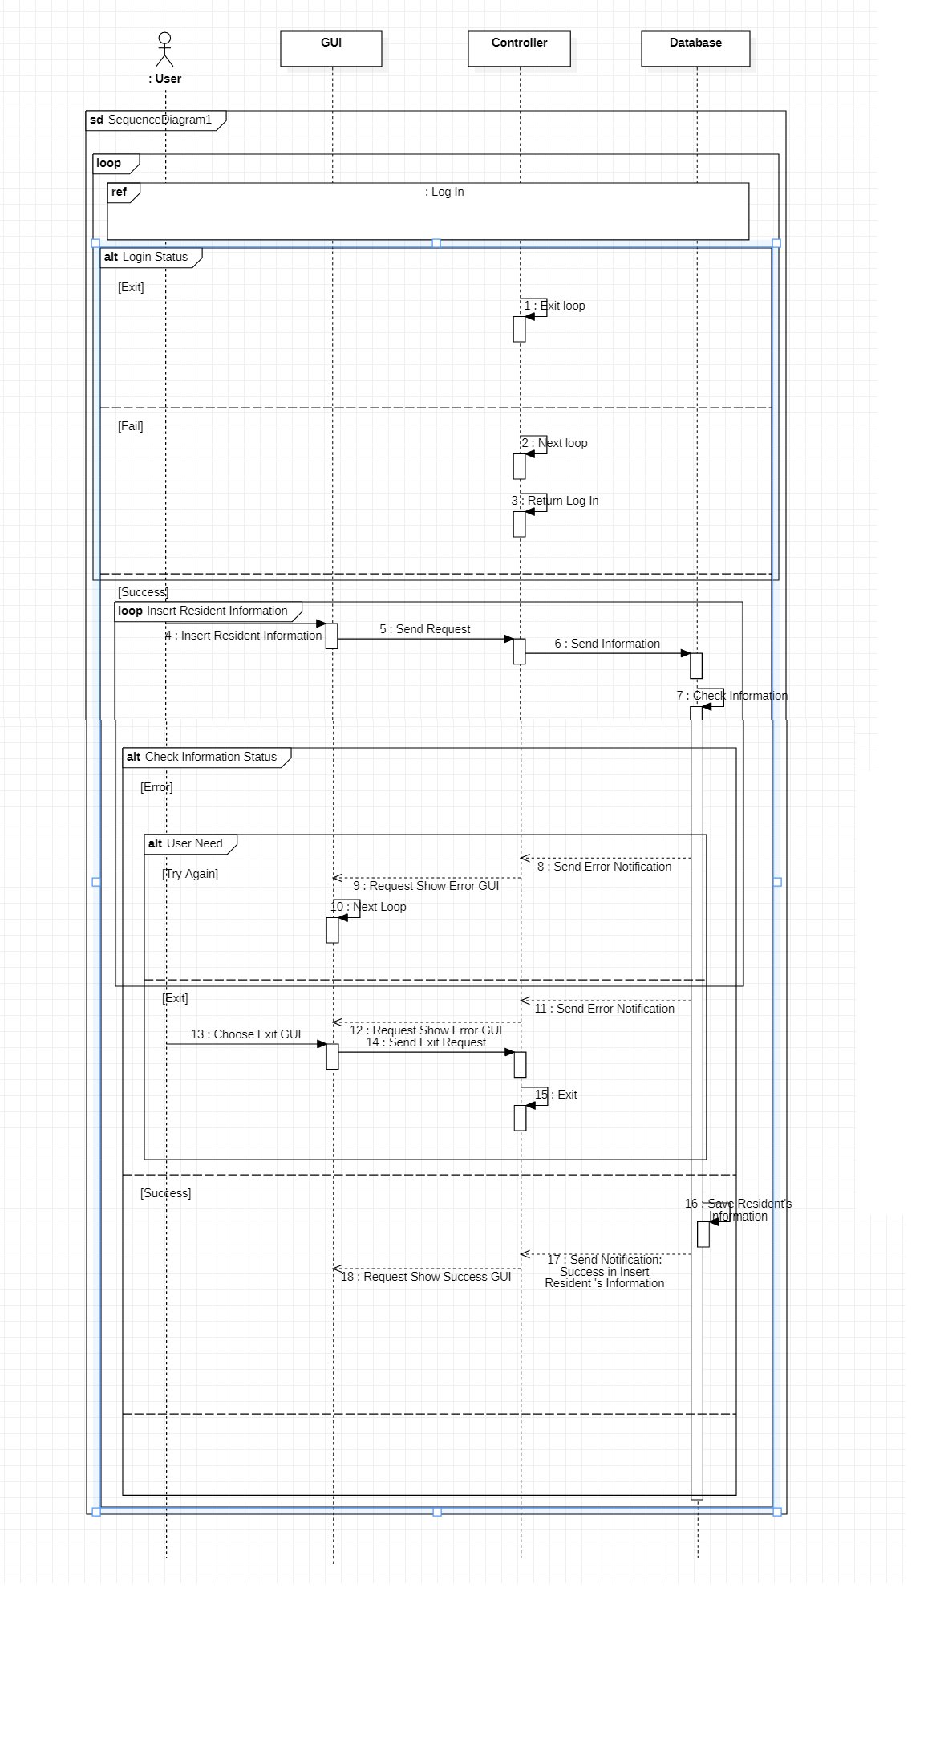1. Insert Resident Information

1. 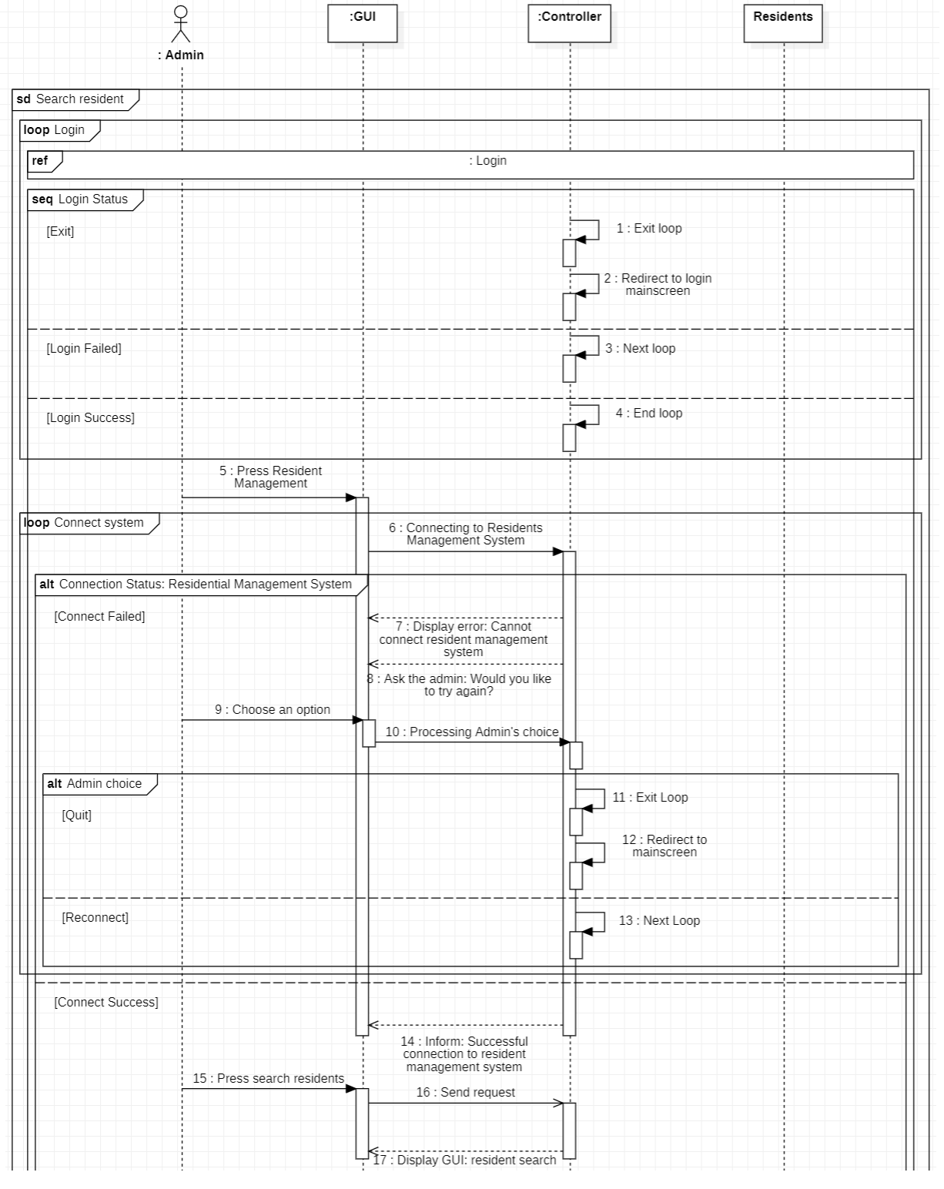Search resident

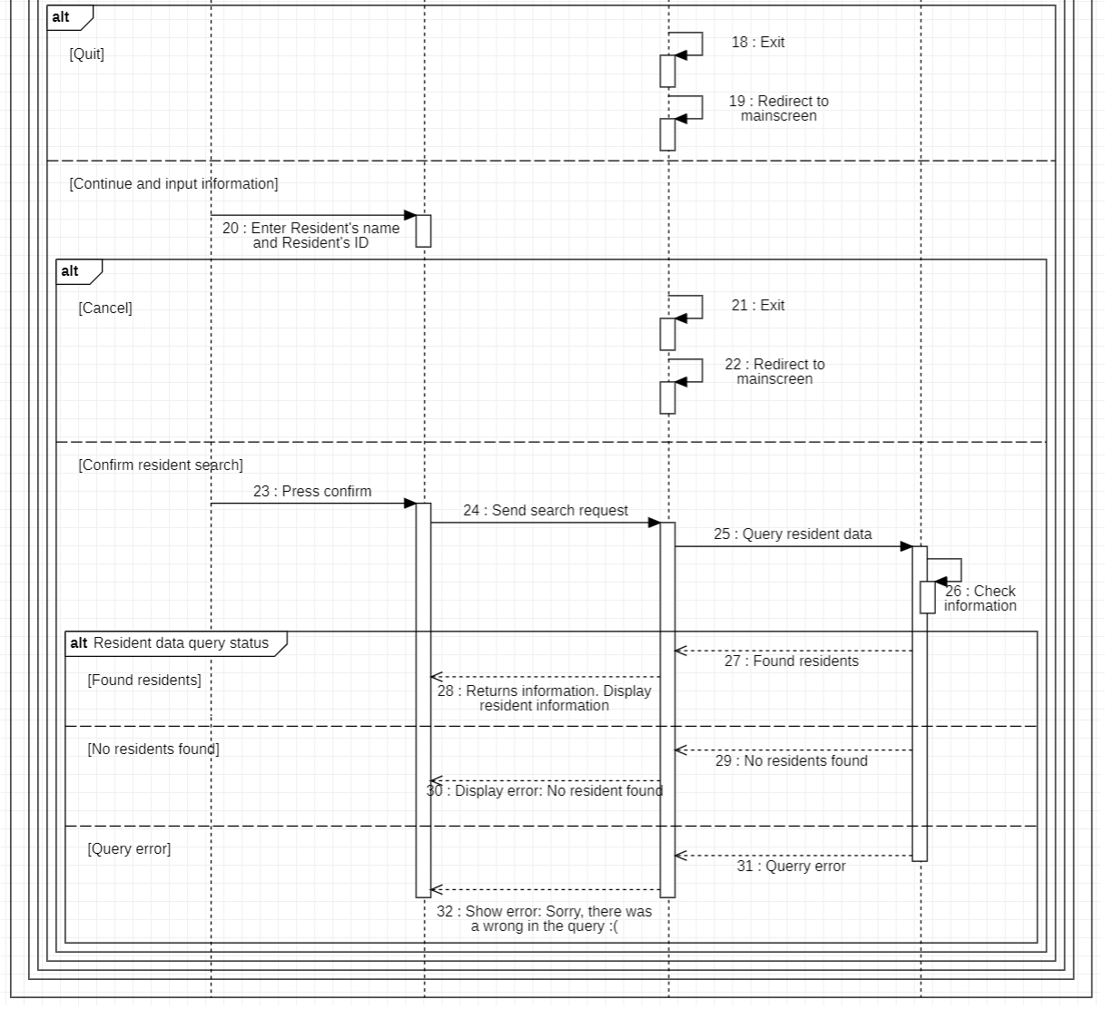

1. Delete resident

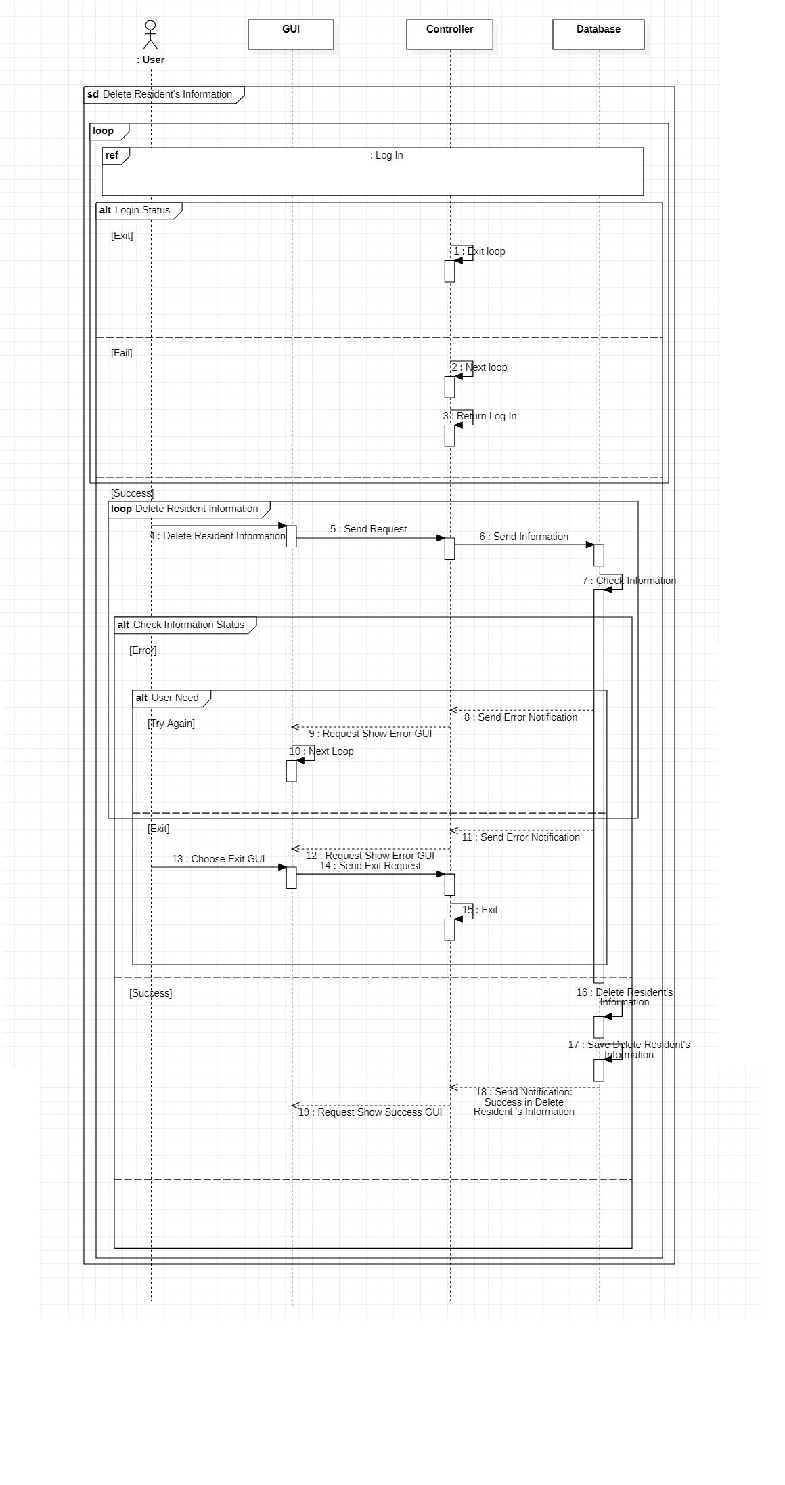

1. 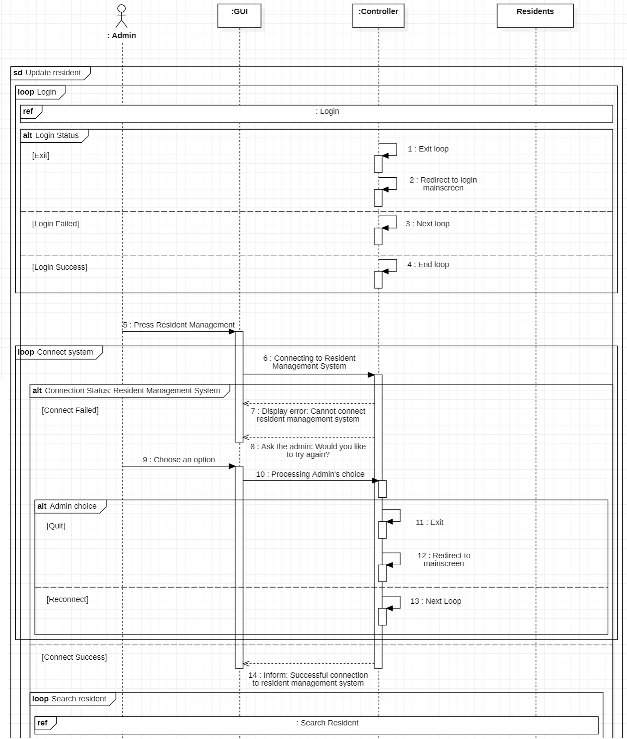Update resident

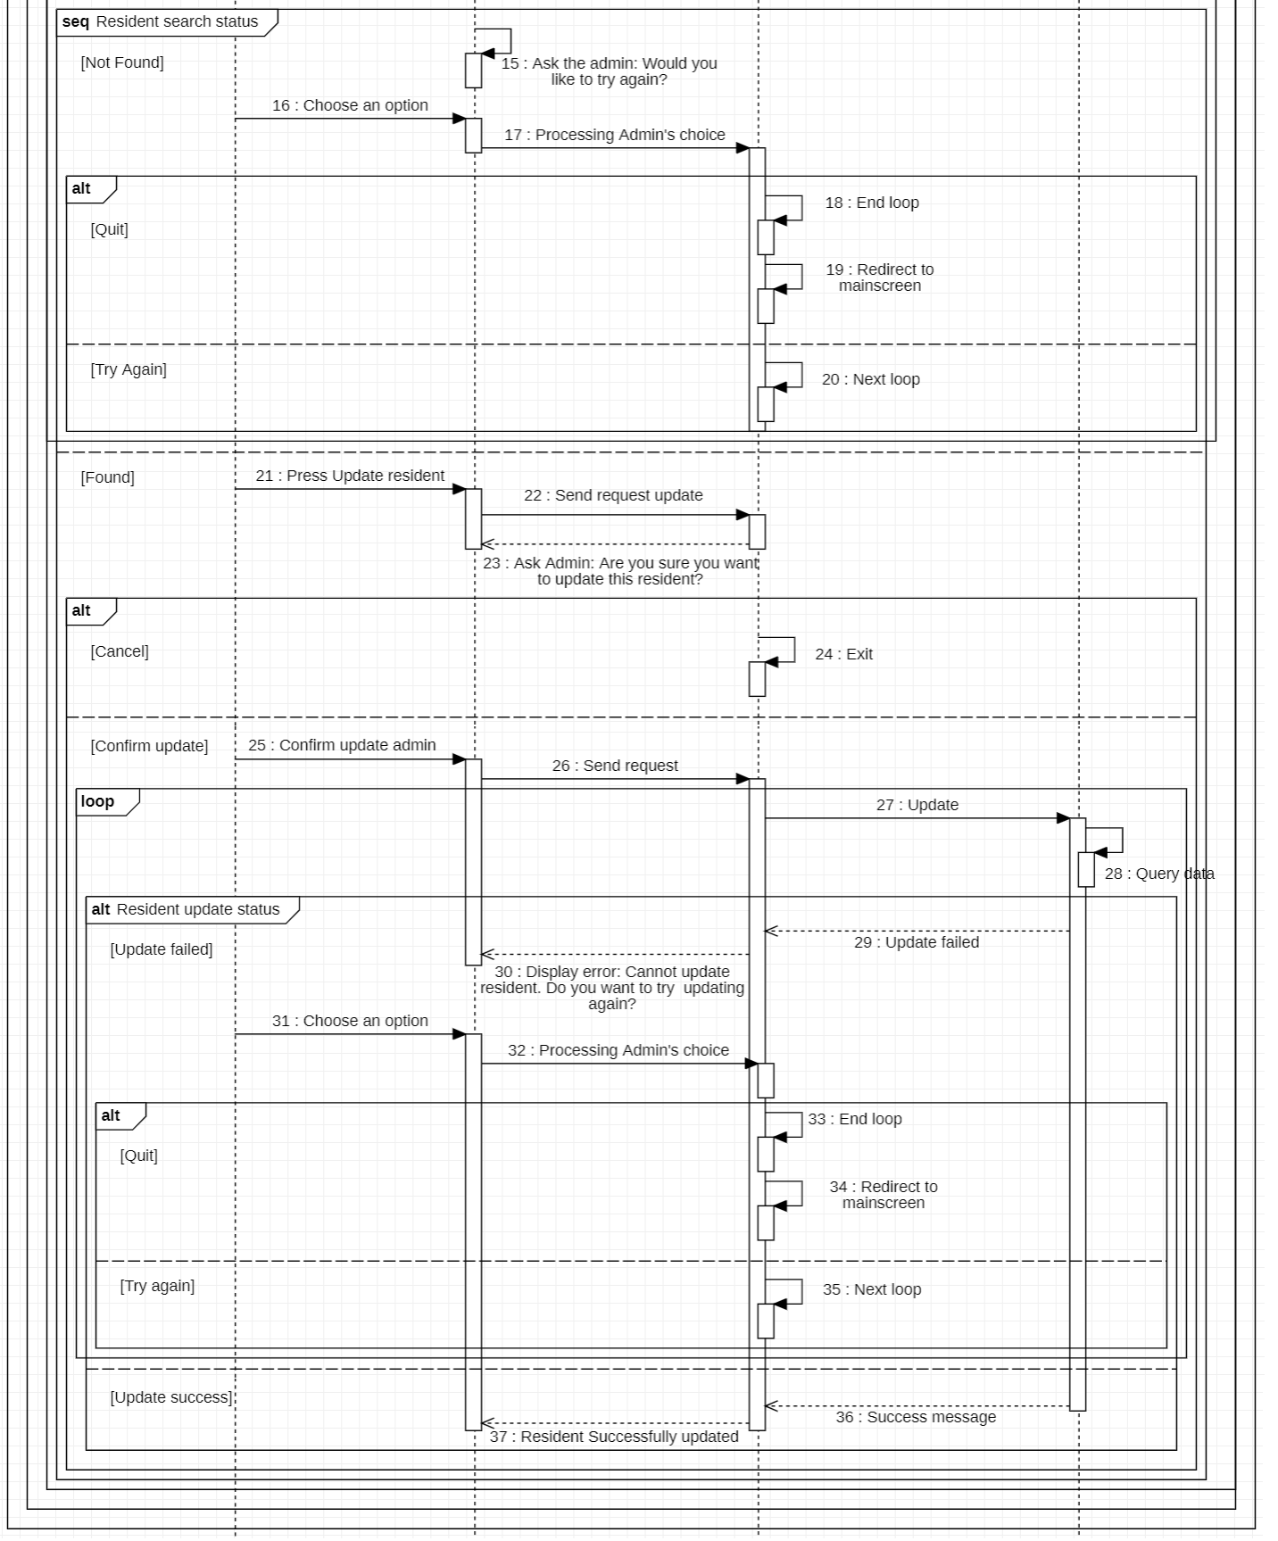

3.7.6. System Management’s Function

1. 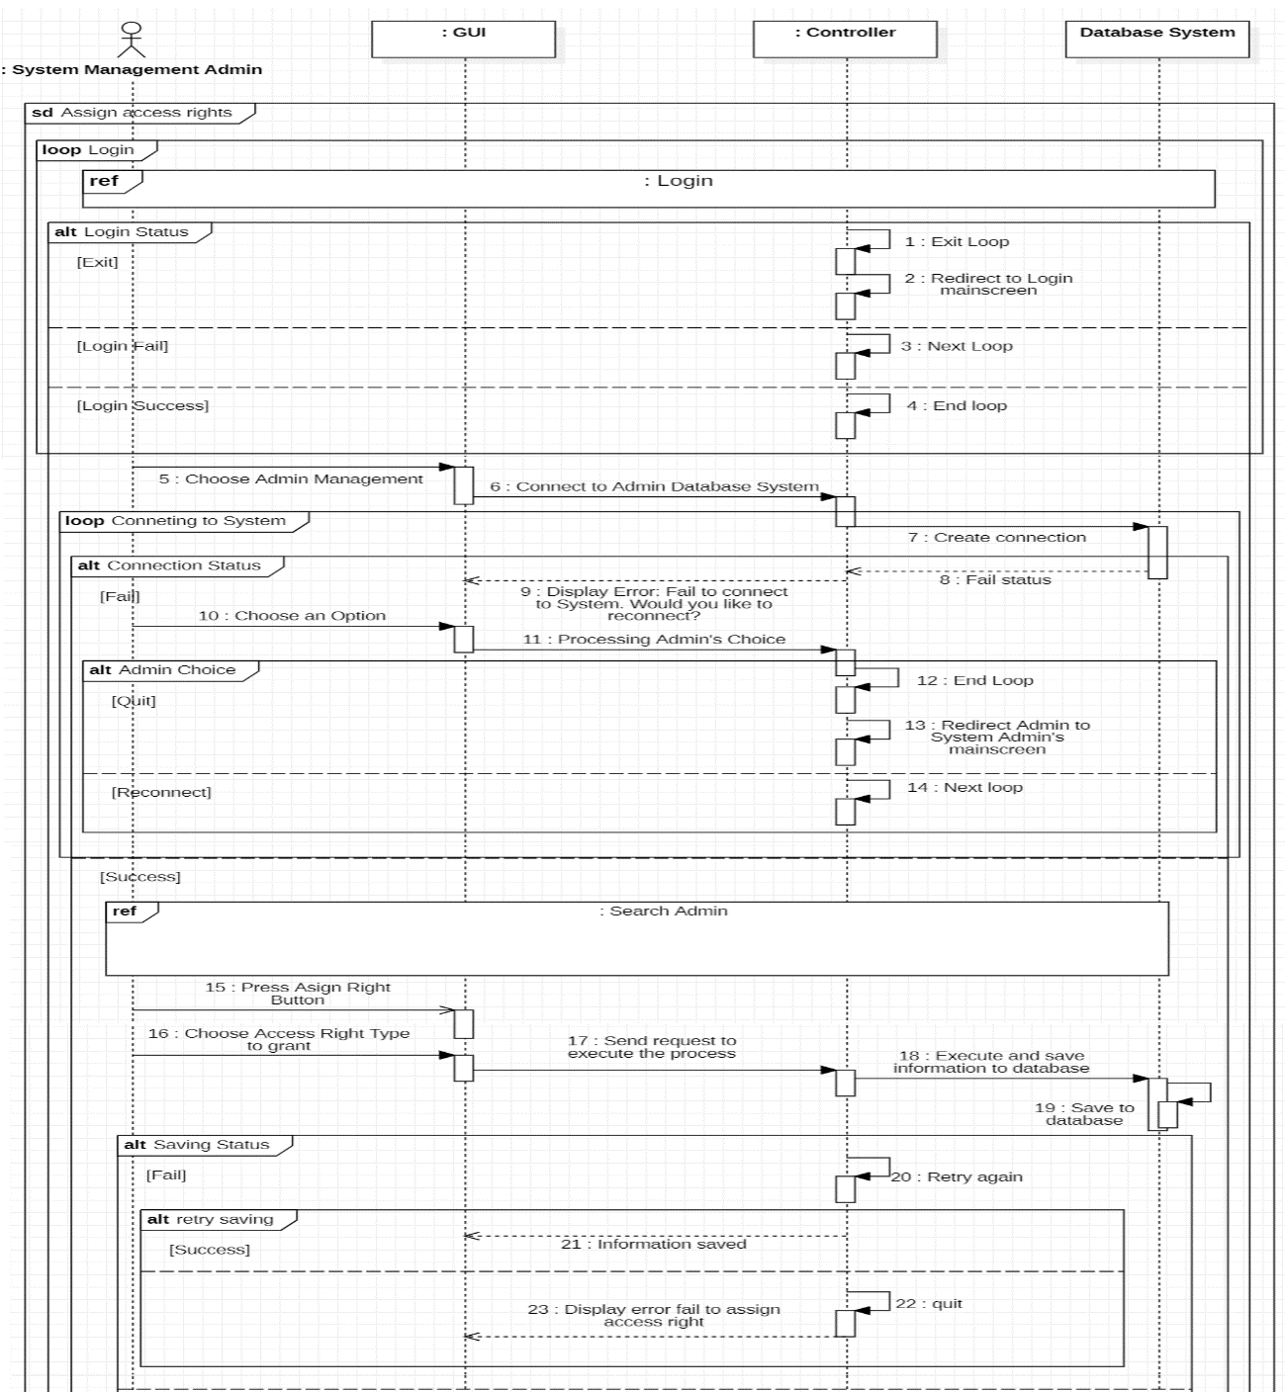Assign access rights
2. Ad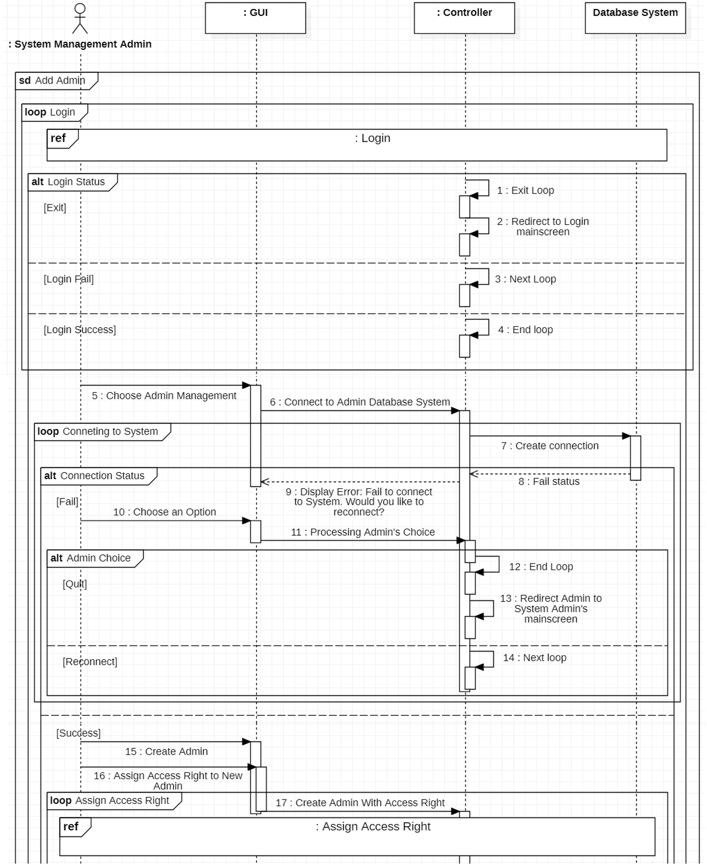d Admin

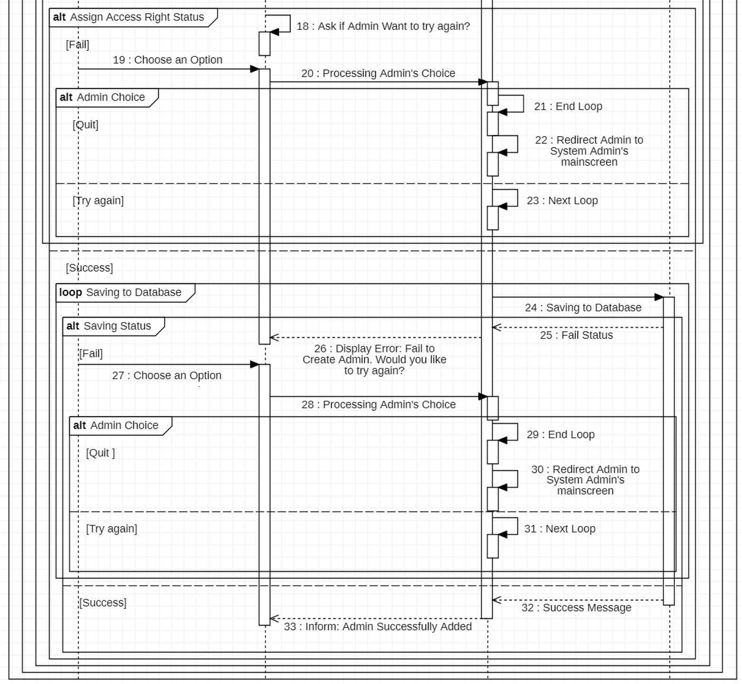

1. Search admin

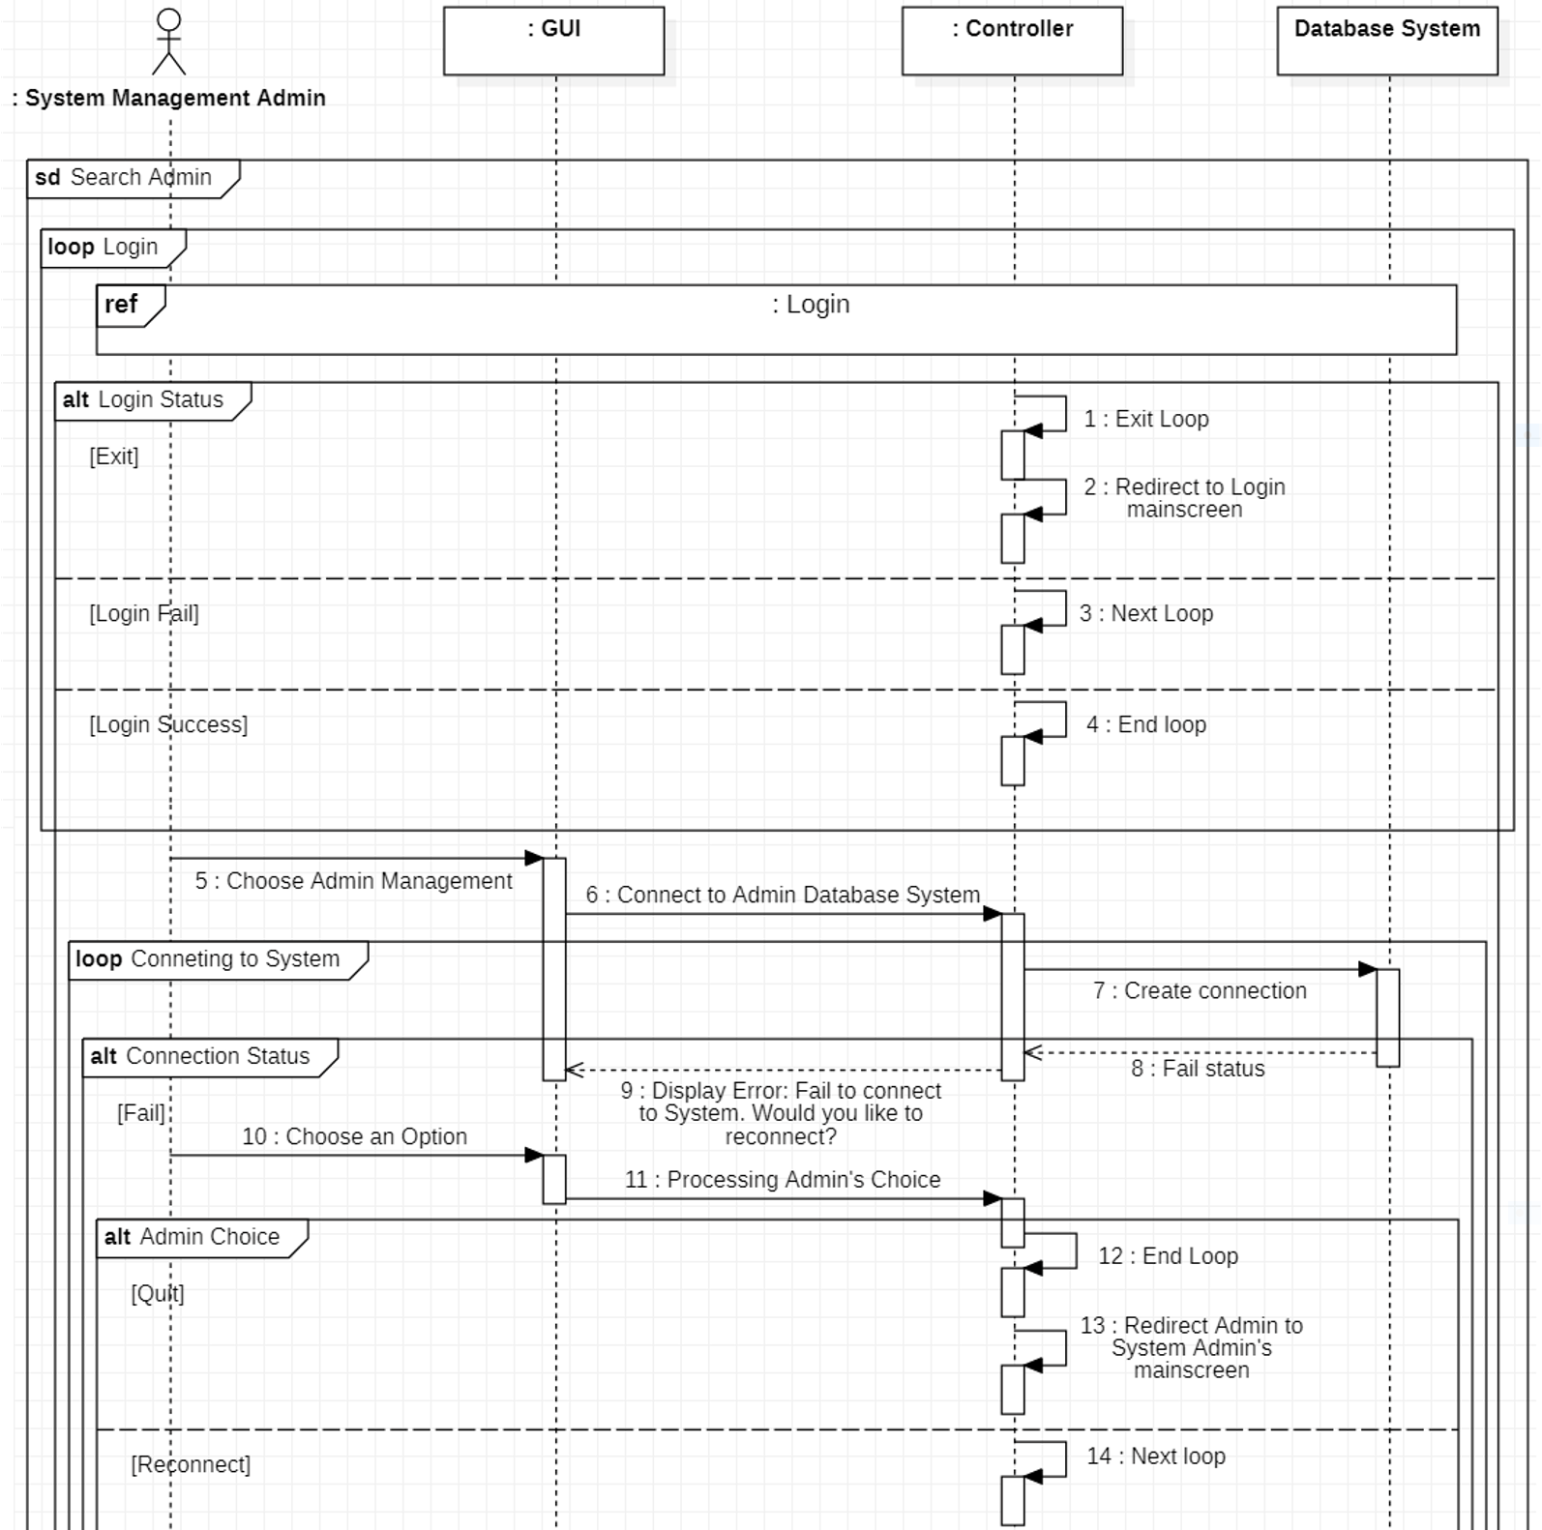

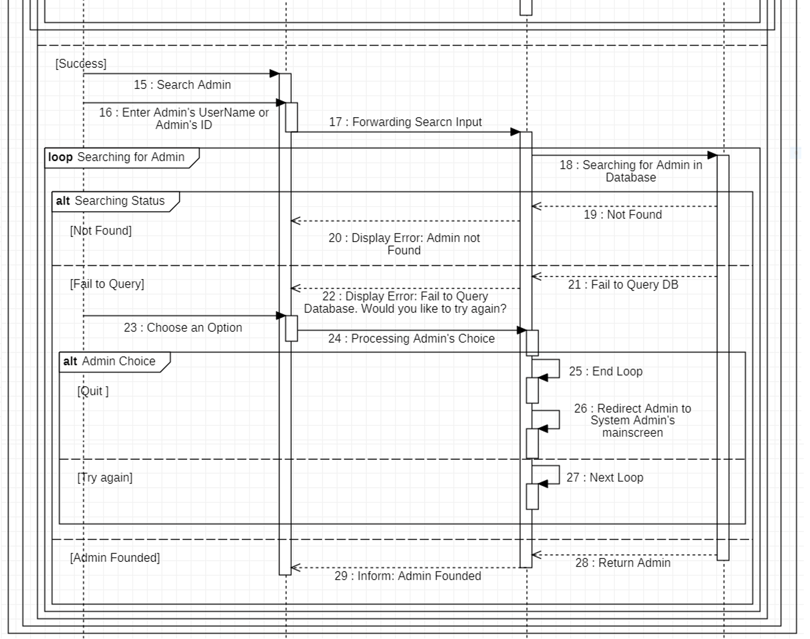

1. System Maintenance

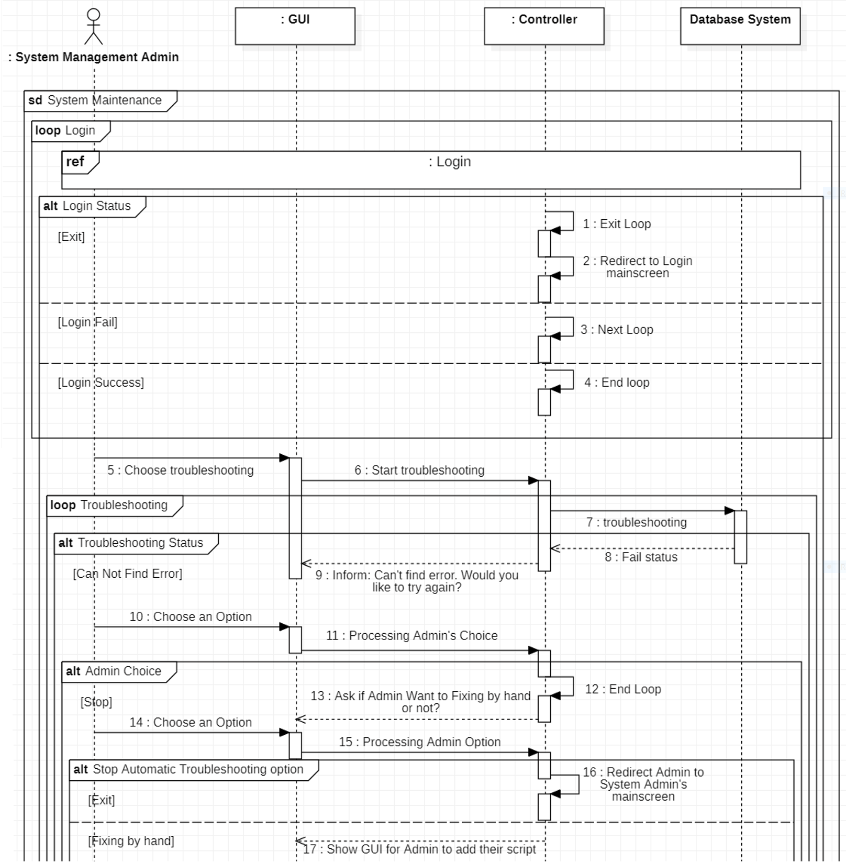

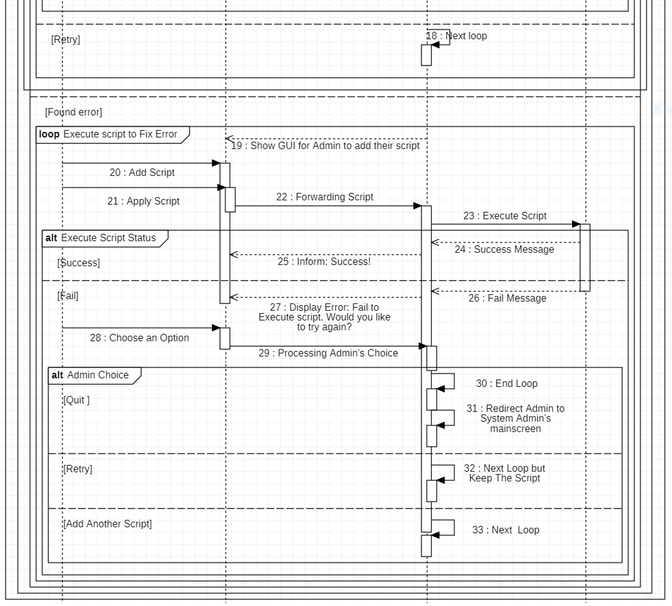

1. Delete admin

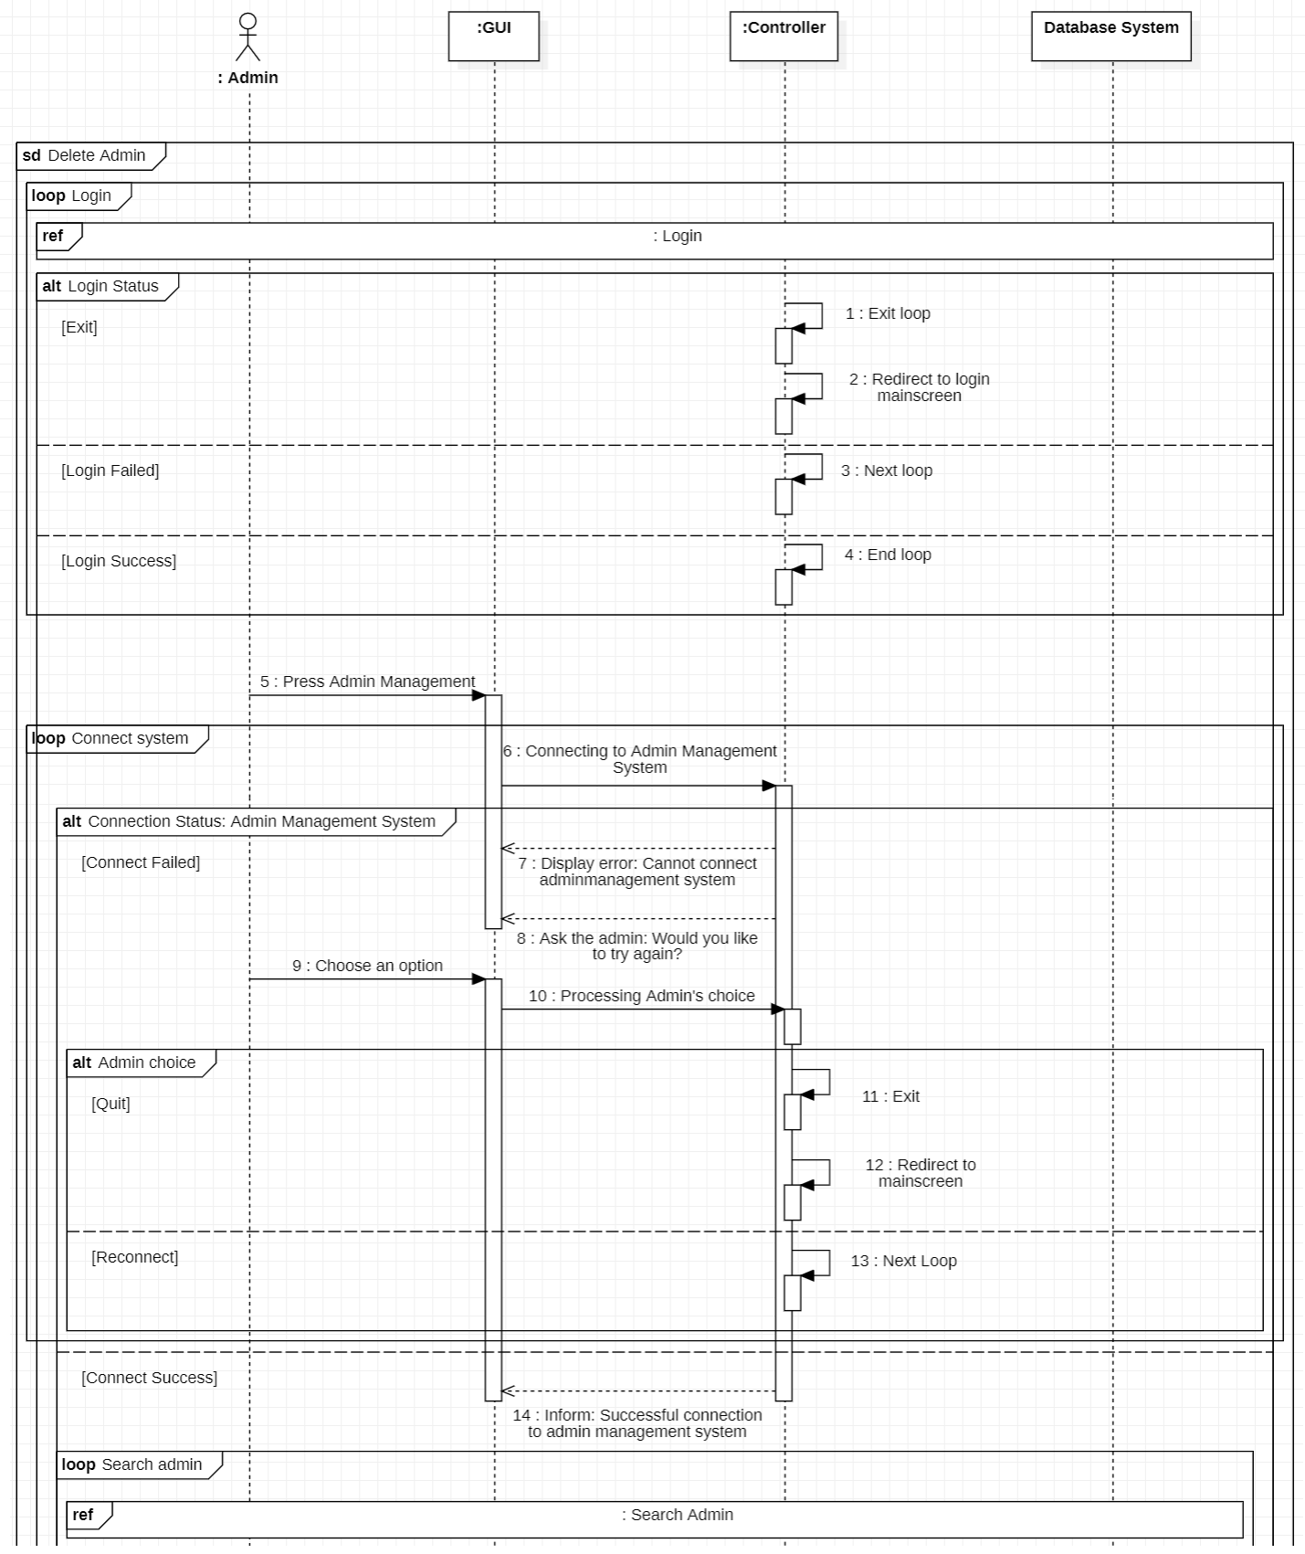

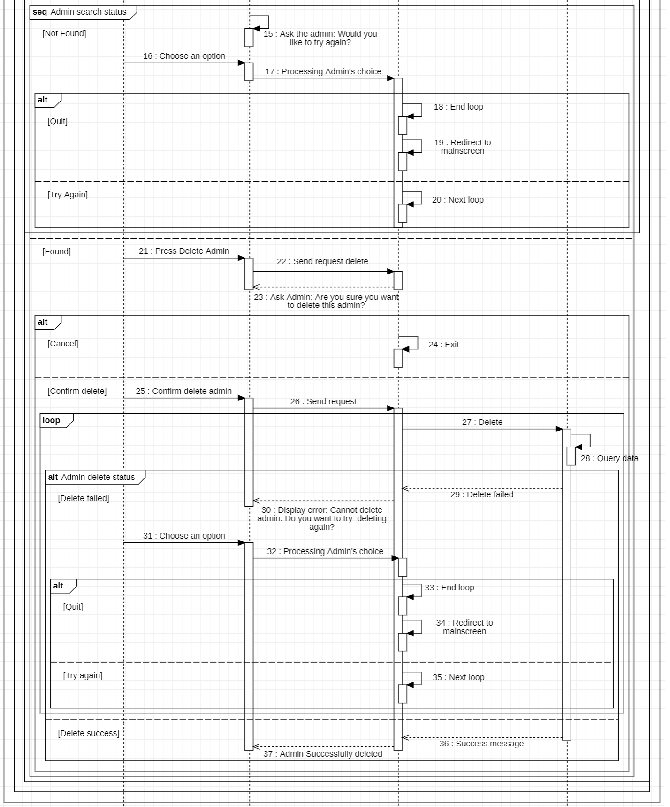

1. Update admin

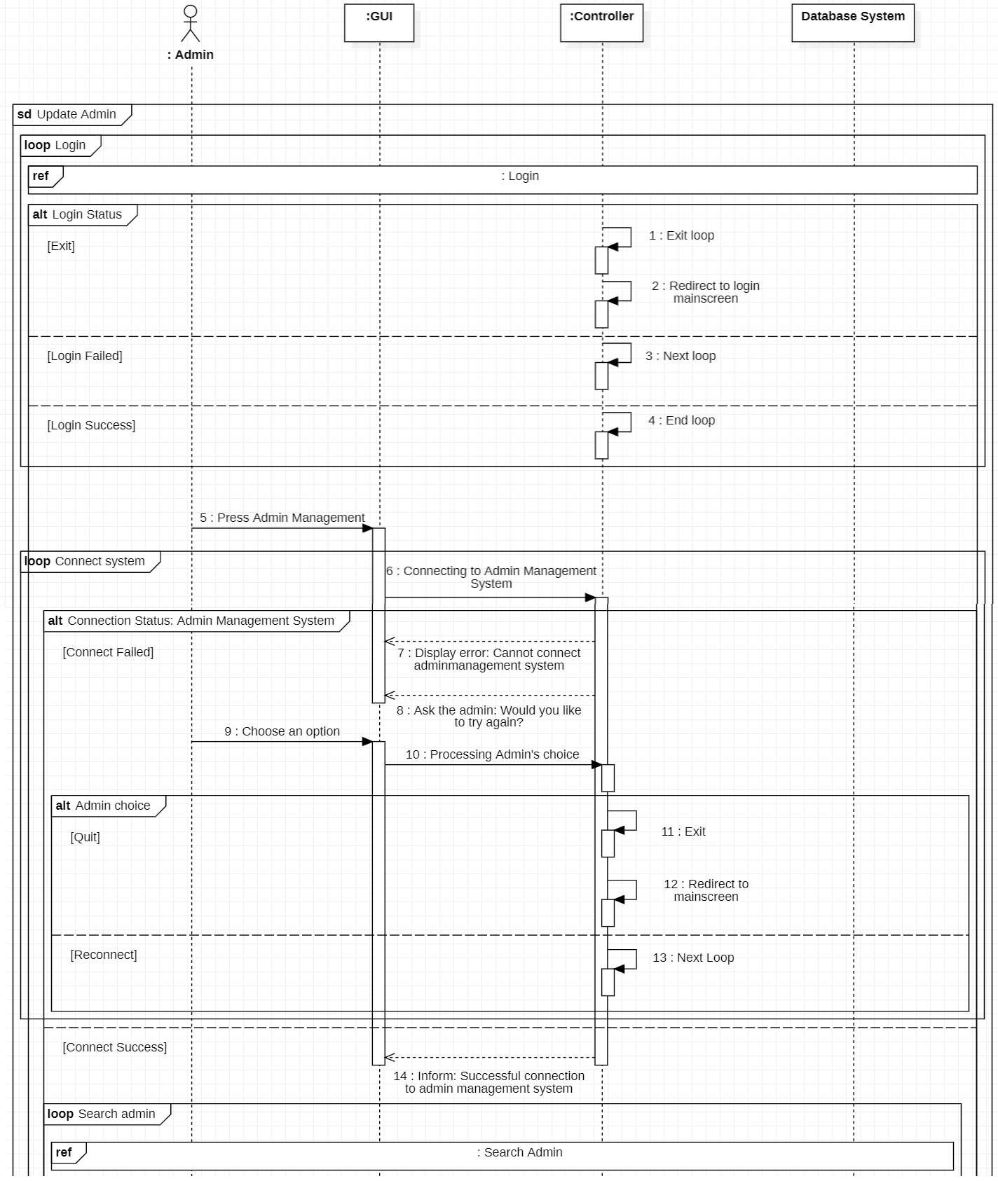

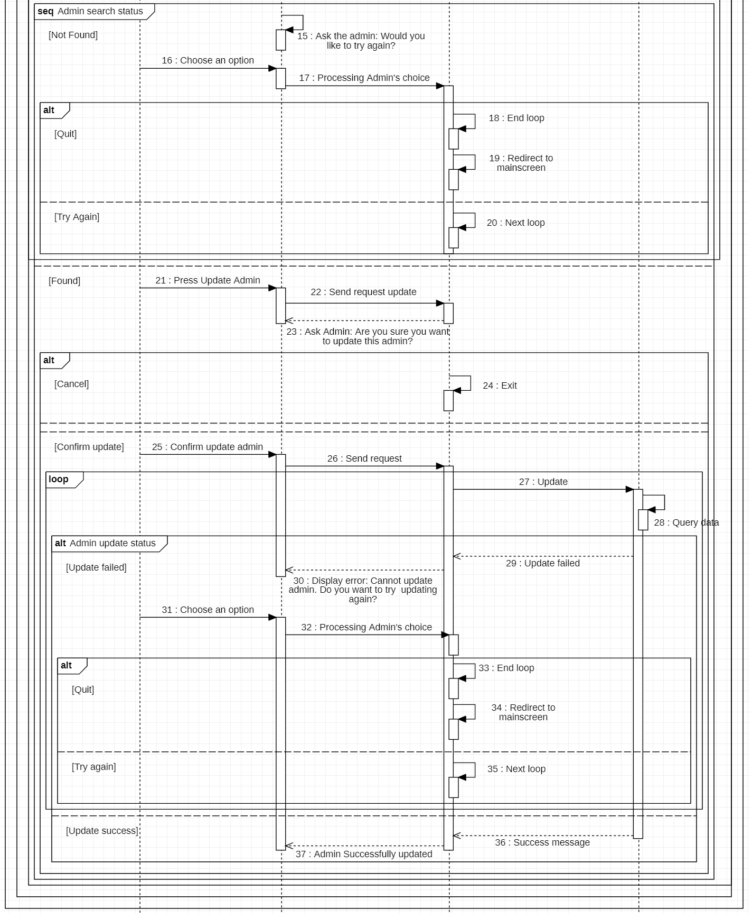

* 1. 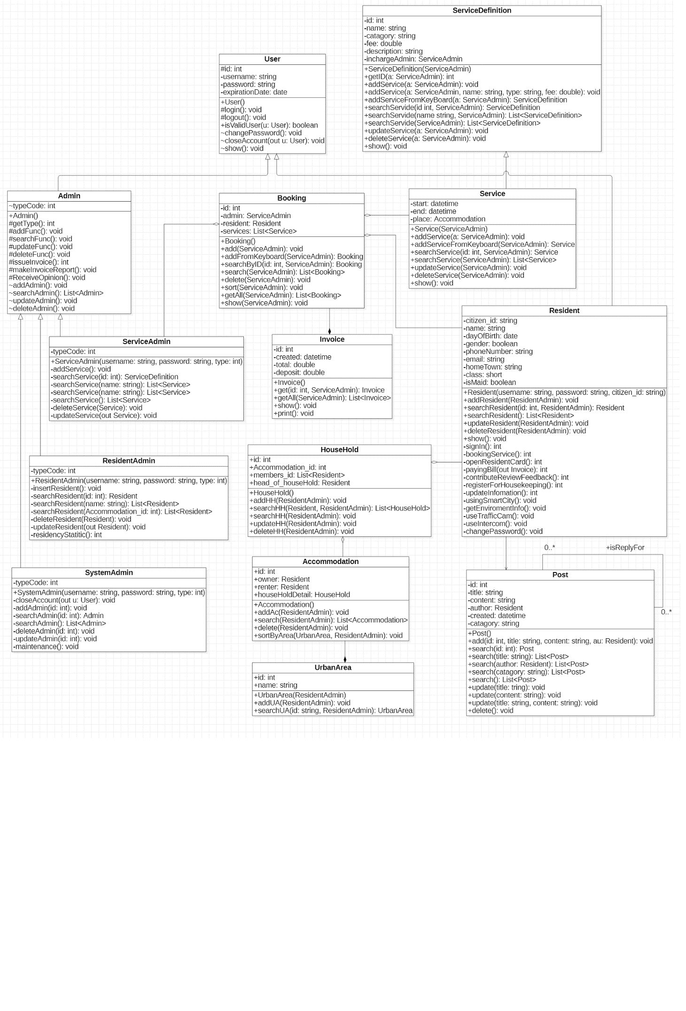***Class Diagram***
  2. ***Mapping to Relational Model from ERDs*** 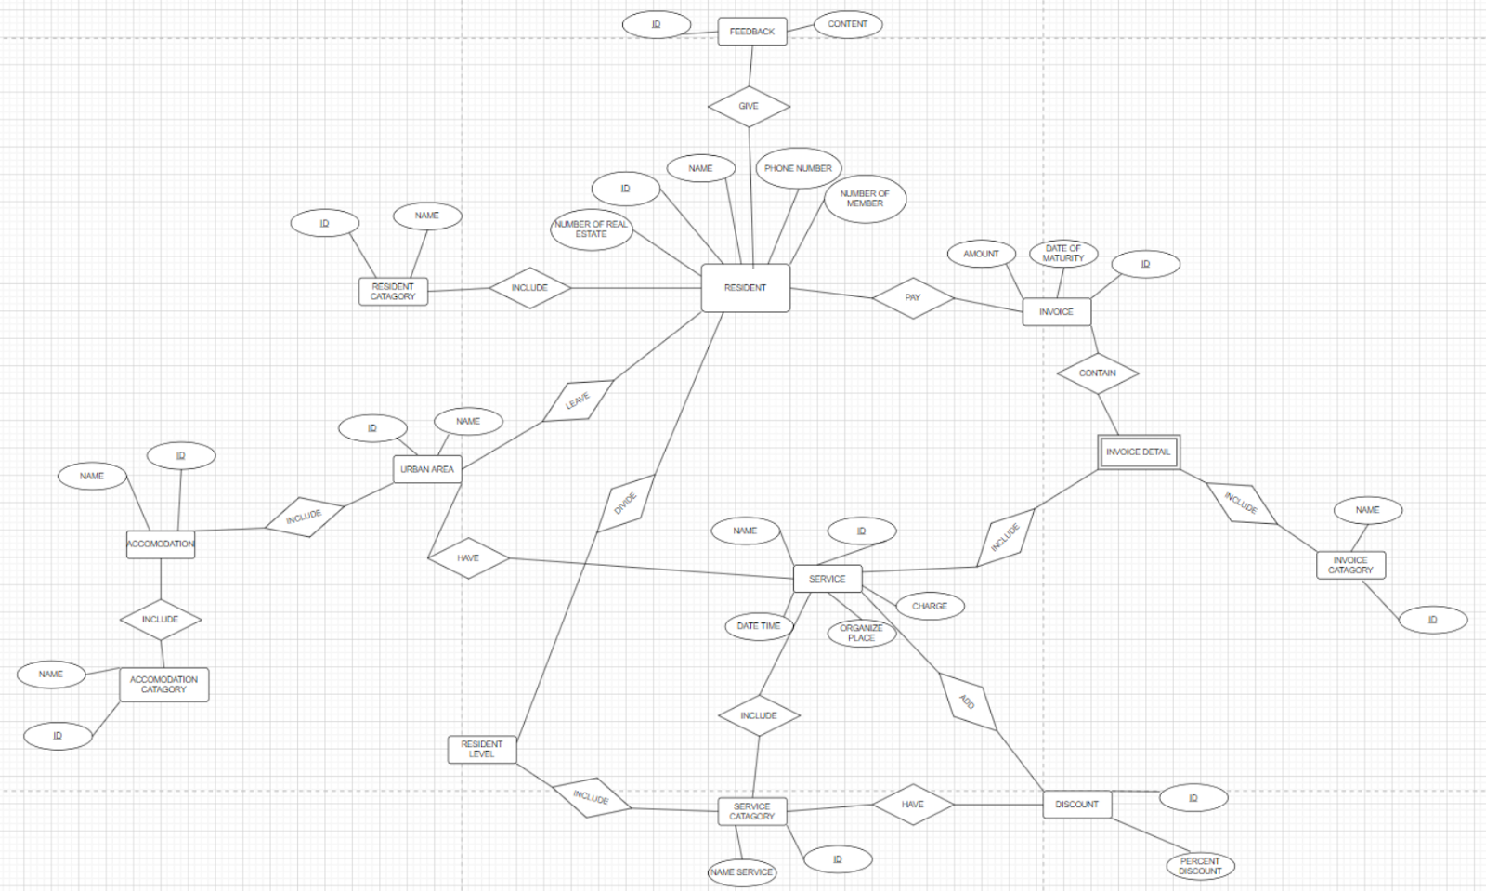

# Chapter 4: IMPLEMENTATION AND TESTING

* 1. **Introduction to the implementation environment**
* Programming Language: Java
* Framework: Hibernate, Porting
* IDE: Netbeans
* Database: MySQL
* Code Model: 3 Layers (DTO,DAL,BLL,GUI)
* Process Management Model: Waterfall Model
  1. **User Interface**

**4.2.1. List of screens**

|  |  |  |  |
| --- | --- | --- | --- |
| **No** | **User interface** | **UI type** | **Function** |
| 1 | Login Form | Input, display and interact interface | Allow the user to enter username and password to login. |
| 2 | Apartment Form | Input, display and interact interface | User can add, update, delete,edit apartment information on the system |
| 3 | Resident Form | Input, display and interact interface | User can add, update, delete,edit resident information on the system |
| 4 | Invoices Form | display and interact interface | User can issue an invoice on the system |
| 5 | Contract Form | Input, display and interact interface | User can manage the information: add, update, delete, edit on the system |

### **4.2.2. Detailed description of Screens**

4.2.2.1. Log-in interface

#### **4.2.2.2 Resident Information Management Interface (Apartment information)**

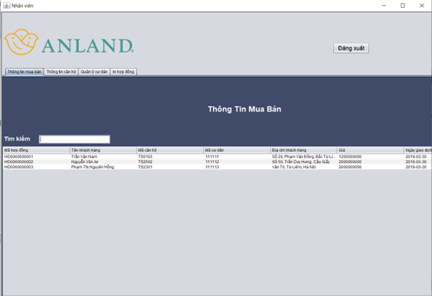

#### **4.2.2.3. Resident Information Interface**

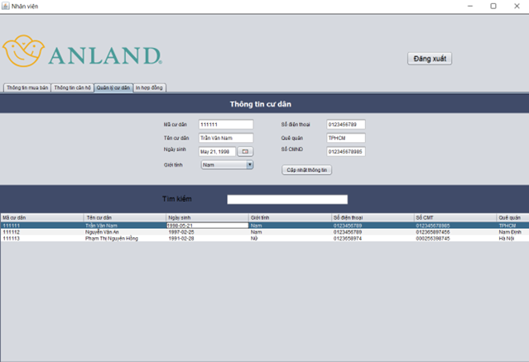

#### **4.2.2.4. Issues an invoice about apartment interface**

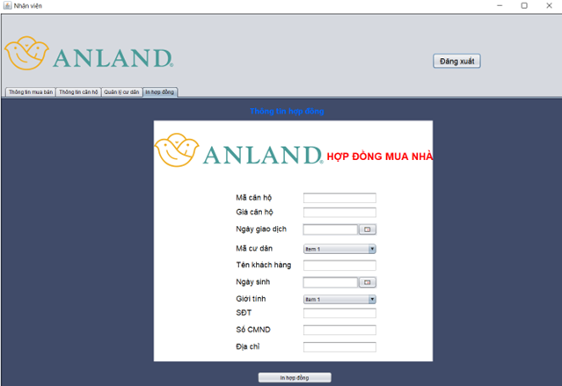

# Chapter 5: CONCLUSION

*Vinhomes resident management is a system for residents. To put into operation there are many factors.*

*This system, besides supporting basic features for residents such as viewing notices, comments, paying bills, scheduling services. The system also has a forum to find housekeepers when residents need to book an housekeeping service.*

*In addition, residents can receive useful information streams from air level measurement features, traffic cameras around the area and intercom - facial recognition function for guests.*

*In parallel with it, system administrators in addition to managing residents' information, they can make statistics, add, delete, edit resident information,*

*manage the accounts of the administrative staff for the admin head. Management of apartments and houses of residents.*

*To build a complete system, we must know how to define goals, survey the market, design use case diagrams and go into each detailed stage of activity diagrams.*

*sequence diagram from which to build a programming system according to the original design.*

# References

# 4.1. Tool for designing Information system

<https://staruml.io/download>

# 4.1.2. Tool for developing

<https://www.oracle.com/java/technologies/downloads/>

4.1.3. Announcement of Vinhomes Resident Application Deployment

<https://luongyen.com/vhsc-thong-bao-trien-khai-ung-dung-vinhomes-resident/>

4.1.4. Framework:

https://netbeans.apache.org/kb/docs/java/hibernate-java-se.html

1.